#### Project Report

**On**

“Student Management System”



As partial fulfillment for the degree of

**Bachelor of Computer Application At**

**K.S.K.V. Kachchh University,**

Bhuj.

(July- 2021)

**Submitted by:**

[ Dharmanshu Agravat (18BCA001) Devarsh Antani (18BCA002 ) Mayank Rathod (18BCA040 ) ]

|  |  |  |
| --- | --- | --- |
| Mr. Dhiraj Solanki | Mr. Dhiraj Solanki | Mr. Chintan P. Morabia |
| Project Guide | I/c. Principal | Director |

**SANSKAR INSTITUTE OF MANAGEMENT & INFORMATION TECHNOLOGY**



**CERTIFICATE**

This is to certify that the project entitled “Student Management System” is a bonafide work carried out by **Dharmanshu Agravat (18BCA001), Devarsh Antani (18BCA002), Mayank Rathod (18BCA040)** for the degree of Bachelor of Computer Application at **Sanskar Institute of Management & Information Technology, Bhuj, Gujarat**.

To the best of our knowledge and belief, this work embodies the work of candidates themselves, has duly been completed, fulfills the requirement of the ordinance relating to the Bachelor degree of the university and is up to the standard in respect to content, presentation and language for being referred to the examiner.

Mr. Dhiraj Solanki

Project Guide

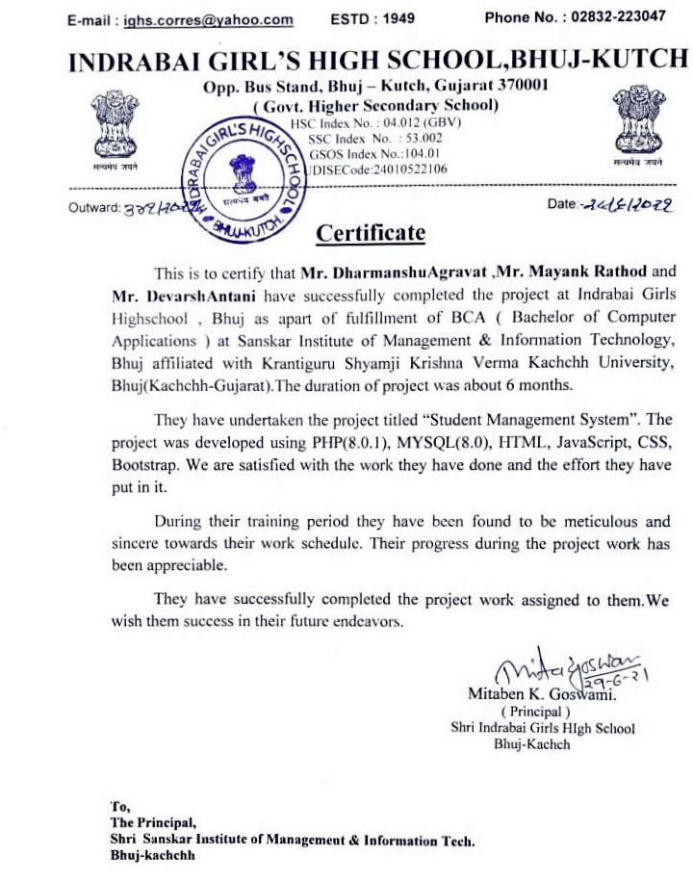

**Candidates Declaration**

We declare that final year report entitle “**Student Management System**” is our own work conducted under the supervision of the guide **Mr. Dhiraj Solanki** at “Sanskar Institute of Management and Information Technology”, As a final year project with the subject System development project in our curriculum of bachelor of computer applications.

##### Dharmanshu Agravat (18BCA001),

##### Devarsh Antani (18BCA002),

##### Mayank Rathod (18BCA040) .

**Acknowledgement**

First of All, We are very thankful to the authority of the Indrabai Girls High School for allowing us to work for them. We would like to take this opportunity to express our heart full gratitude to them.

We would like to thank all those people who helped us directly or indirectly to complete our project. Whenever we found our self n problem our all faculties encouraged us and boosted our moral to accomplish this project.

Last but not least, We would like to express our gratitude to those friends or faculties who directly or indirectly helped in final year project.

##### Dharmanshu Agravat (18BCA001),

##### Devarsh Antani (18BCA002),

##### Mayank Rathod (18BCA040) .

**INDEX**

|  |  |  |
| --- | --- | --- |
| **Sr.** | **Topic** | **Page No.** |
| 1 | Introduction | 6-7 |
| 2 | Organization Profile | 8-9 |
| 3 | Existing System | 10-12 |
| 4 | Problem areas and need for the new system | 13-14 |
| 5 | Proposed system | 15-17 |
| 5.1 | Development tools and technologies used | 18-22 |
| 5.2 | System Features | 23 |
| 5.2.1 | Data Flow diagram | 24-25 |
| 5.2.2 | Use case diagram | 26 |
| 5.2.3 | Activity diagram | 27-29 |
| 5.2.4 | Entity-relationship diagram | 30 |
| 5.2.5 | Data Dictionary | 31-42 |
| 5.2.6 | Screen Layouts | 43-149 |
| 6 | Proposed Enhancement | 150-151 |
| 7 | Conclusion | 152 |
| 8 | Bibliography | 153 |

1.

Project Overview

**1. Project Overview**

Student Management System is web application for the education that can be used to managed student information and data. This system is designed for high school to help administrators and teachers in the management of students. Students Management System consists of seven modules including Teachers, Students and Admin Profile, resources, chat system, notification, events and gallery and logs.

Admin will register students’ and teachers’ profile by our import system. Admin will give students and teachers their static password which can be changed later by OTP verification. Teacher will select their subjects according to their particular classes. Admin can send events, notifications and images to students and teachers. Students can download materials which will be sent by teachers according with their classes. Students can send messages to any Teacher while that Teacher can reply to that student by real time chatting system. Admin can see all the actions performed by students and teachers by our Log system.

### 2.

Organization Profile

#### 2. Company Profile

Name :- Indrabai Girls High School.

Address :- Opp. Bus Station Rd, Ghanshyam Nagar, Bhuj, Gujarat 370001.

Indrabai Girls High School is a government school established in 1949, in BHUJ-KUTCH. It consists of class 9, 10, 11 and 12 with Science, Commerce, Arts and Home Science streams. It is a well-known organization for its quality education.

School is being managed by principal Mitaben k. Goswami. There are currently 1341 Students, 55 Classrooms, 4 computer labs with 25 computers per lab, 2 staff rooms, 1 library, 1 first aid room, 1 chemistry lab, 1 physics lab, 1 biology lab, 1 home science lab, 1 P.T. room, 1 music room.

Indrabai Girls High School was visited by Dr. APJ Abdul Kalam in year 2007 and gave wonderful speech. The school has received many awards. The staff members received awards such as best teacher award at state level from Indian president, Former chief minister of Gujarat Narendra Modi.

School has participated in many competitions and won many awards. School performs many activities Such as N.S.S. activity, Eco-club activity, awareness activity, Art activity, medical check-up activity, career guidance activity, karate training.

## 3.

Existing System

**Existing System.**

* Currently firm is using Registers and Excel files to manage students and all school's data. They Create Different Registers for Different classes to manage data.
* There is no dedicated system for data management.
* Students have to visit school’s library to get resources.
* There is no facility for students to ask any queries outside the campus.
* Students must visit school to see their personal data.
* There is no other service to pass notices to students.

# Our Project Definition

We have prepared "Student Management System" in which our firm can handle all the students, Teachers, and admins data easily to overcome the limitations of existing system.

Our project can be divided into 3 parts as admin side , teacher side, And student side.

* **Admins :** 
  + Admin can perform add, edit , delete actions for students, teachers, notifications, events data.
  + Admin can promote students to transfer students to their next year class.
  + Admin can also add other admin accounts and manage their details.
  + Admin can also see systems logs to keep track of which actions are performed by other users (teachers, students, admins).
  + Admin can also see their Profile and change password.
* **Teachers :** 
  + Teacher can upload resource files to website, delete these files, and download these files too.
  + Also teachers can chat with their students to resolve students queries.
  + Teachers can see events, notifications, and gallery images too.
  + teachers can also see their profile and change password.
* **Students :**
* Students can download resources uploaded by their subject teachers.
* Students can start chat with teachers to resolve their queries.
* Students can receive notifications uploaded by admins.
* And also see event details and gallery images.

## 4.

### Problem areas & need for the new system

**Problem areas & need for the new system**

* + There is no dedicated system for data management.
  + Students have to visit school’s library to get resources.
  + There is no facility for students to ask any queries outside the campus.
  + Students must visit school to see their personal data.
  + There is no other service to pass notices to students
  + It is very time consuming.
  + There are high chances of data redundancy in this system.
  + There are high chances to lose or damage their records in long time.

Due to this all Problems a new system was required..

## 5.

System Description

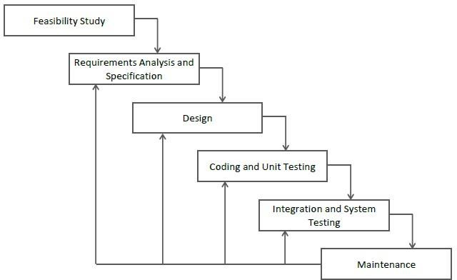

##### Iterative Model

In this Model, you can start with some of the software specifications and develop the first version of the software. After the first version if there is a need to change the software, then a new version of the software is created with a new iteration. Every release of the Iterative Model finishes in an exact and fixed period that is called iteration.

The Iterative Model allows the accessing earlier phases, in which the variations made respectively. The final output of the project renewed at the end of the Software Development Life Cycle (SDLC) process.

##### The various phases of Iterative model are as follows:

* + **Requirement gathering & analysis:** In this phase, requirements are gathered from customers and check by an analyst whether requirements will fulfill or not. Analyst checks that need will achieve within budget or not. After all of this, the software team skips to the next phase.
  + **Design:** In the design phase, team design the software by the different diagrams like Data Flow diagram, activity diagram, class diagram, state transition diagram, etc.
  + **Implementation:** In the implementation, requirements are written in the coding language and transformed into computer programs which are called Software.
  + **Testing:** After completing the coding phase, software testing starts using different test methods. There are many test methods, but the most common are white box, black box, and grey box test methods.
  + **Deployment:** After completing all the phases, software is deployed to its work environment.

* + **Review:** In this phase, after the product deployment, review phase is performed to check the behavior and validity of the developed product. And if there are any error found then the process starts again from the requirement gathering.
  + **Maintenance:** In the maintenance phase, after deployment of the software in the working environment there may be some bugs, some errors or new updates are required. Maintenance involves debugging and new addition options.

We used Iterative model for our project because,

* + Testing and debugging during smaller iteration is easy.
  + A Parallel development can plan.
  + It is easily acceptable to ever-changing needs of the project.
  + Risks are identified and resolved during iteration.
  + Limited time spent on documentation and extra time on designing.

In our project we have multiple modules so if there is a need to change in a particular module, then a new version of that module will be created with a new iteration. By this method

our project will be well synchronized.

## 5.1

Development tools And Technologies

Front-end tools :

HTML, CSS , JavaScript, Bootstrap 4, Ajax with xml

Back-end Tools :

PHP (version 8.0.1), MYSQL (version 8.0).

##### Cascading Style sheets (CSS)



* + Cascading Style sheets (CSS) is a style sheet language used for describing the presentation of a document written in a markup language like HTML. CSS is a cornerstone technology of the World Wide Web, alongside HTML and JavaScript. CSS is to designed to enable the separation of presentation and content. Including layout, colors and fonts.
  + This separation can improve content accessibility. Provide more flexibility and control in the specification of presentation characteristics. Enable multiple web pages to share formatting by specifying the relevant CSS in a separate .CSS file, and reduce complexity and repetition in the structural content

##### JavaScript



* + JavaScript is a high level, dynamic, untyped, and interpreted programming language. It has been standardized in the ECMA Script language specification. Alongside HTML and CSS, it is one of the three essential technologies of World Wide Web content production. The majority of websites employ it and it is supported by all modern web browsers without plug-ins.
  + JavaScript is prototype-based with first-class functions, making it a multi-paradigm language, supporting object-oriented, imperative, and functional programming styles.
  + It has an API for working with text, arrays, dates and regular expressions, but does not include any I/O, such as networking, storage or graphics facilities, relying for these upon the host environment in which it is embedded.

##### BOOTSTRAP 4

* + Bootstrap is the most popular HTML, CSS and JavaScript framework for developing a responsive and mobile friendly website.
  + It is absolutely free to download and use.
  + It is a front-end framework used for easier and faster web development.
  + It includes HTML and CSS based design templates for typography, forms, buttons, tables, navigation, modals, image carousels and many others.
  + It can also use JavaScript plug-ins.
  + It facilitates you to create responsive designs.

##### jQuery



* + jQuery is a fast, small, and feature-rich JavaScript library. It makes things like HTML document traversal and manipulation, event handling, animation, and Ajax much simpler with an easy-

to-use API that works across a multitude of browsers. With a combination of versatility and extensibility, jQuery has changed the way that millions of people write JavaScript. jQuery is a lightweight, "write less, do more", JavaScript library. The purpose of jQuery is to make it much easier to use JavaScript on your website. jQuery takes a lot of common tasks that require many lines of JavaScript code to accomplish, and wraps them into methods that you can call with a single line of code. jQuery also simplifies a lot of the complicated things from JavaScript, like AJAX calls and DOM manipulation. The jQuery library contains the following features:

* + - HTML/DOM manipulation
    - CSS manipulation
    - HTML event methods
    - Effects and animations
    - AJAX
    - Utilities

##### AJAX with XML



* + AJAX is an acronym for Asynchronous JavaScript and XML. It is a group of inter-related technologies like JavaScript, DOM, XML, HTML/XHTML, CSS, XML Http Request etc.
  + AJAX allows you to send and receive data asynchronously without reloading the web page. So it is fast. AJAX allows you to send only important information to the server not the entire page. So only valuable data from the

client side is routed to the server side. It makes your application interactive and faster.

##### ABOUT PHP

* + PHP is a widely-used open-source general-purpose scripting language that is especially suited for web development and can be embedded into HTML. Created by Rasmus Lerdorf in 1994. PHP originally stood for Personal Home Page but in now stands for the hypertext pre- processor. PHP has been widely ported and can be deployed on most web servers on almost every operating system and platform.

##### What’s new in php version 8.0.1

* + PHP 8.0.1 is a major version update and a remarkable milestone in PHP, as it brings several new features to type system, syntax, error handling, strings, object-oriented programming, and more. It is the efforts of hundreds of people coming together to shape the future of a programming language that powers a significant portion of the Internet web sites and applications.
  + PHP tries to be conservative with changes that can break a majority of the applications, and yet, it brings several new major features to PHP 8.0.1. Features such as Named Parameters, JIT, Attributes, and Constructor Properties bring major improvements and syntax changes, while several minor improvements such as resource to object migrations, improved error handling, and changes and improvements in operators and engine comparisons help seamlessly reduce the chances of overlooked bugs.

##### About MySQL

 MySQL is an open-source relational database management system (RDBMS). Major Features of MySQL:

* + - Stored procedure
    - Triggers
    - Cursors
    - Updatable views
    - Query caching
    - Sub-Select (i.e., nested Selects)
    - Embedded database library Commit grouping, gathering multiple transaction from multiple connections together.

##### phpMyAdmin

* + phpMyAdmin is a free and open-source tool written in PHP intended to handle the administration of MySQL with the use of a web Browser. It can perform various tasks such as creating, modifying or deleting databases, tables, fields or rows, executing SQL statements, or managing users and permission.
  + Features: Import data from CSV and SQL Export data to various format: CSV, SQL, XML, PDF. Creating complex queries using Query-by-Example (QBE) Searching globally in database or subset of it.

## **5.2**

|  |  |  |
| --- | --- | --- |
| **Chapters** | **Title** | **Page No.** |
| 5.2.1 | Data Flow Diagram | 24-25 |
| 5.2.2 | Use Case Diagram | 26 |
| 5.2.3 | Activity Diagram | 27-29 |
| 5.2.4 | Entity-relationship diagram | 30 |
| 5.2.5 | Data Dictionary | 31-42 |
| 5.2.6 | Screen Layouts | 43-149 |

|  |
| --- |
|  |
|  |
|  |
|  |
|  |
|  |



**5.2.1 Data Flow Diagram**

**CONTEXT LEVEL DFD**

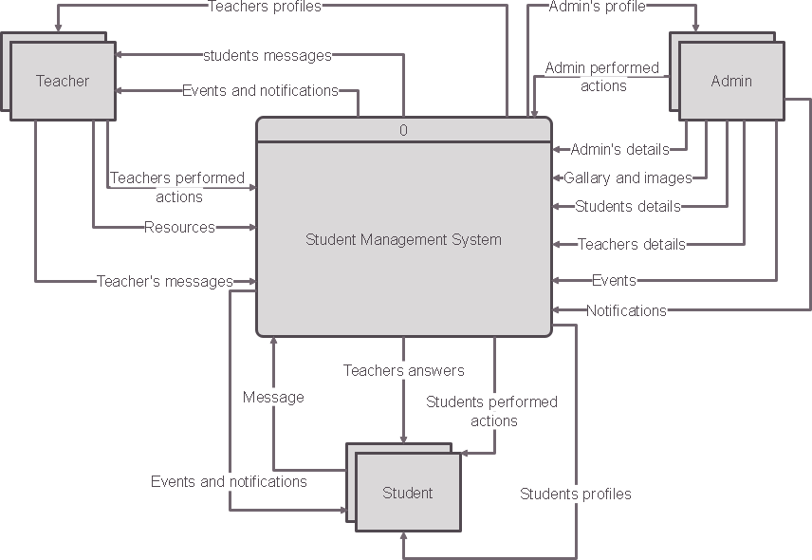



LEVEL 0 DFD

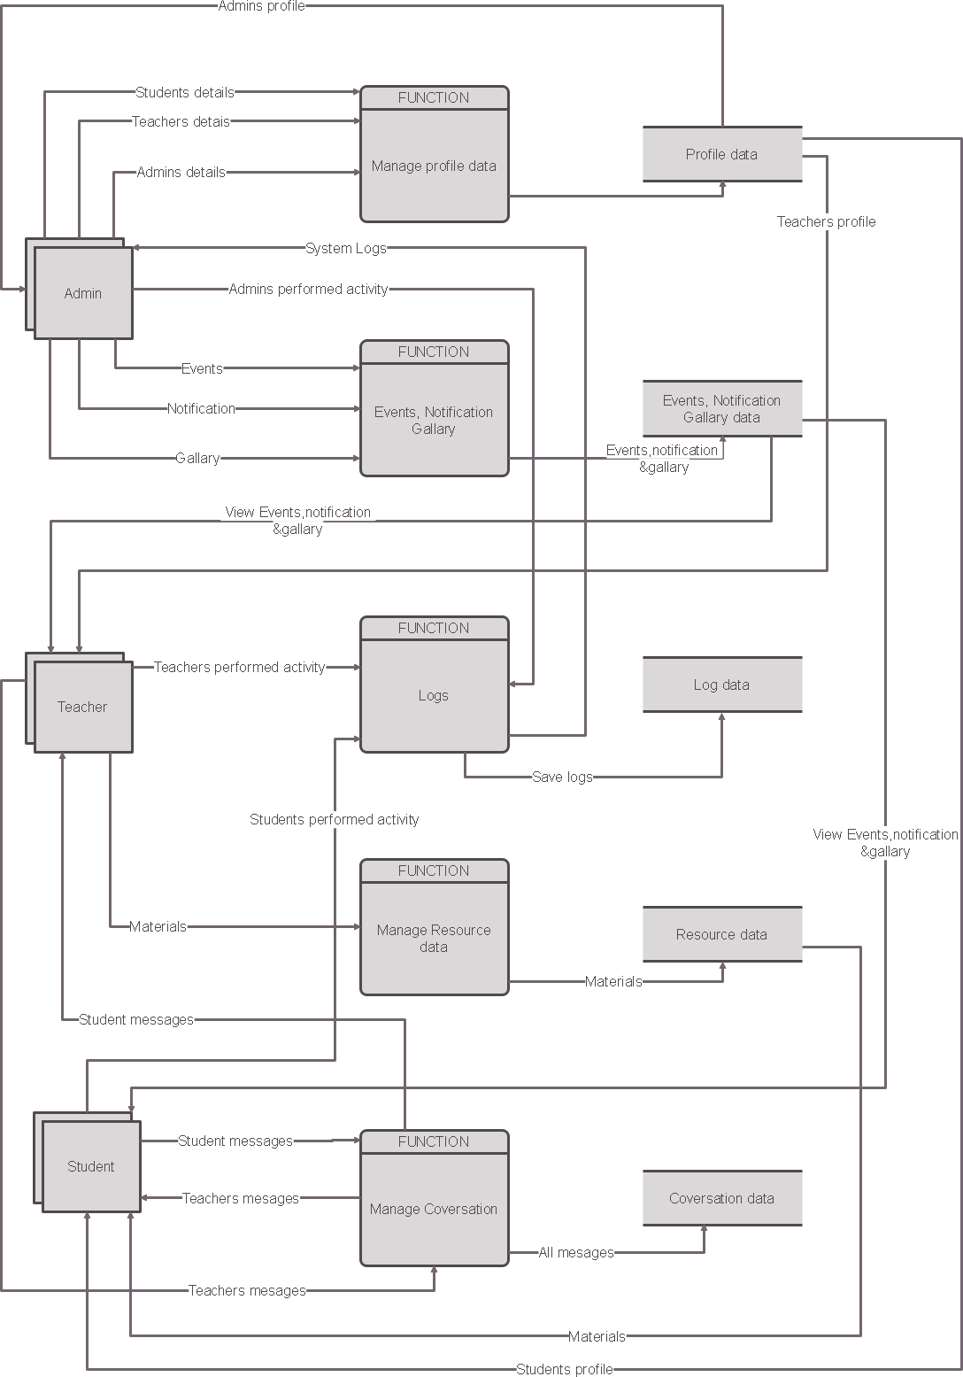

* + 1. **5.2.2- USE-CASEDIAGRAM**

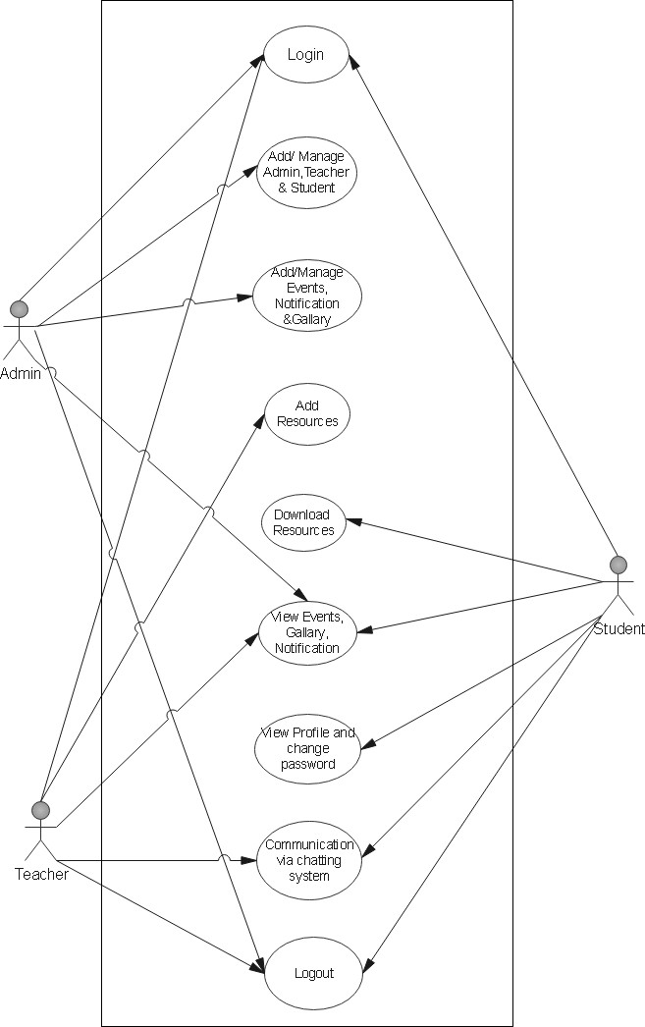

**5.2.3 - ACTIVITYDIAGRAM**

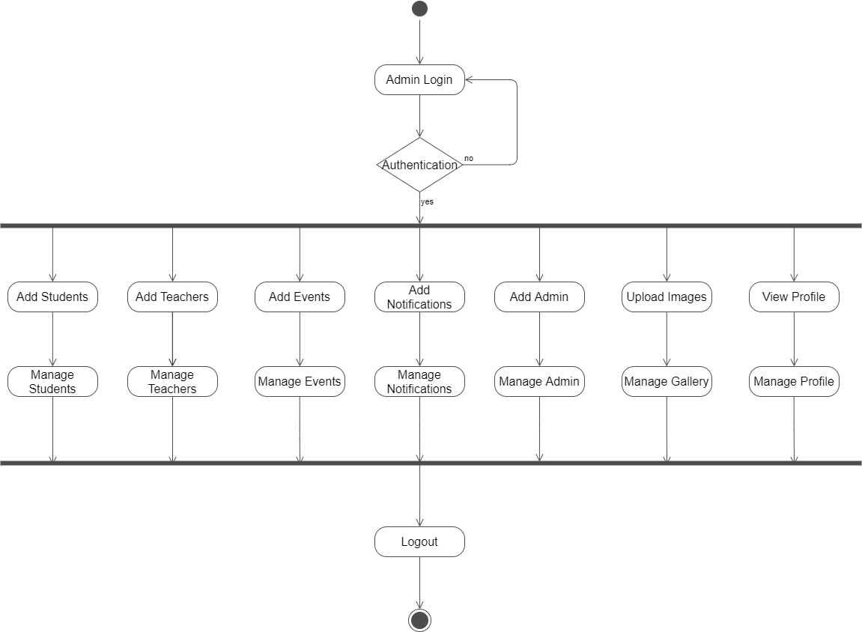**Admin’s Activity Diagram**

**Teacher’s Activity Diagram**

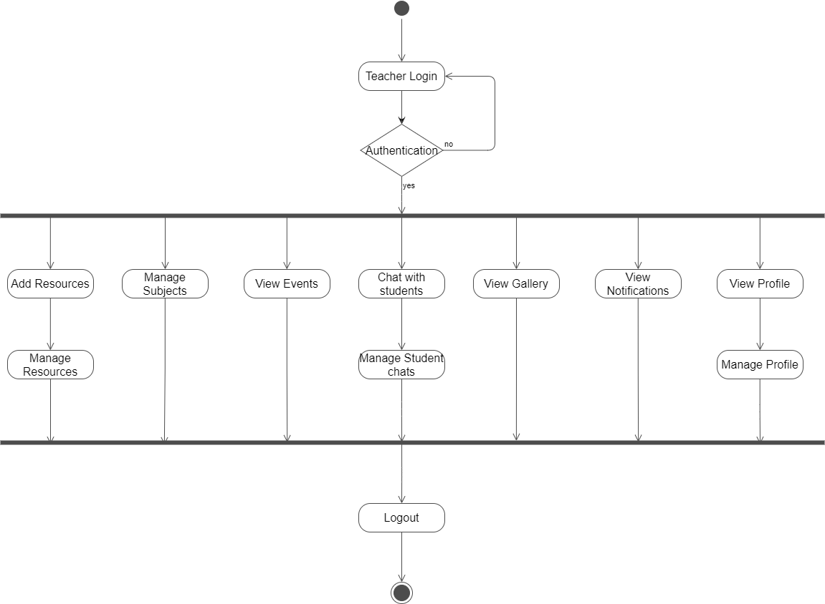

**Student’s Activity Diagram**

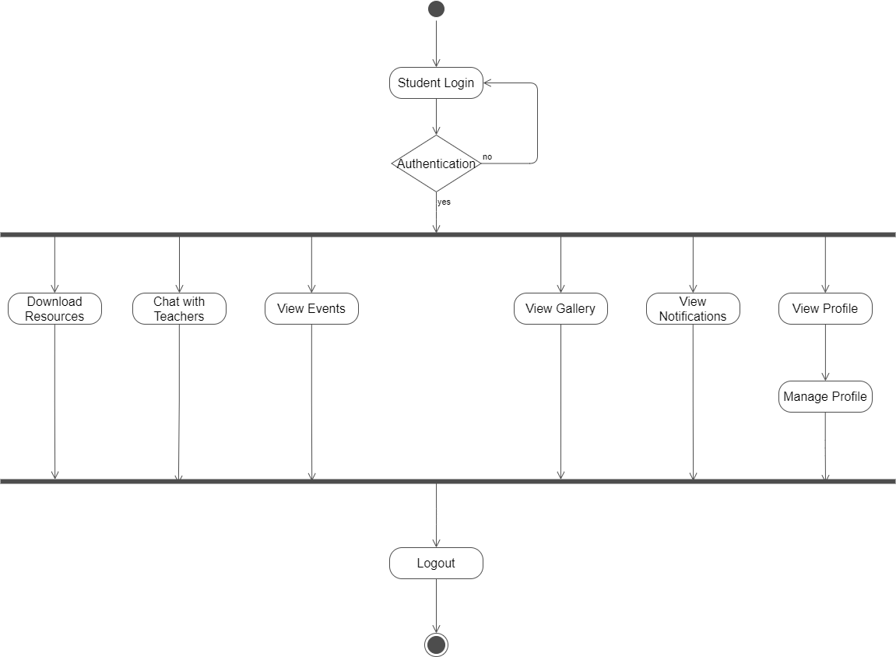

**5.2.4 - Entity-relationship diagram**

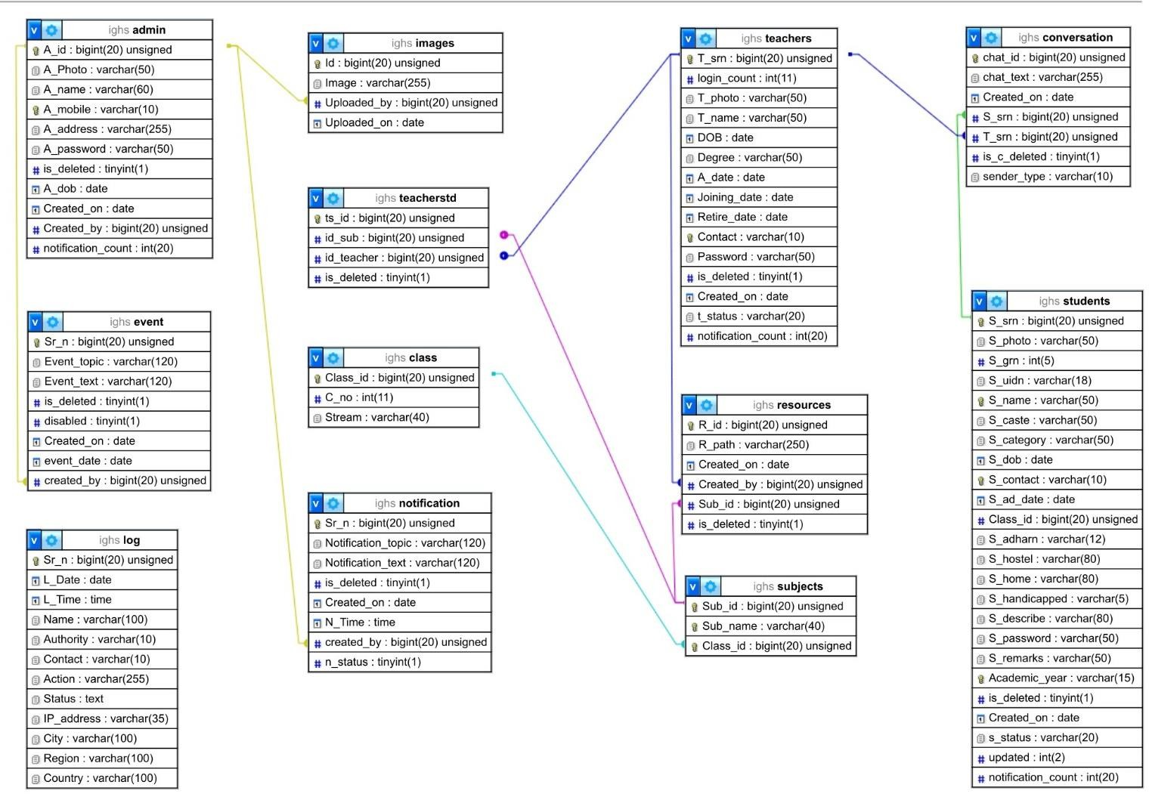

**5.2.5 - Data Dictionary**

**Table:-admin**

|  |  |  |  |
| --- | --- | --- | --- |
| **Column** | **Type** | **Null** | **Default** |
| A_id *(Primary)* | bigint(20) | No |  |
| A_Photo | varchar(50) | Yes | *NULL* |
| A_name | varchar(60) | No |  |
| A_mobile | varchar(10) | No |  |
| A_address | varchar(255) | No |  |
| A_password | varchar(50) | No |  |
| is_deleted | tinyint(1) | No |  |
| A_dob | date | No |  |
| Created_on | date | No | curdate() |
| Created_by | bigint(20) | No |  |
| notification_count | int(20) | No |  |

**Table:-Class**

|  |  |  |
| --- | --- | --- |
| **Column** | **Type** | **Null** |
| Class_id *(Primary)* | bigint(20) | No |
| C_no | int(11) | No |
| Stream | varchar(40) | No |

**Table:-conversation**

|  |  |  |  |  |
| --- | --- | --- | --- | --- |
| **Column** | **Type** | **Null** | **Default** | **Links to** |
| chat_id | bigint(20) | No |  |  |
| chat_text | varchar(255) | No |  |  |
| Created_on | date | No | curdate() |  |
| S_srn | bigint(20) | No |  | students ->S_srn |
| T_srn | bigint(20) | No |  | teachers ->T_srn |
| is_c_deleted | tinyint(1) | No |  |  |
| sender_type | varchar(10) | No |  |  |

**Table:-event**

|  |  |  |  |  |
| --- | --- | --- | --- | --- |
| **Column** | **Type** | **Null** | **Default** | **Links to** |
| Sr_n *(Primary)* | bigint(20) | No |  |  |
| Event_topic | varchar(120) | No |  |  |
| Event_text | varchar(120) | No |  |  |
| is_deleted | tinyint(1) | No |  |  |
| disabled | tinyint(1) | No | 0 |  |
| Created_on | date | No | curdate() |  |
| event_date | date | No |  |  |
| created_by | bigint(20) | No |  | admin ->A_id |

**Table:-Images**

|  |  |  |  |  |
| --- | --- | --- | --- | --- |
| **Column** | **Type** | **Null** | **Default** | **Links to** |
| Id *(Primary)* | bigint(20) | No |  |  |
| Image | varchar(255) | No |  |  |
| Uploaded_by | bigint(20) | No |  | admin ->A_id |
| Uploaded_on | date | No | curdate() |  |

**Table:-log**

|  |  |  |  |
| --- | --- | --- | --- |
| **Column** | **Type** | **Null** | **Default** |
| Sr_n *(Primary)* | bigint(20) | No |  |
| L_Date | date | No | curdate() |
| L_Time | time | No | current_timestamp() |
| Name | varchar(100) | No |  |
| Authority | varchar(10) | No |  |
| Contact | varchar(10) | No |  |
| Action | varchar(255) | No |  |
| Status | text | No |  |
| IP_address | varchar(35) | No |  |
| City | varchar(100) | No |  |
| Region | varchar(100) | No |  |
| Country | varchar(100) | No |  |

**Table:-notification**

|  |  |  |  |  |
| --- | --- | --- | --- | --- |
| **Column** | **Type** | **Null** | **Default** | **Links to** |
| Sr_n *(Primary)* | bigint(20) | No |  |  |
| Notification_topic | varchar(120) | No |  |  |
| Notification_text | varchar(120) | No |  |  |
| is_deleted | tinyint(1) | No |  |  |
| Created_on | date | No | curdate() |  |
| N_Time | time | No | current_timestamp() |  |
| created_by | bigint(20) | No |  | admin ->A_id |
| n_status | tinyint(1) | No |  |  |

**Table:-resources**

|  |  |  |  |  |
| --- | --- | --- | --- | --- |
| **Column** | **Type** | **Null** | **Default** | **Links to** |
| R_id *(Primary)* | bigint(20) | No |  |  |
| R_path | varchar(250) | No |  |  |
| Created_on | date | No | curdate() |  |
| Created_by | bigint(20) | No |  | teachers ->T_srn |
| Sub_id | bigint(20) | No |  | subjects ->Sub_id |
| is_deleted | tinyint(1) | No | 0 |  |

**Table:-students**

|  |  |  |  |
| --- | --- | --- | --- |
| **Column** | **Type** | **Null** | **Default** |
| S_srn *(Primary)* | bigint(20) | No |  |
| S_photo | varchar(50) | Yes | *NULL* |
| S_grn | int(5) | No |  |
| S_uidn | varchar(18) | No |  |
| S_name | varchar(50) | No |  |
| S_caste | varchar(50) | No |  |
| S_category | varchar(50) | No |  |
| S_dob | date | No |  |
| S_contact | varchar(10) | No |  |
| S_ad_date | date | No |  |
| Class_id | bigint(20) | No |  |
| S_adharn | varchar(12) | No |  |
| S_hostel | varchar(80) | No |  |
| S_home | varchar(80) | No |  |
| S_handicapped | varchar(5) | No |  |
| S_describe | varchar(80) | No |  |
| S_password | varchar(50) | No |  |
| S_remarks | varchar(50) | No |  |
| Academic_year | varchar(15) | No |  |
| is_deleted | tinyint(1) | No |  |
| Created_on | date | No | curdate() |
| s_status | varchar(20) | No |  |
| updated | int(2) | No |  |
| notification_count | int(20) | No |  |

**Table:-subjects**

|  |  |  |  |
| --- | --- | --- | --- |
| **Column** | **Type** | **Null** | **Links to** |
| Sub_id *(Primary)* | bigint(20) | No |  |
| Sub_name | varchar(40) | No |  |
| Class_id | bigint(20) | No | class ->Class_id |

**Table:-teachers**

|  |  |  |  |
| --- | --- | --- | --- |
| **Column** | **Type** | **Null** | **Default** |
| T_srn *(Primary)* | bigint(20) | No |  |
| login_count | int(11) | No |  |
| T_photo | varchar(50) | Yes | *NULL* |
| T_name | varchar(50) | No |  |
| DOB | date | No |  |
| Degree | varchar(50) | No |  |
| A_date | date | No |  |
| Joining_date | date | No |  |
| Retire_date | date | No |  |
| Contact | varchar(10) | No |  |
| Password | varchar(50) | No |  |
| is_deleted | tinyint(1) | No |  |
| Created_on | date | No | curdate() |
| t_status | varchar(20) | No |  |
| notification_count | int(20) | No |  |

**Table:-teacherstd**

|  |  |  |
| --- | --- | --- |
| **Column** | **Type** | **Null** |
| ts_id *(Primary)* | bigint(20) | No |
| id_sub | int(11) | No |
| id_teacher | int(11) | No |
| is_deleted | tinyint(1) | No |

* + 1. **2.5.6 - Screen Layouts**

**System Snapshots**

* There are total 3 sections in our system .
  + Admin Panel
  + Teacher Panel
  + Student Panel
* Admin Panel is most important part of our project and it consist of most featured to manage student's, teacher's and other admin's data.
* Teacher Panel enables teacher to send study material to students and receive message from student and send reply to those messages. And also, teachers can see images, event information, and notifications uploaded by admin.
* Student Panel allows students to download study material from site uploaded by their subject teachers, Students can message teacher to solve their query. And also, students can see images, event information, and notifications uploaded by admin.

#### Admin Panel

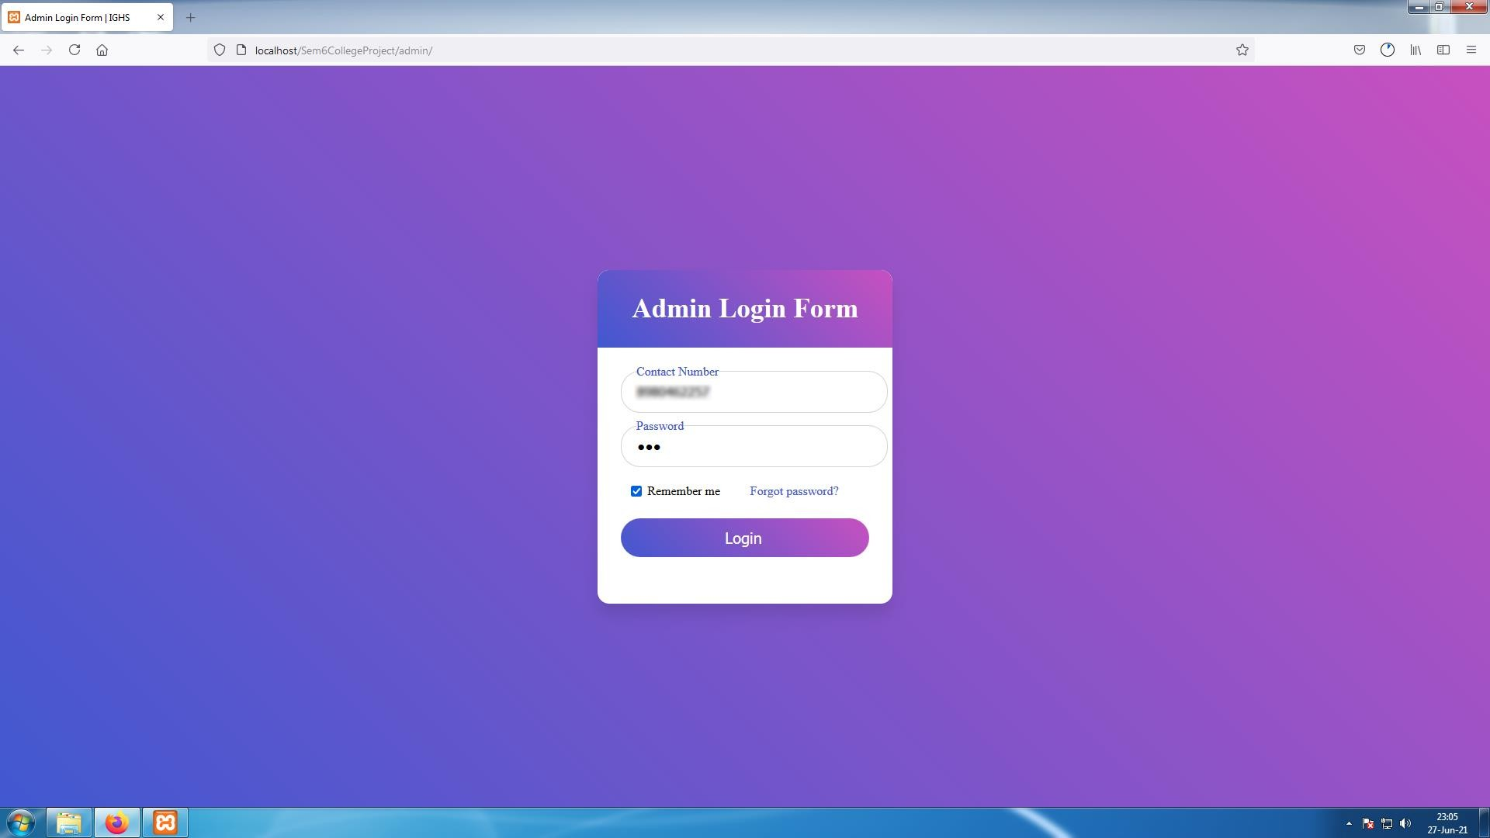

**[Image- 1-Admin Login Page]**

* This is the Login page for Admin.
* Admin will need to enter their registered mobile number and their password in order to login to their account.
* They can choose to save their details by selecting "Remember me " checkbox and if they want to delete their details they can deselect checkbox next time they login
* If admin forgot his/her account password they can click on "Forgot password" and receive an OTP (One Time Password), to the mobile number registered in their account and reset the password.

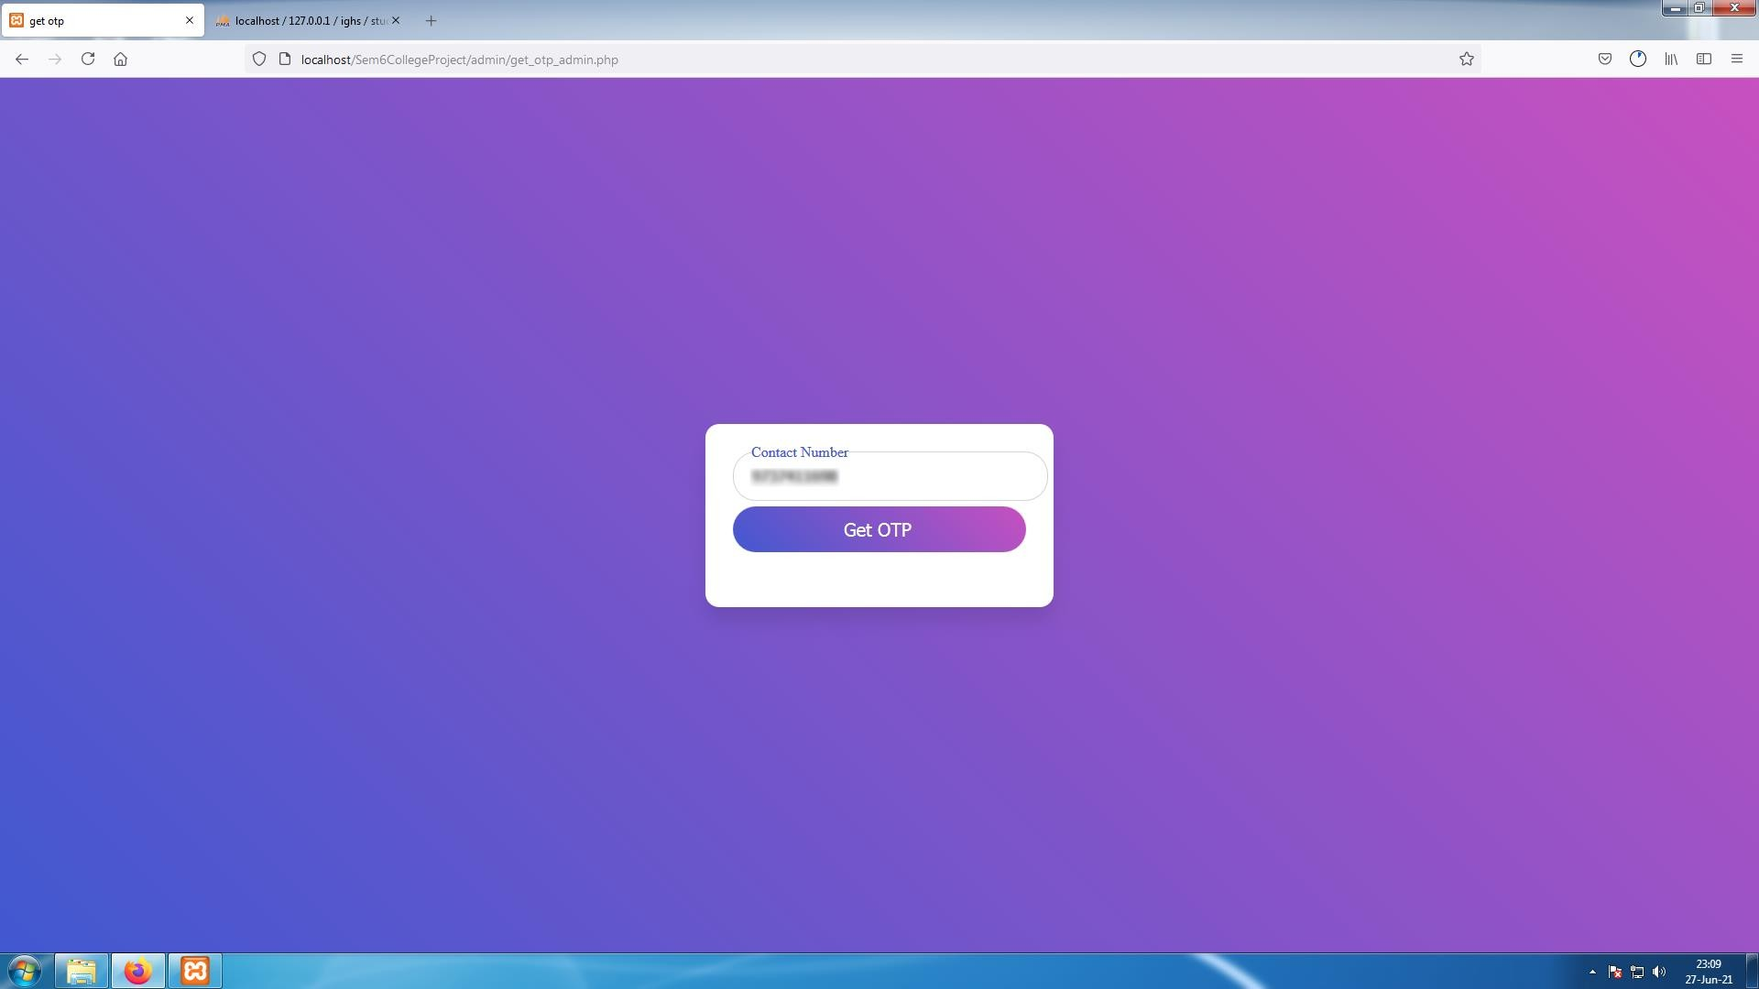

**[ Image 1.1 Admin Forgot Password ]**

* Step after clicking on "Forgot Password". Enter mobile number in the given text box and click on "Get OTP" to receive OTP.

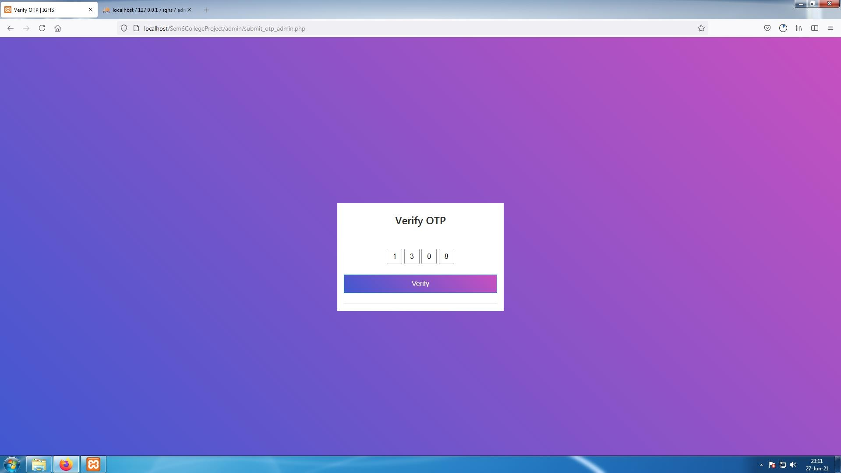

**[Image 1.2- Confirm OTP]**

* User will receive an OTP on the mobile number , enter that code in next page as below. And click on Verify to confirm code .

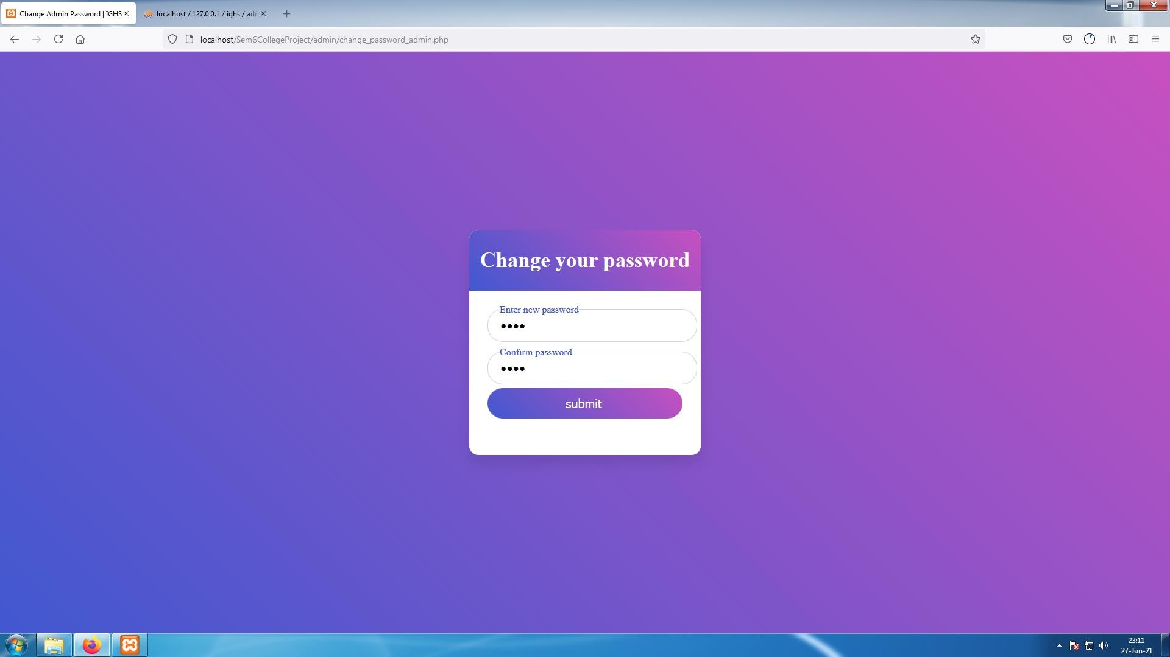

**[ Image 1.3 - Change Password ]**

* If OTP code is correct User can reset password in next page .And Submit to login into their account.

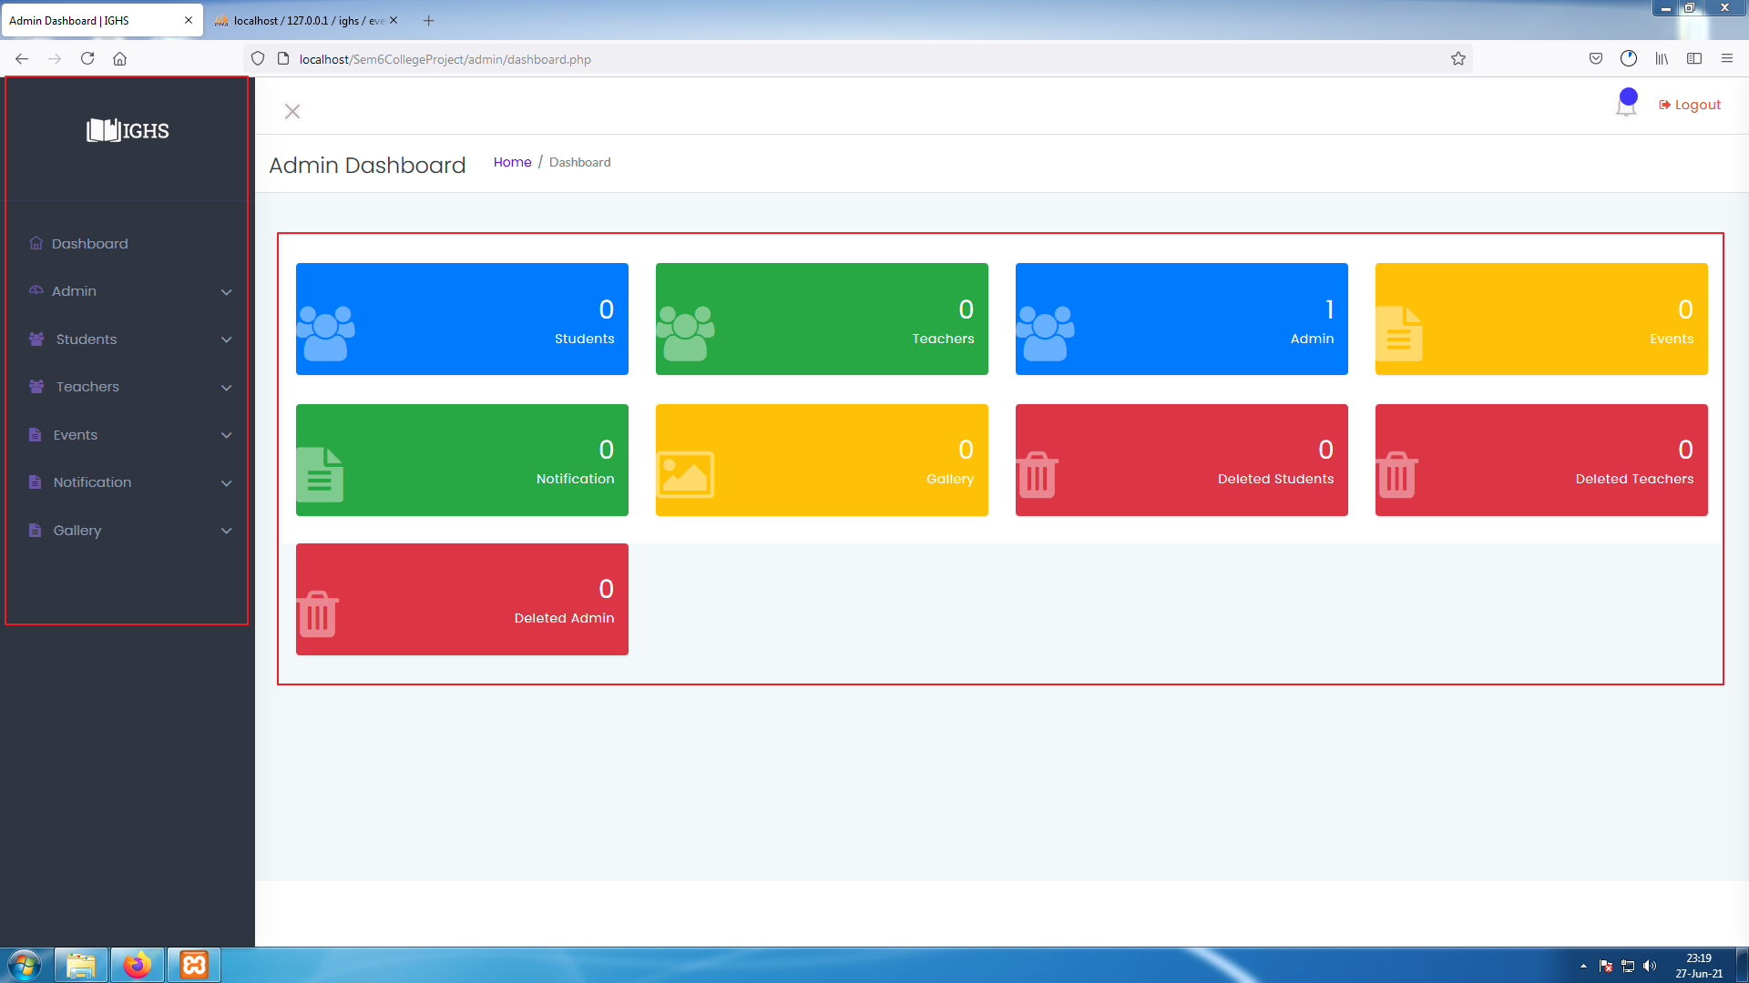

#### [ Image 2- Admin Dashboard ]

#### Admin Dashboard

* This is Admin Dashboard where Admin can access all features to manage every data .
* Admin can see how many students, Teachers , Admins, Events , Notifications, Images in Gallery, Deleted students
* ,Deleted teachers ,Deleted admins are in system.
* On left side of the screen admin can use Side-bar to easily navigate through system.

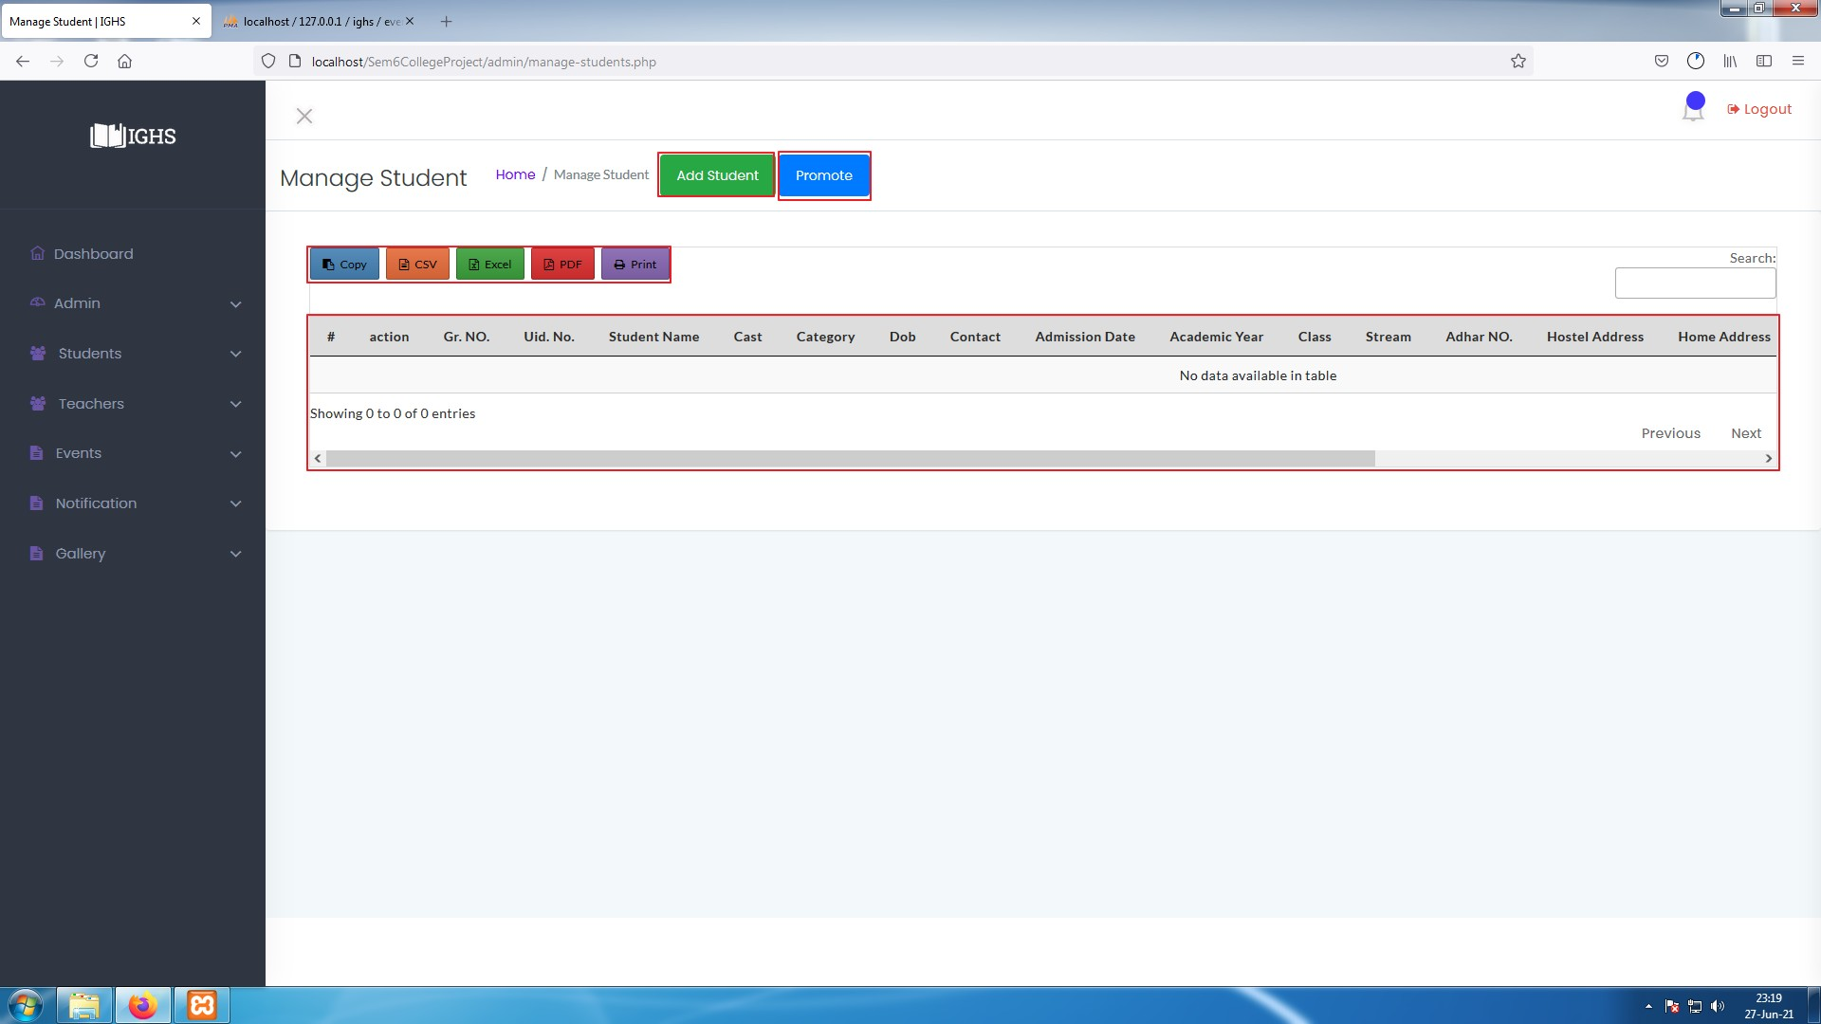

**[ Image 2.1 - Manage Student Table before data entry ]**

#### Admin : Manage Student Data & Add Students

* Admin can access this page ( Manage Student Window) by clicking on "Students ", on **image 2**.
* In image 2.1 the table is empty because there are no data in system yet, To add a student data click on "Add Student" highlighted with red box in **image 2.1**.

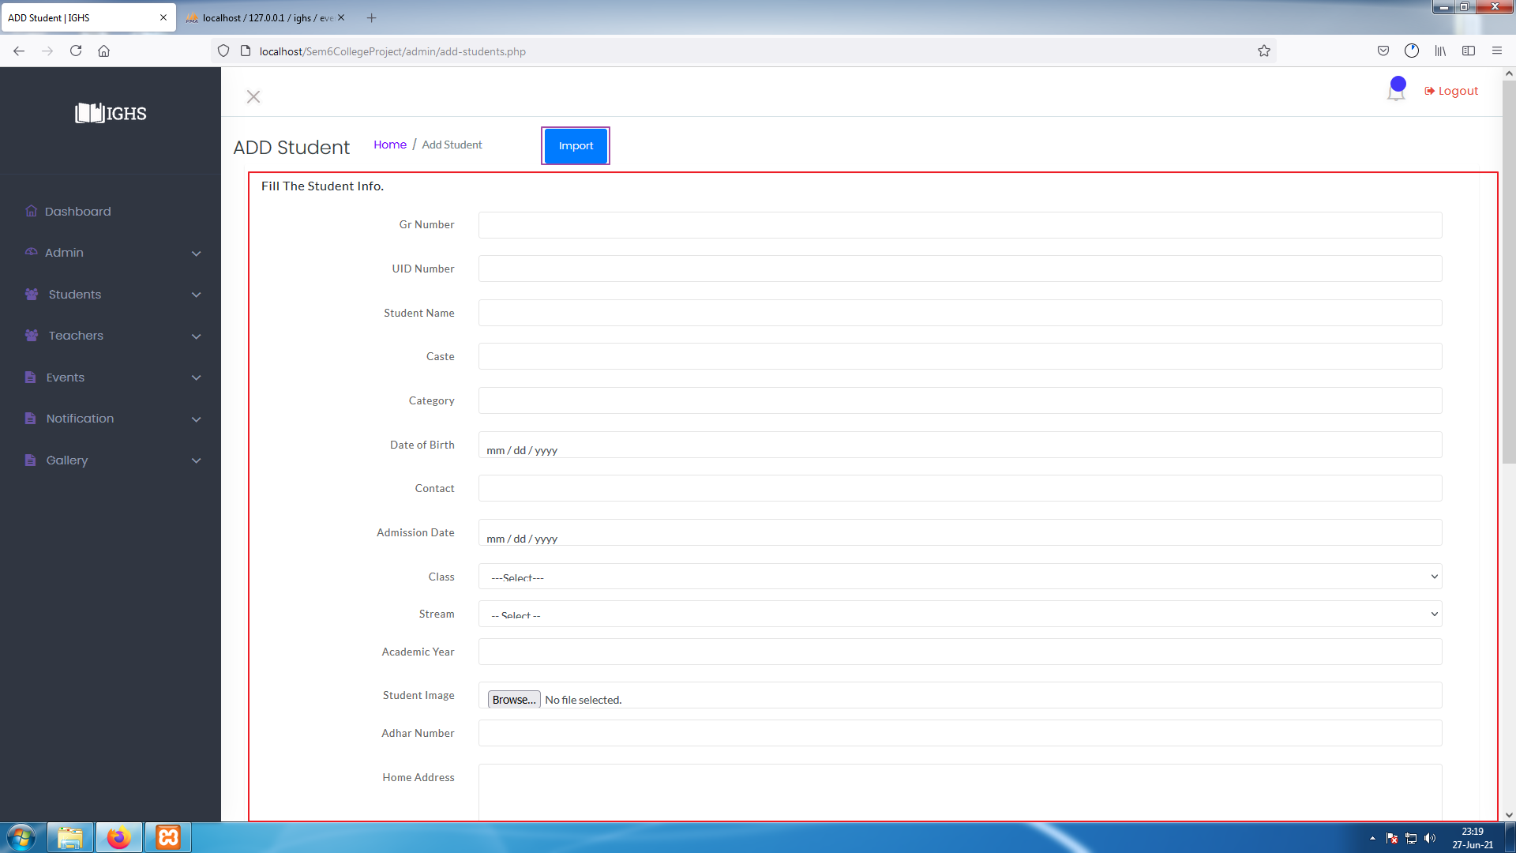

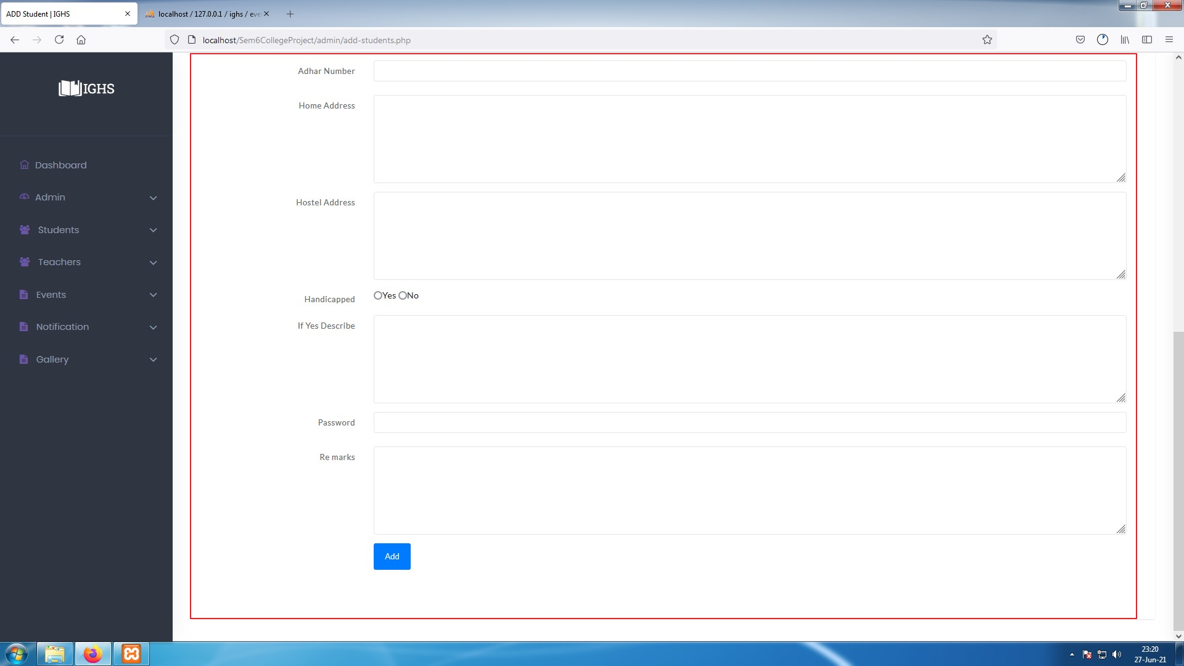**[ Image 2.2- Add student form ]**

**[ Image 2.2- Add student form ]**

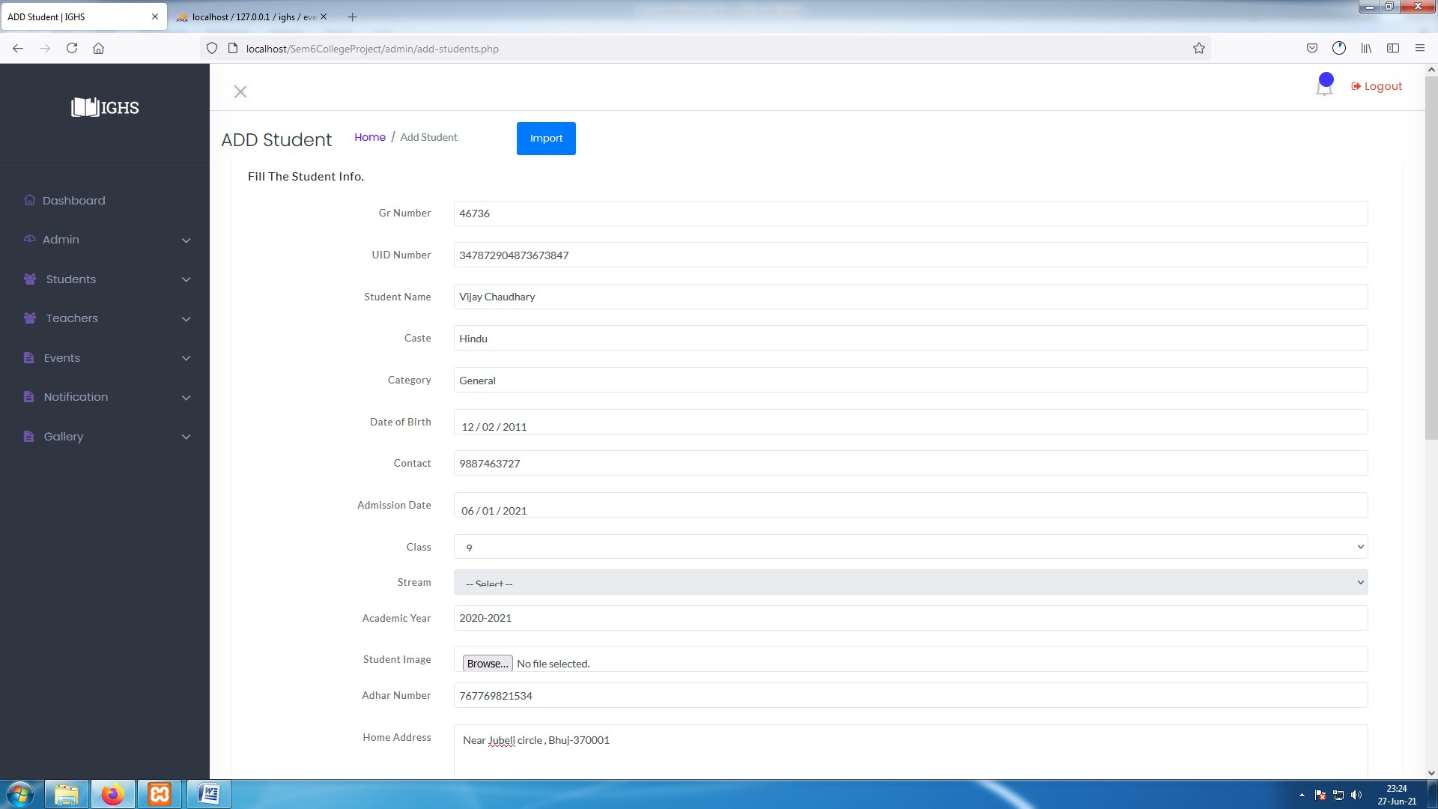

**[ Image 2.2.1- Add Student ]**

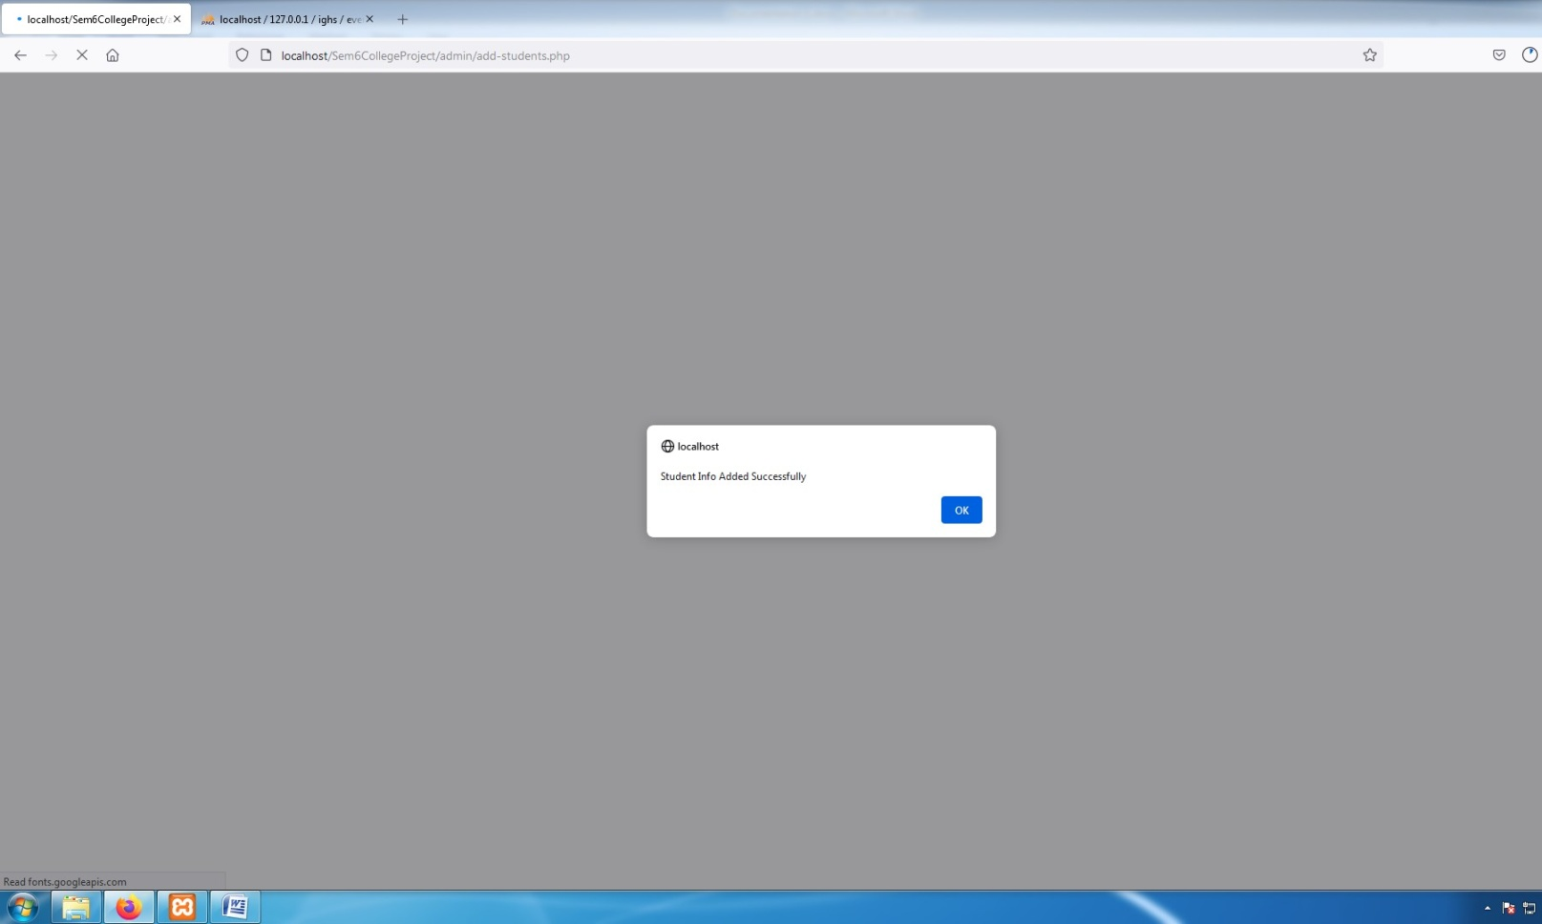

**[ Image 2.2.2- Student Added Success alert ]**

* Admin can Enter a single Student at a time by filling up the form highlighted with red box in **Image- 2.2** , and click on "Add" button available at end of form .
* After filling the form ,it will look like **image-2.2.1**, And After submitting it if the data is proper then data will be stored and generate an Success alert shown in **image-2.2.2**.
* If data is not valid then it won't let admin to submit form.
* To Add multiple student data at a time then click on "Import" button highlighted with purple box in **image-2.2**.

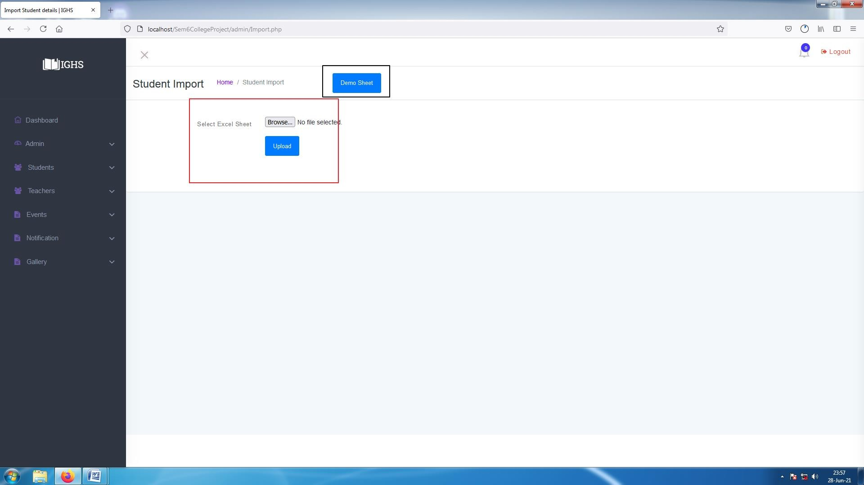

**[ Image 2.3 - Import Student ]**

* Then click on "Demo Sheet" highlighted with black box in **image-2.3** to download an empty sheet with column names which will look like as **Image-2.3.1** as shown in next page.

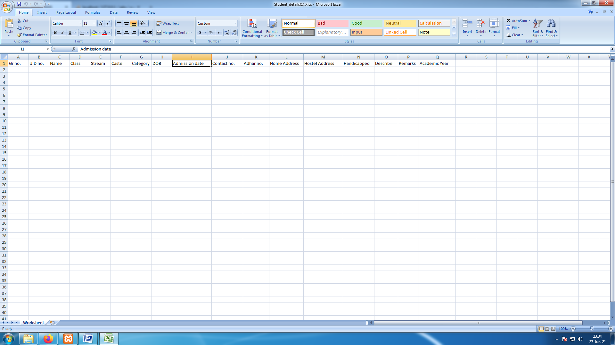

**[ Image 2.3.1-Demo Sheet Generated by system ]**

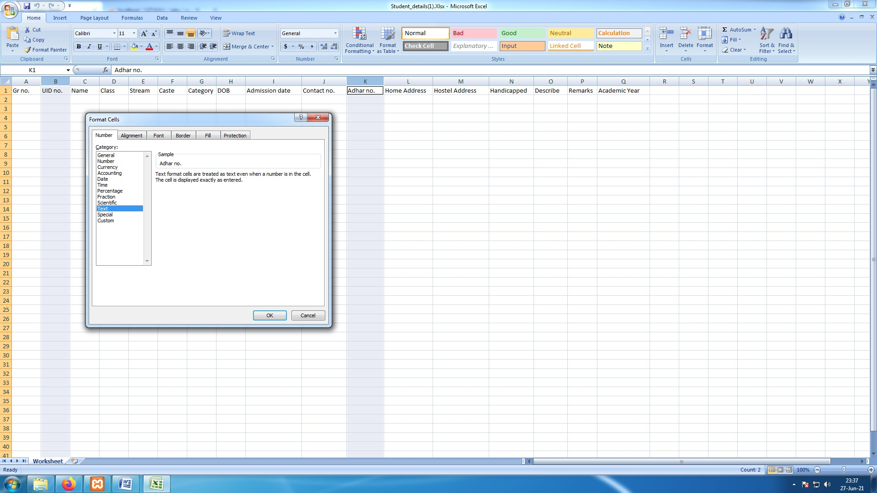

**[ Image 2.3.1- Set Column's Format ]**

* admin will need to set format column-B and column-K to "Text" as shown in above **image-2.3.1** .

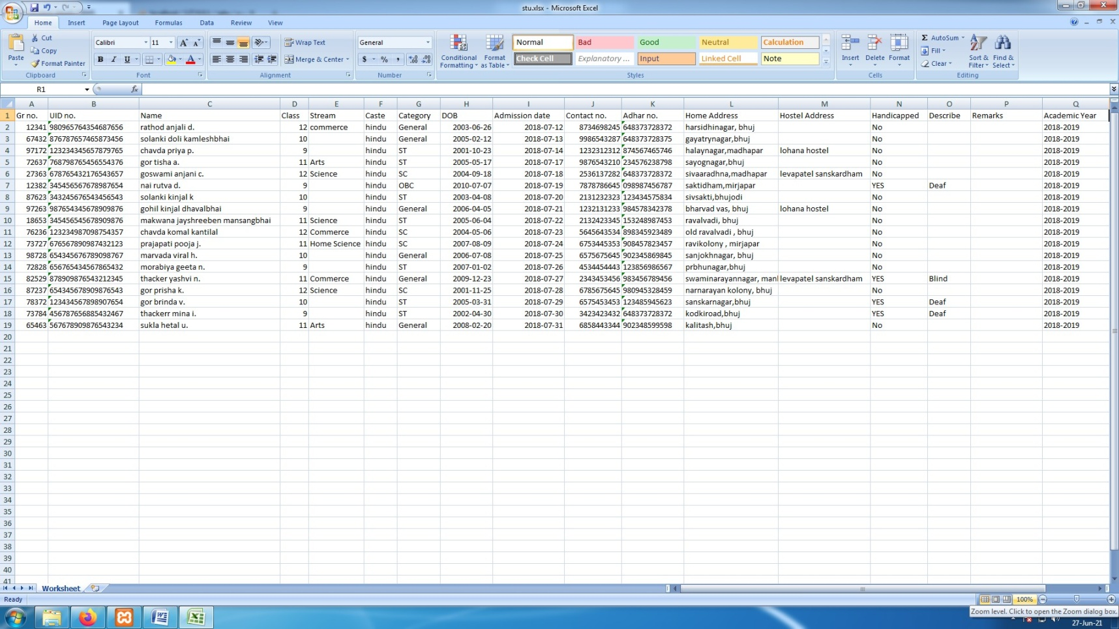

**[ Image 2.3.2- Demo sheet after admin fill columns ]**

* Every column must be filled except column-M ("Hostel Address) and column-P (Remarks) are completely OPTIONAL

.

* If student is handicapped then fill "yes" in column-N else fill "no". If student is handicapped then it's description must be filled or system won't let admin to insert data in system.

**Upload :-**

* After filling up the Excel sheet admin can upload the sheet by clicking on "Browse" highlighted by red box in **Image-**

**2.3** and select file to be upload

* If file is successfully uploaded it will show a success message on screen. And if any error occurs it will show error on screen.

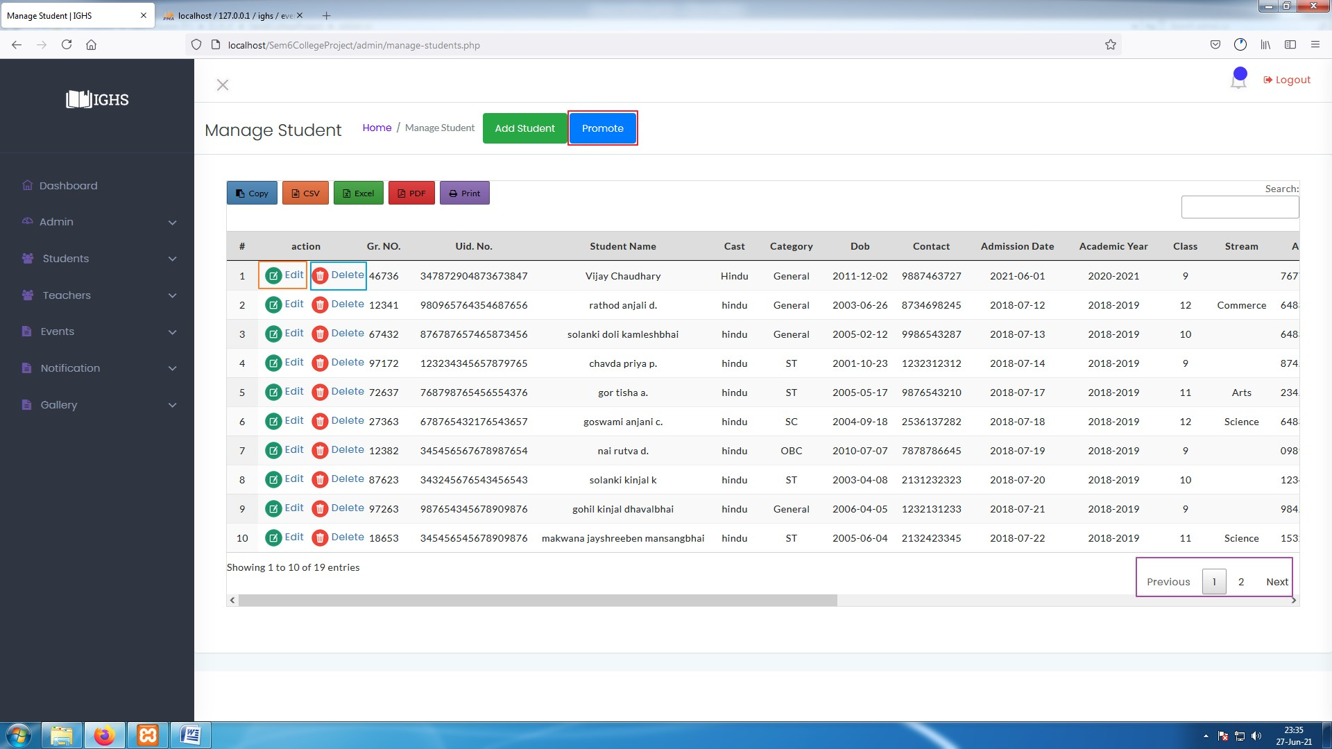

**[ Image 2.4- Manage Students after Adding data ]**

* After a successful import "Manage Student" tab would look like as shown in **Image-2.3.3** .

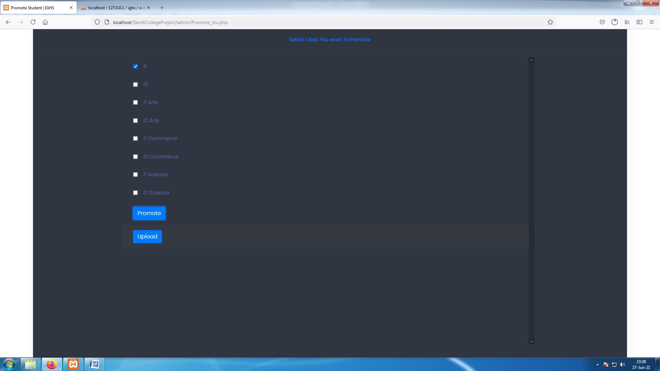

**[ Image 2.4.1- Promote Students ]**

* After clicking on "Promote" a list of class appears on screen as shown in **image-2.4.1**.
* Admin can select which classes he/she wants to promote and click on "Promote" button available at the end of list, The System will generate an Excel sheet containing students' details whose classes are selected by admin .

**PROMOTE :-**

* Admin can promote students to next class by clicking on "Promote" button highlighted by red box in **Image 2.4** .

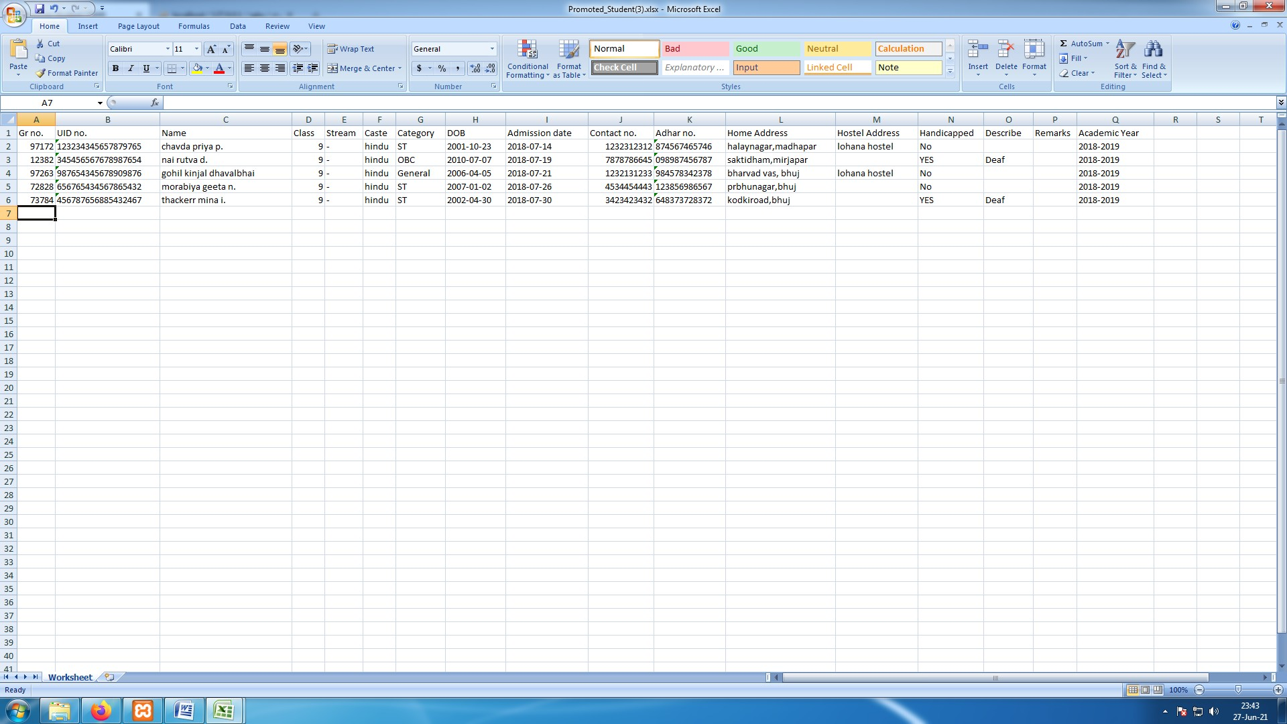

**[ Image 2.4.2 - Sheet generated with selected classes ]**

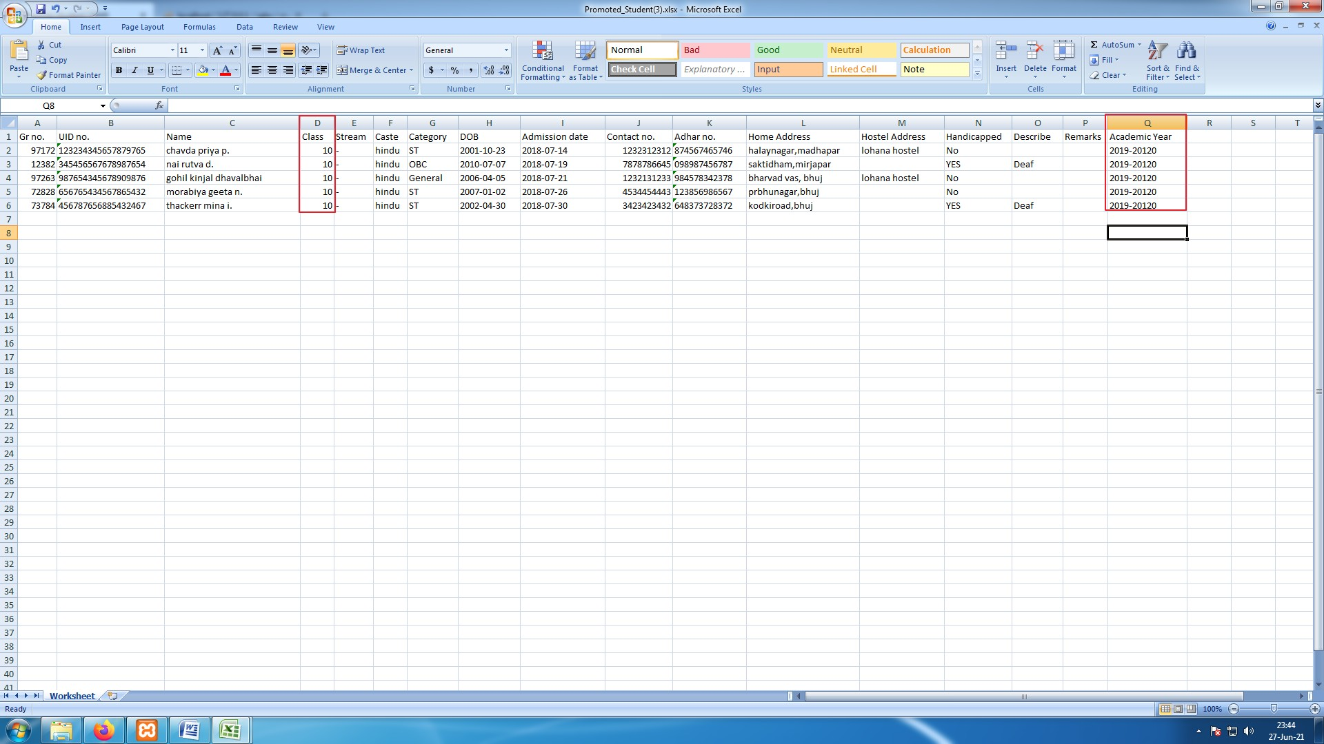

**[ Image 2.4.3 - Excel Sheet after admin making changes ]**

* Admin must change Every students "Class" and "Academic Year" in order to promote Students to next class .
* Excel sheet **in Image 2.4.2** is system generated sheet and Excel sheet in **Image-2.4.3** is updated by admin .Admin can also change other details as per requirement.

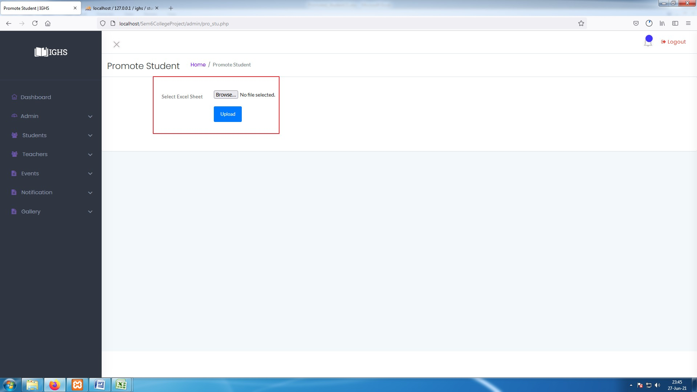

**[ Image 2.4.4- Upload Promote Student Sheet ]**

* Click on "Browse" button highlighted with red box in **Image-2.4.4** and upload the updated excel sheet from **image 2.4.3**.. It will show success message if data is proper else it will show error on screen.

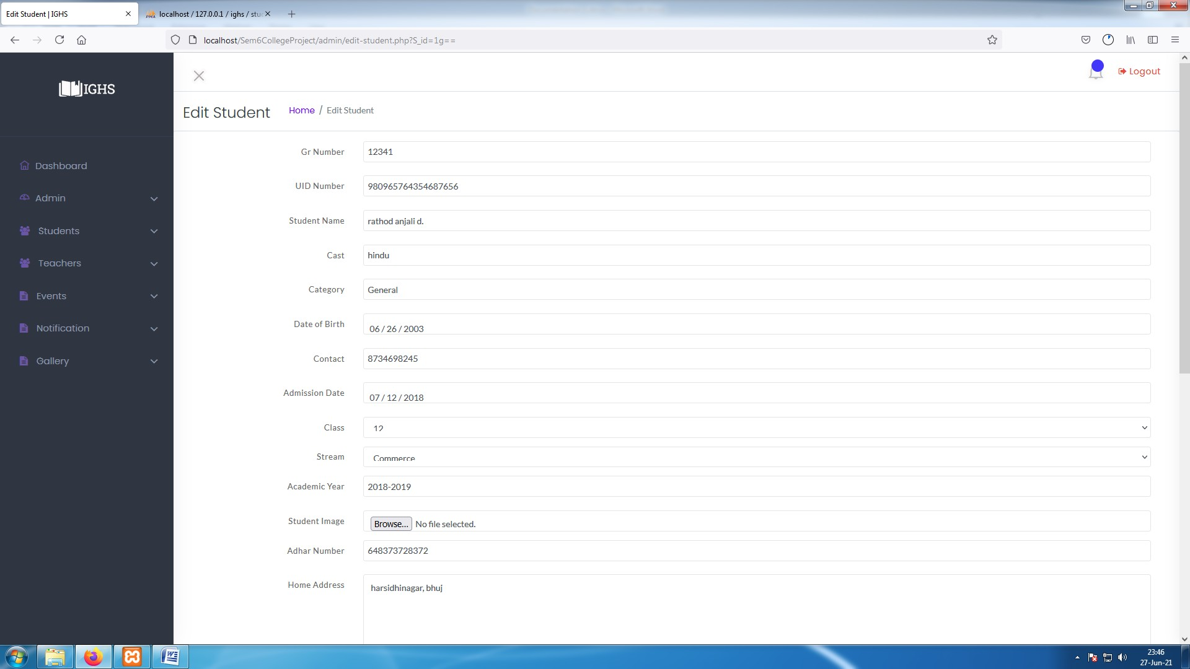

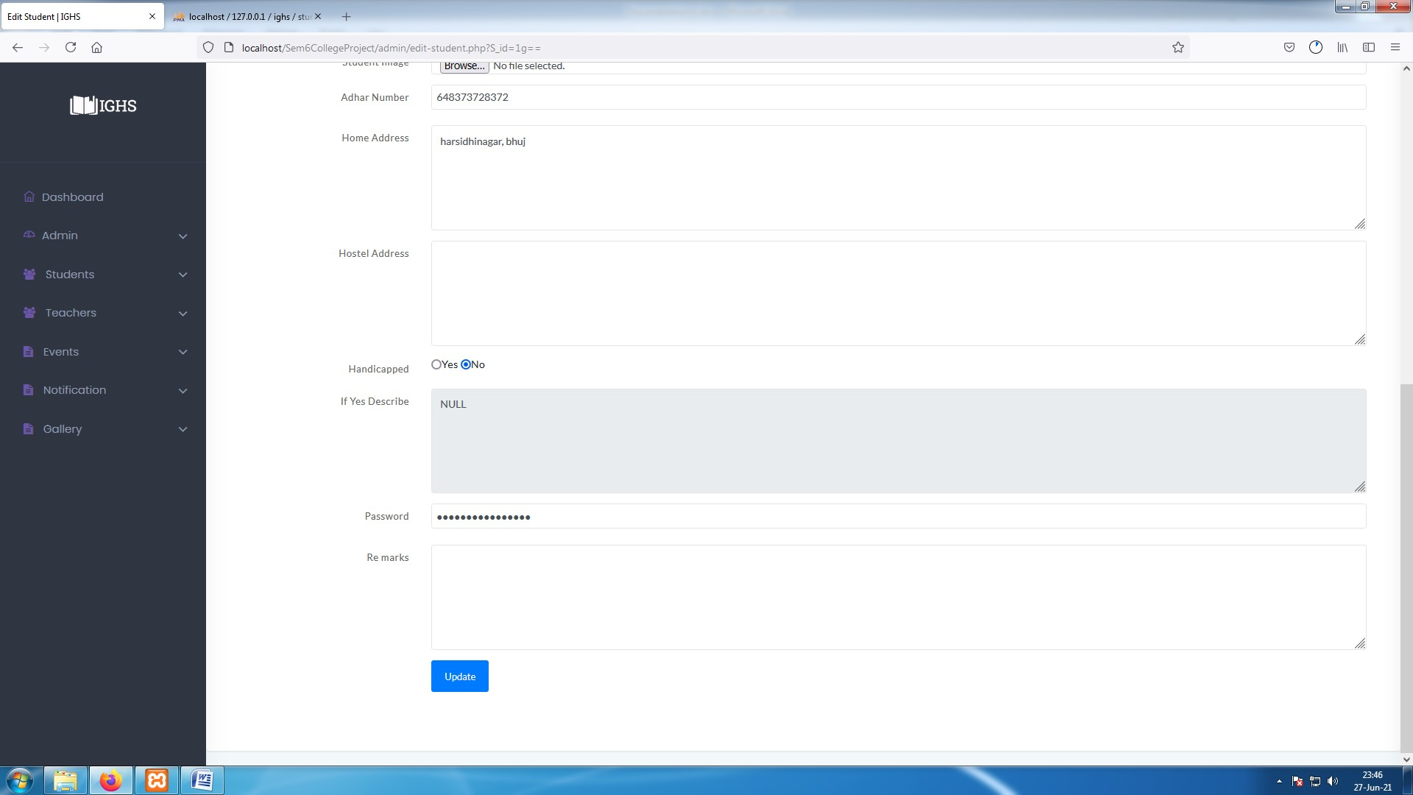**[ Image 2.4.5- Edit Student ]**

**[ Image 2.4.5- Edit Student ]**

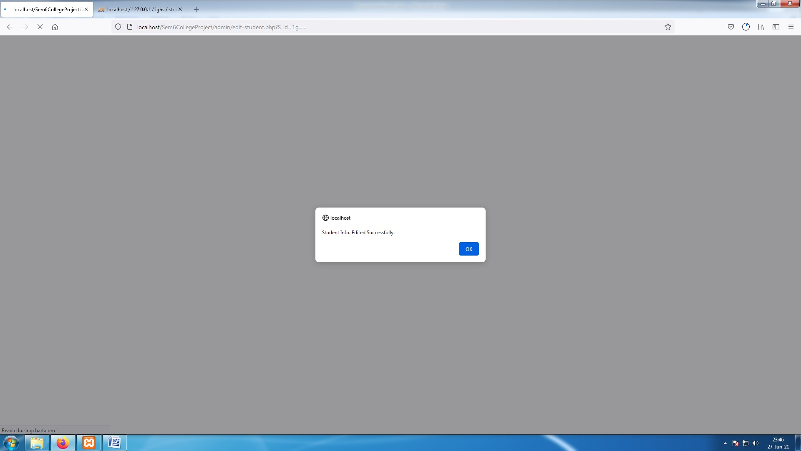

[ **Image 2.4.5.1- Edited Student Success Alert ]**

* Click on "Edit" button highlighted with orange box in **Image-2.4** given beside of student details, which will open that students detail in a form format. As shown in **Image-2.4.5** .
* **N**ow Edit details as per requirement and click on "Update" button to submit the form and student details will be updated in system with a success message on screen .Or if data is invalid error will be displayed on screen.

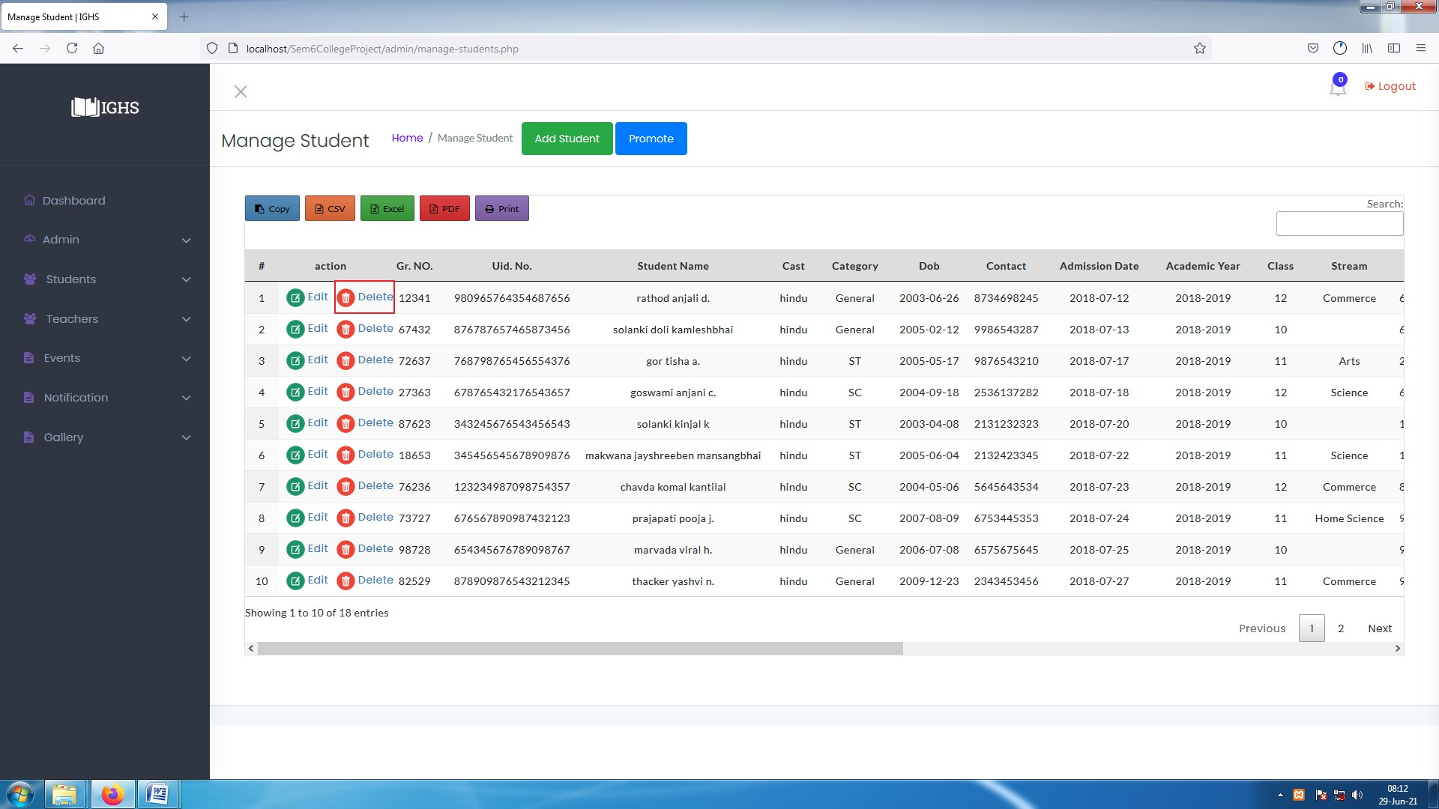

##### [ Image 2.4.6- Delete Student ]

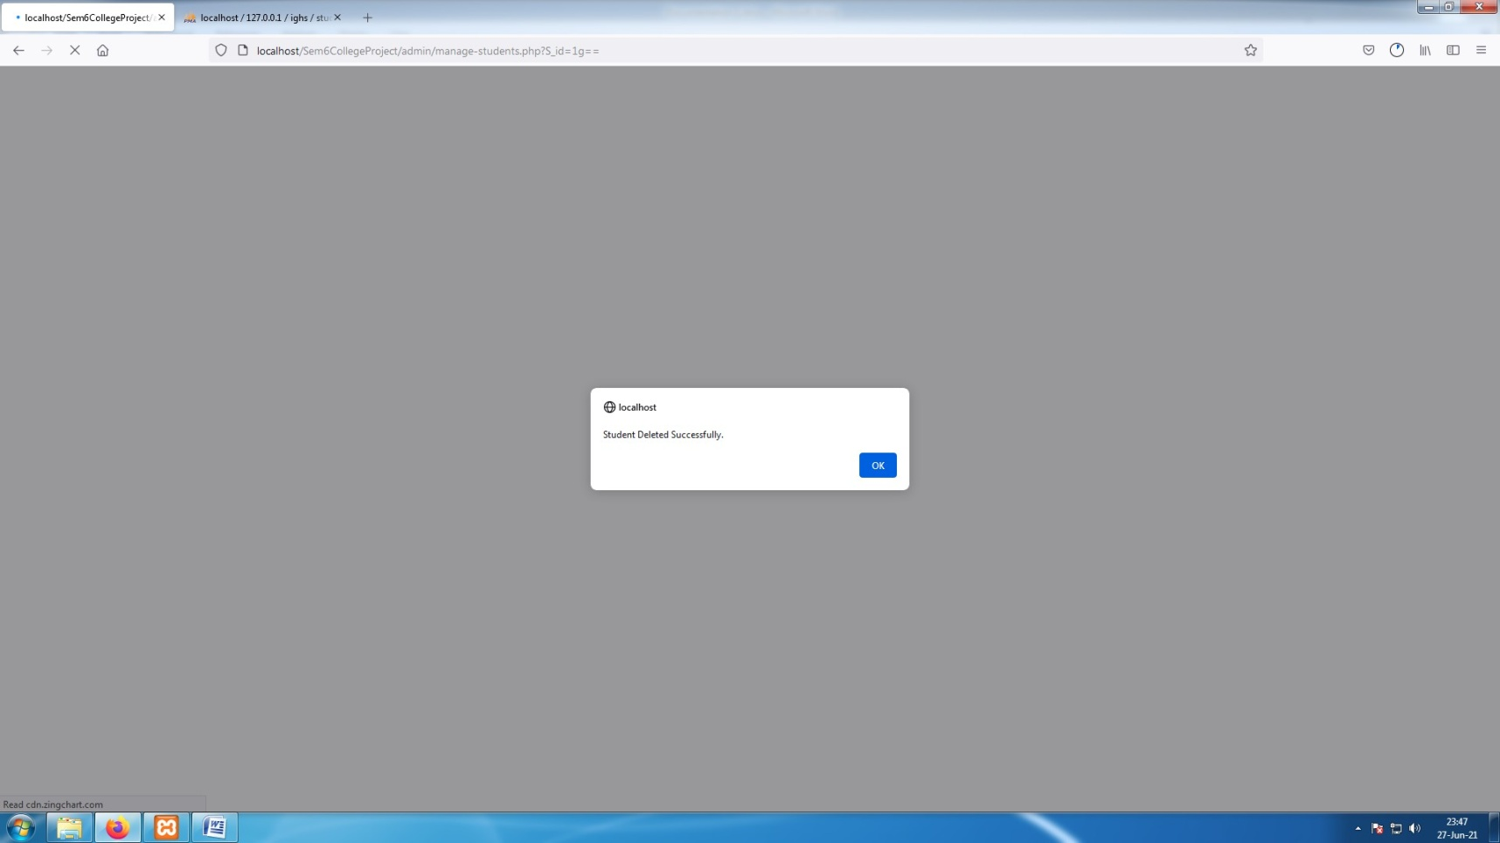

**[ Image 2.4.6.1- Deleted Student success alert ]**

**Delete students : -**

* To delete student data from system click on "Delete" button highlighted blue box in **Image-2.4** beside of student details, which will delete that student's details and keep that data in Bin named "Deleted Students " where admin can restore that data if needed.

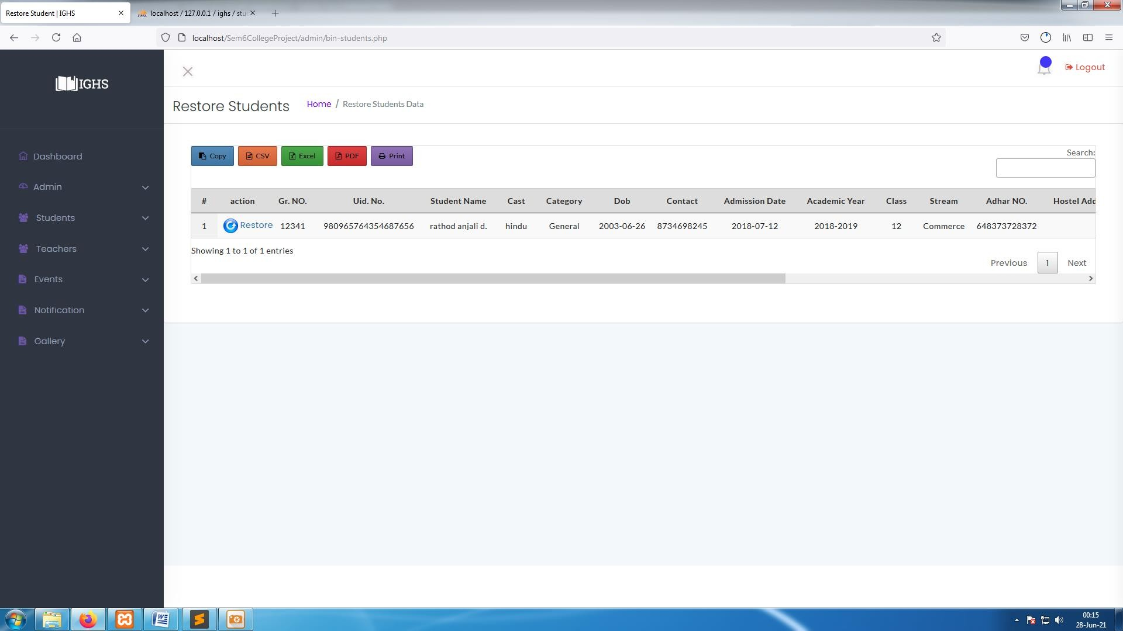

**[ Image 2.4.6.2 - Deleted Student list ]**

**Restore Student Data :-**

* To restore student data click on "Deleted students" from "Admin Dashboard" as shown in **Image-2** and it will show list of deleted students as shown in **Image-2.4.6.2** .
* Click on "Restore" icon highlighted with red box in **Image -2.4.6.2** and it will show a success message and restore the student's data .

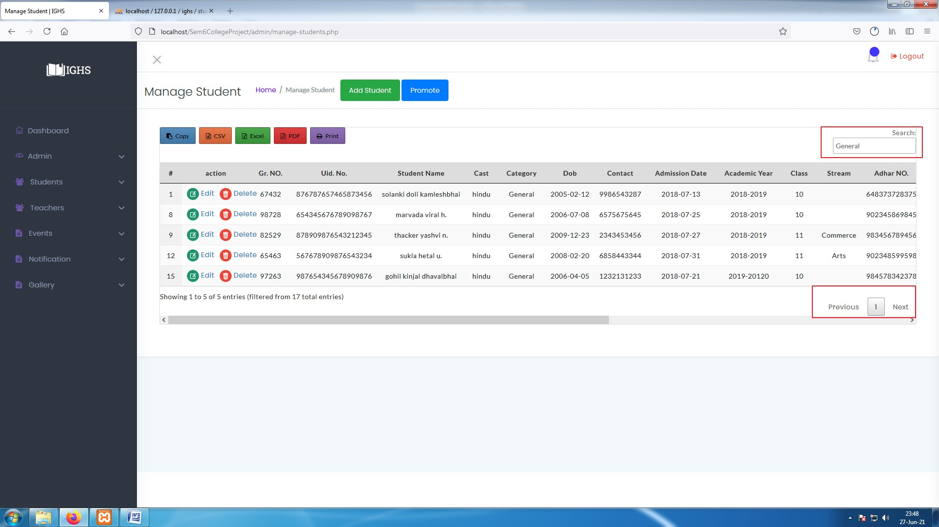

[ **Image 2.4.7- Browse data in Manage Student page ]**

**Browse all Data :**

* To browse all student data admin can use navigation buttons highlighted with red box at bottom of **Image 2.4.7** . Admin can also search specific data from search option highlighted with red box in image shown below.

**Search for specific Data :**

* To search for any specific data admin can use search box highlighted with red box in top right corner in **Image 2.4.7**.
* Admin can search using mobile number, Gr. number , UID number, caste , category, admission date, Stream, adhar number, address.

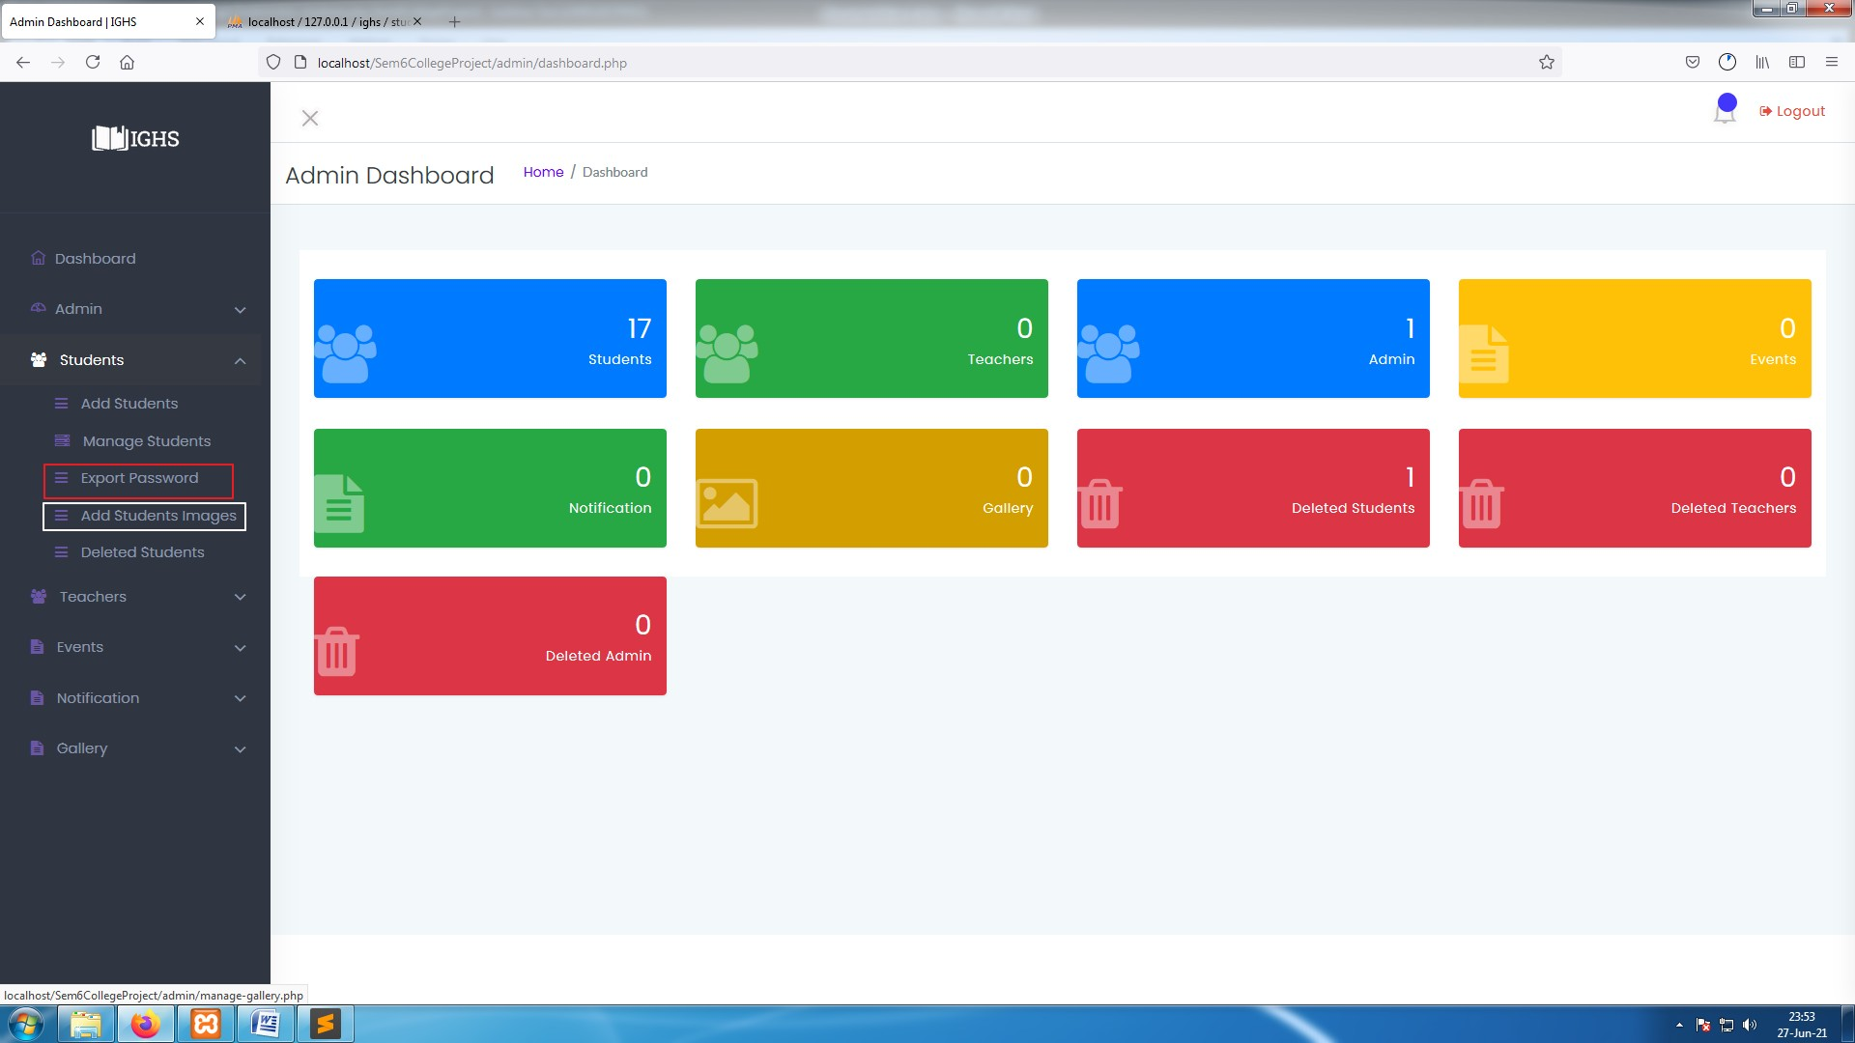

**[ Image 2.4.8- Admin panel ]**

* Admin can use this Sidebar shortcuts to easily navigate through system and access all features.

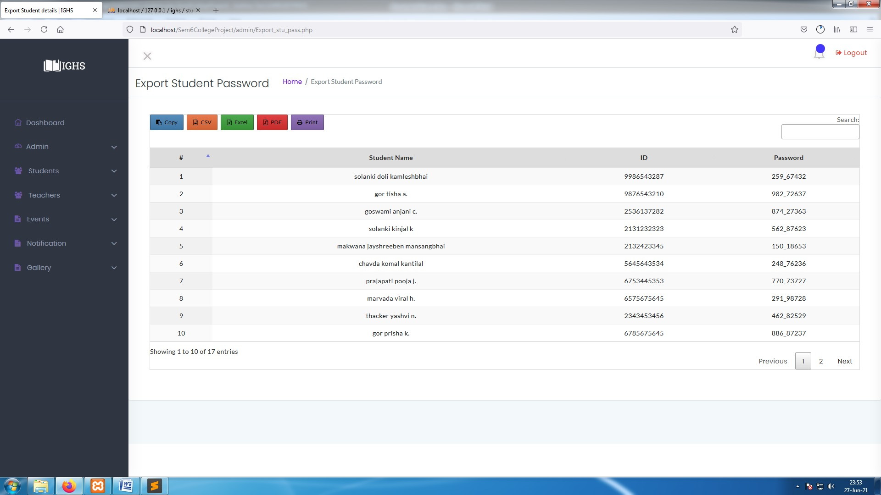

**[ Image 2.4.8.1- Export Student Passwords ]**

**Export Students' ID-Passwords** : -

* Admin will make all students account so in order to give access to students follow steps as below :-
  + Click on "Export Password" option available in side-bar highlighted with red box in **Image-2.4.8**
  + After clicking on "Export Password" a window with students name ,contact number and their passwords as shown in

**Image-2.4.8.1** .

* + To export them either tool can be used from copy, CSV, Excel, PDF or Print available above the data table in **Image-**

**2.4.8.1** .

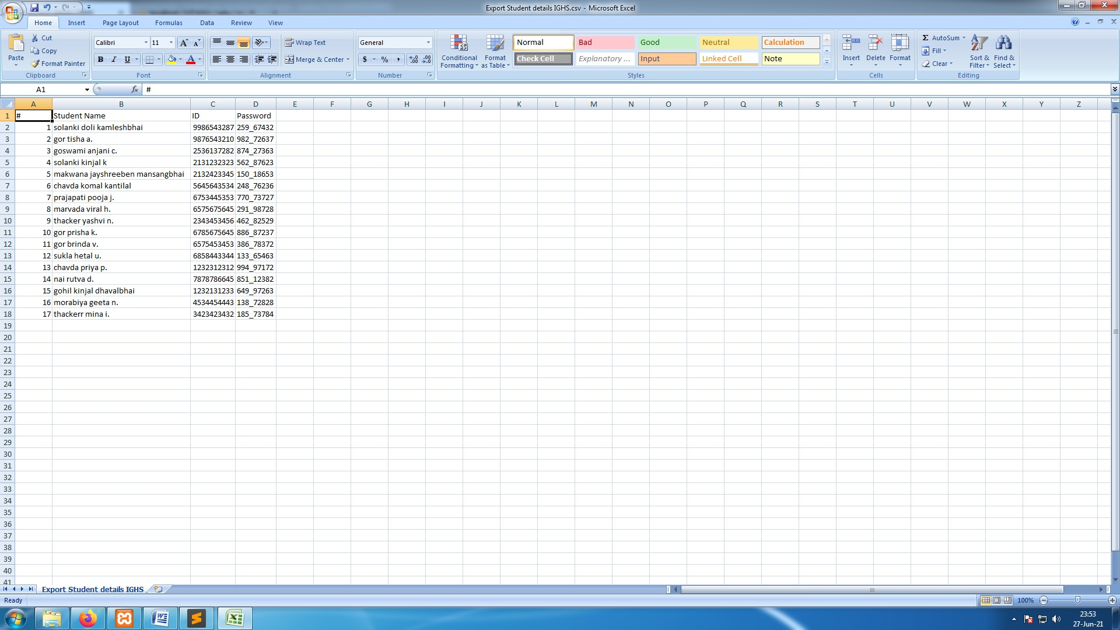

**[ Image 2.4.8.2- System generated document for Export Student passwords ]**

* This is CSV File generated from **Image 2.4.8.2** data table.

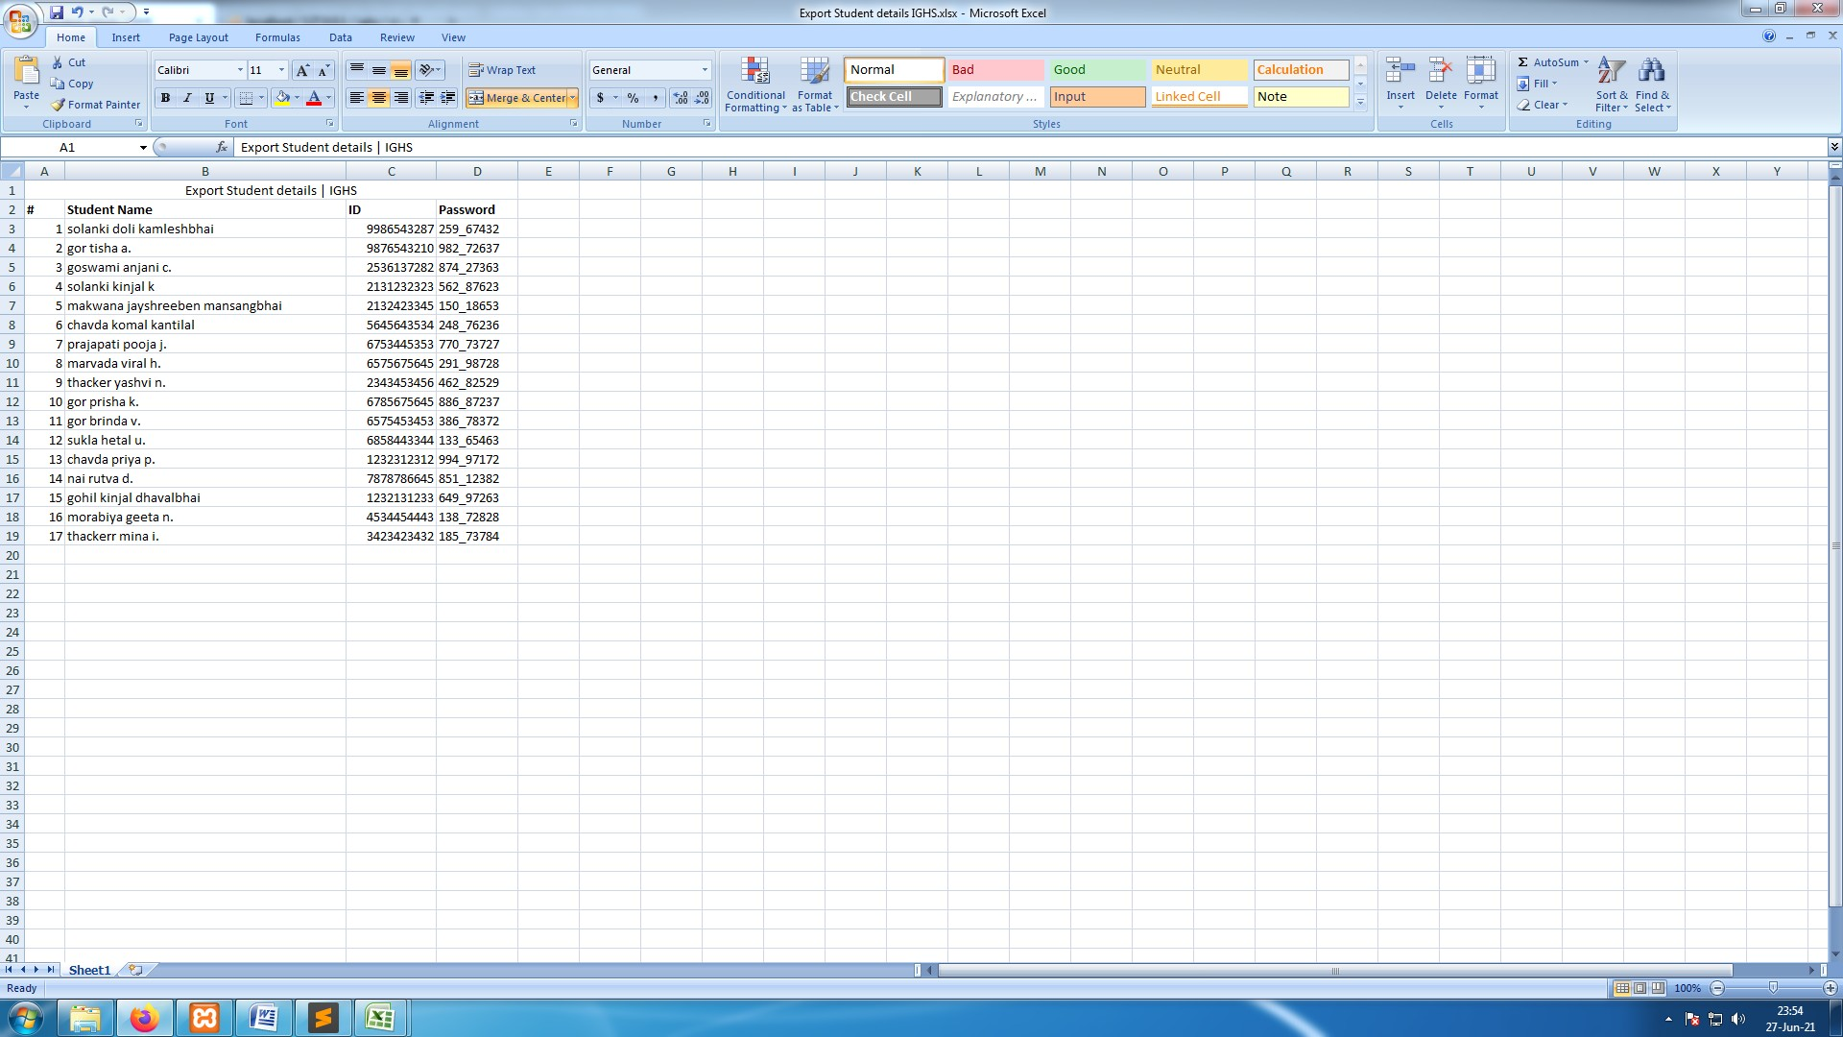

**[ Image-2.4.8.3- System generated document for Export Student passwords ]**

* This is Excel File generated from **Image 2.4.8.2** data table.

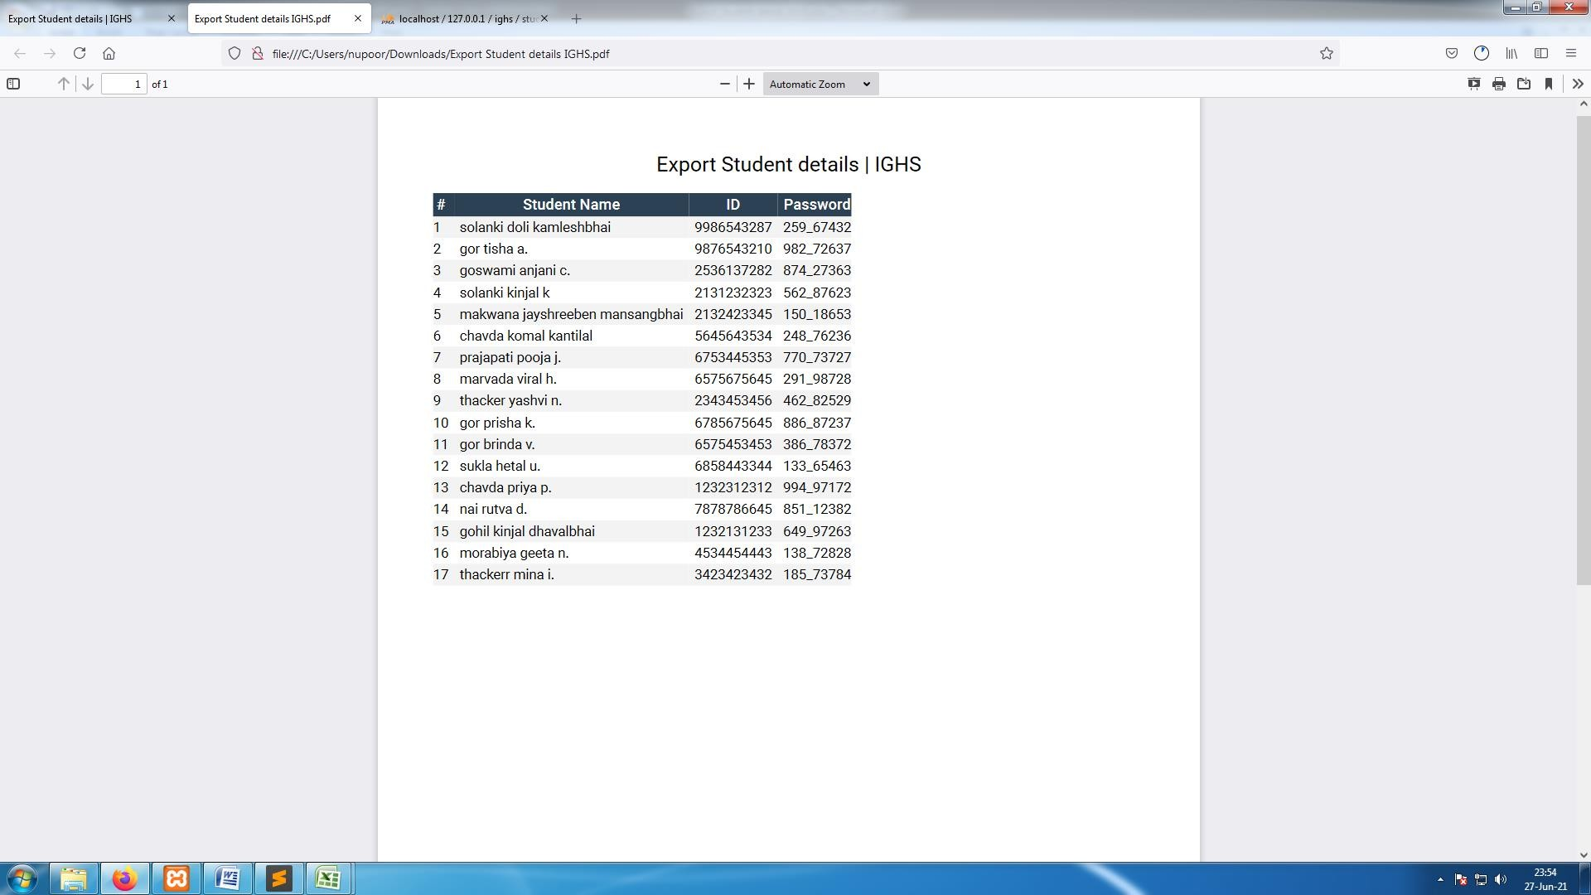

**[ Image 2.4.8.4-- System generated document for Export Student passwords ]**

* This is PDF File generated from **Image 2.4.8.2** data table.

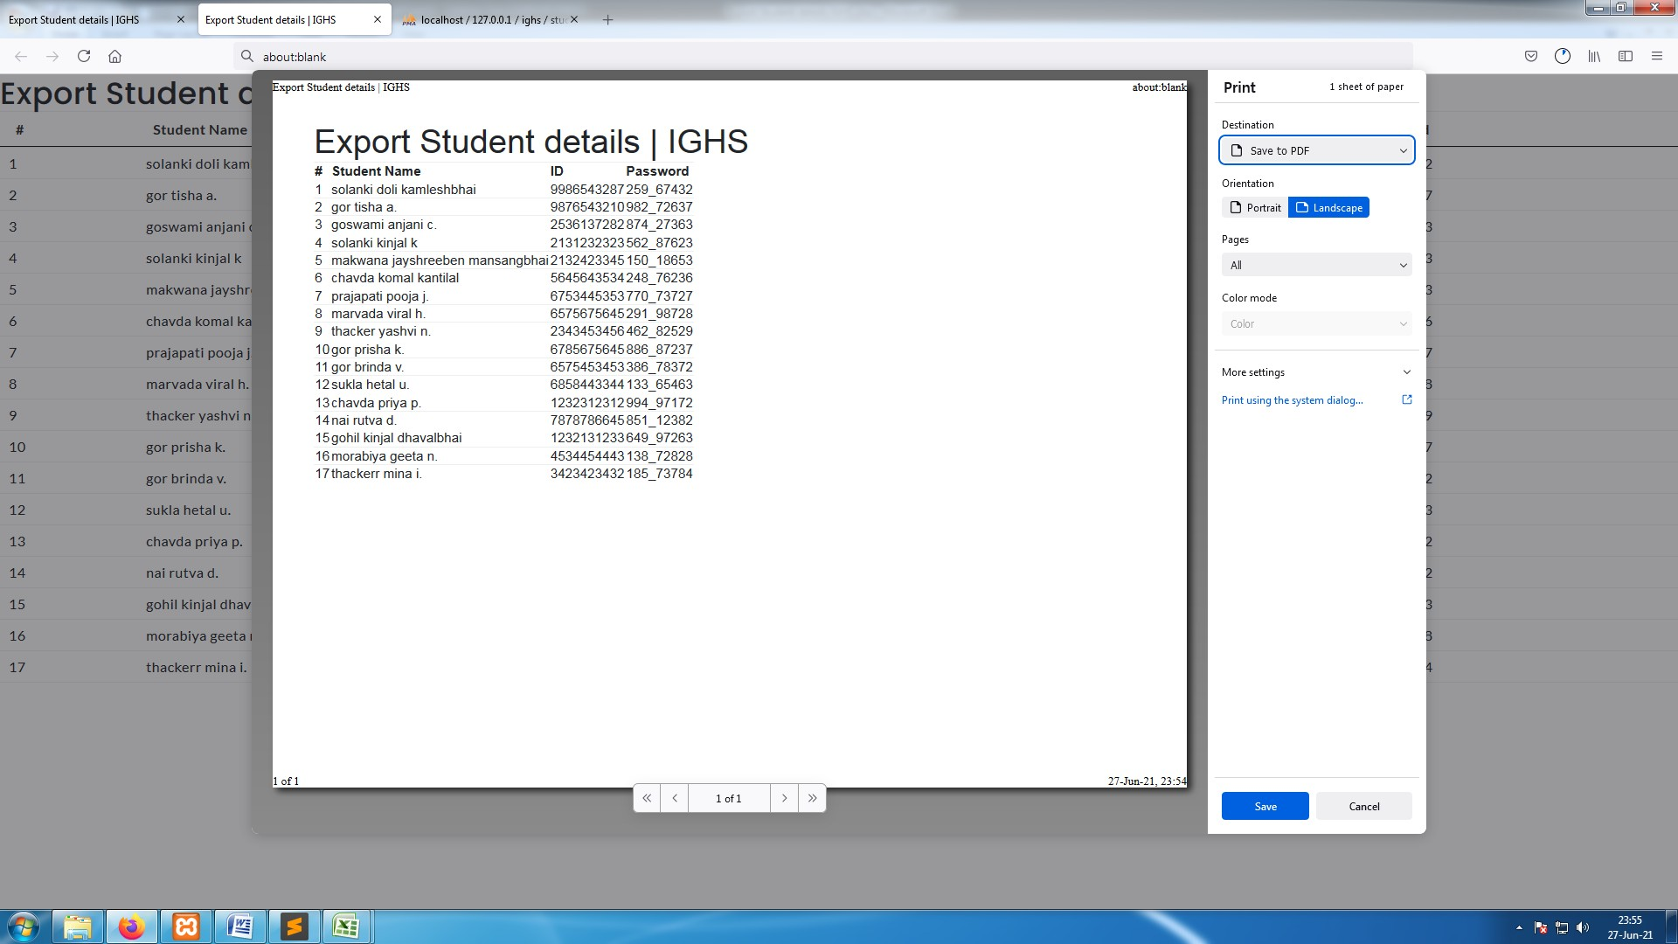

**[ Image 2.4.8.5- System generated document for Export Student passwords ]**

* This is Print view of **Image 2.4.8.2** data table.

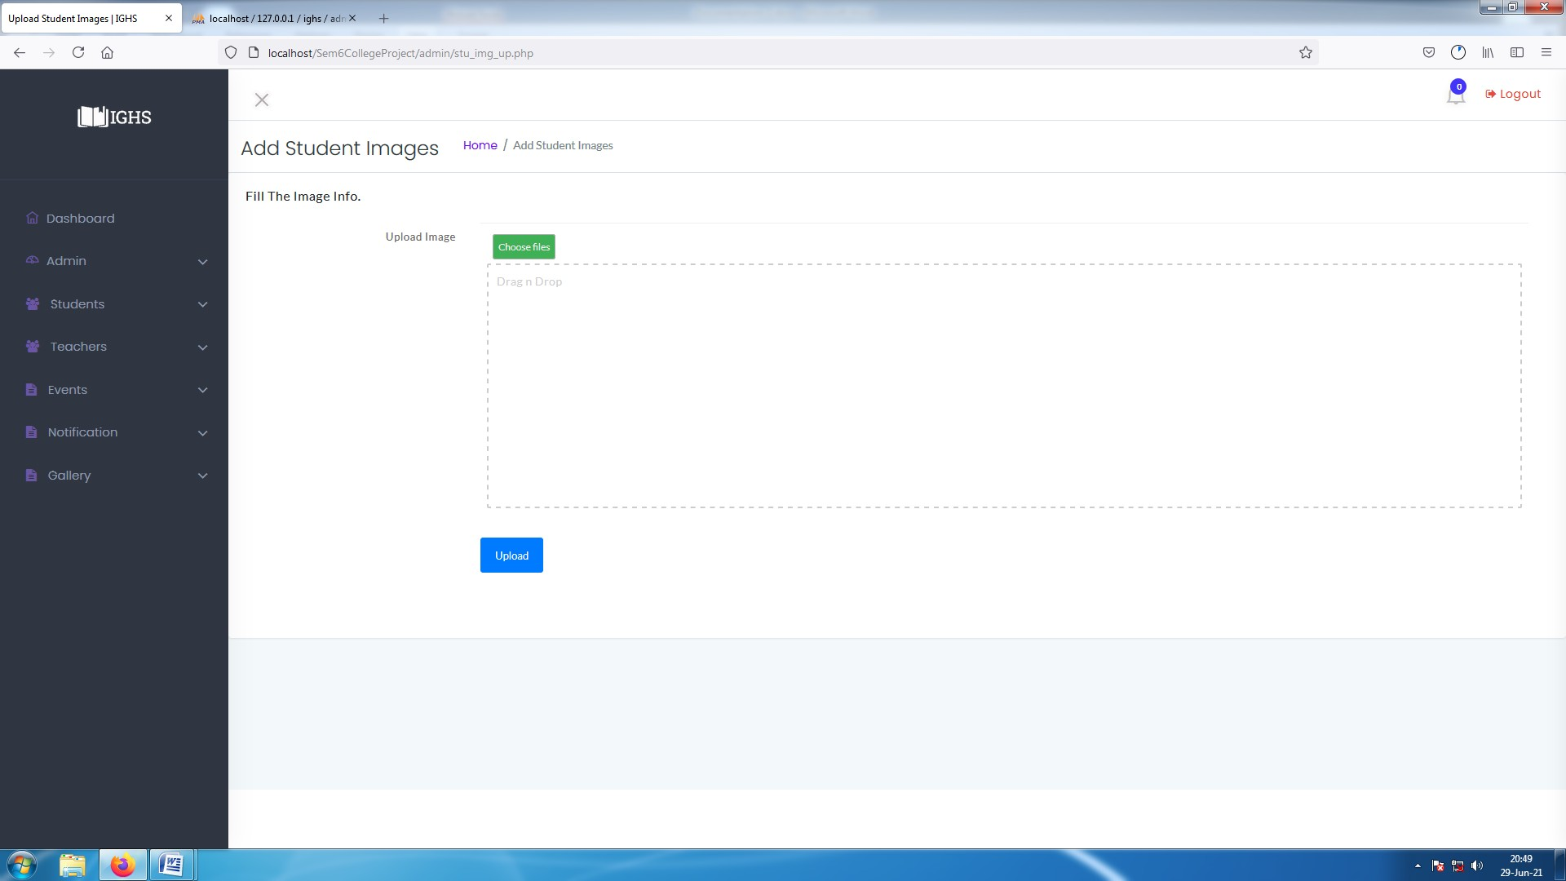

**[ Image 2.5- Add Student Images ]**

**Insert Student Images : -**

* Click on "Add student images " available in Side-bar highlighted by white box in **Image-2.4.7** which will open a window as shown in **Image 2.4.8** .

#### ADMIN : MANAGE TEACHERS

Every process listed below ,

* + **Add Teacher ,**
  + **Import Teacher ,**
  + **Manage Teacher ,**
  + **Delete Teacher ,**
  + **Restore Teacher ,**
  + **Export Teacher Password ,**
  + **Edit Teacher ,**
  + **Add Teacher Images,**

are same as Admin : Manage Student except "Add Teacher Image". In For students admin needs to rename images to Gr. number and for Teachers Admin requires to write Full name of Teacher as Image name .

Its snapshots are as following,

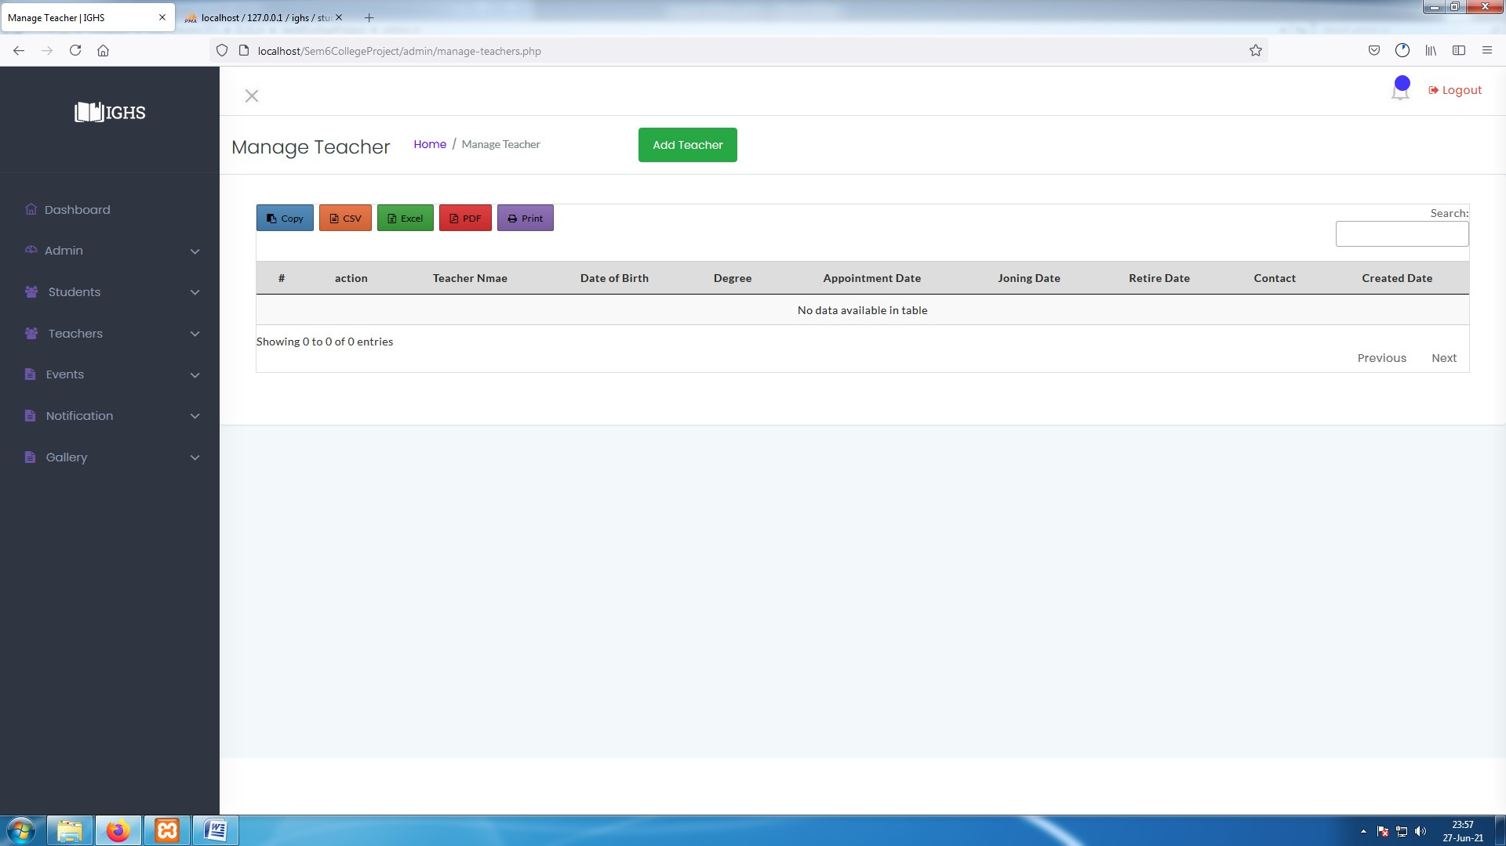

**[ Image 3- Manage Teacher Page before Data entry ]**

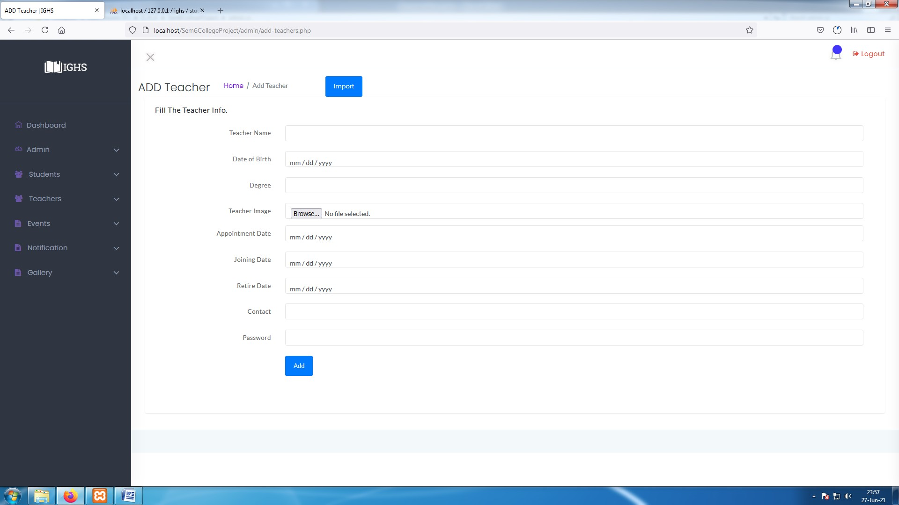

**[ Image 3.1- Add teacher ]**

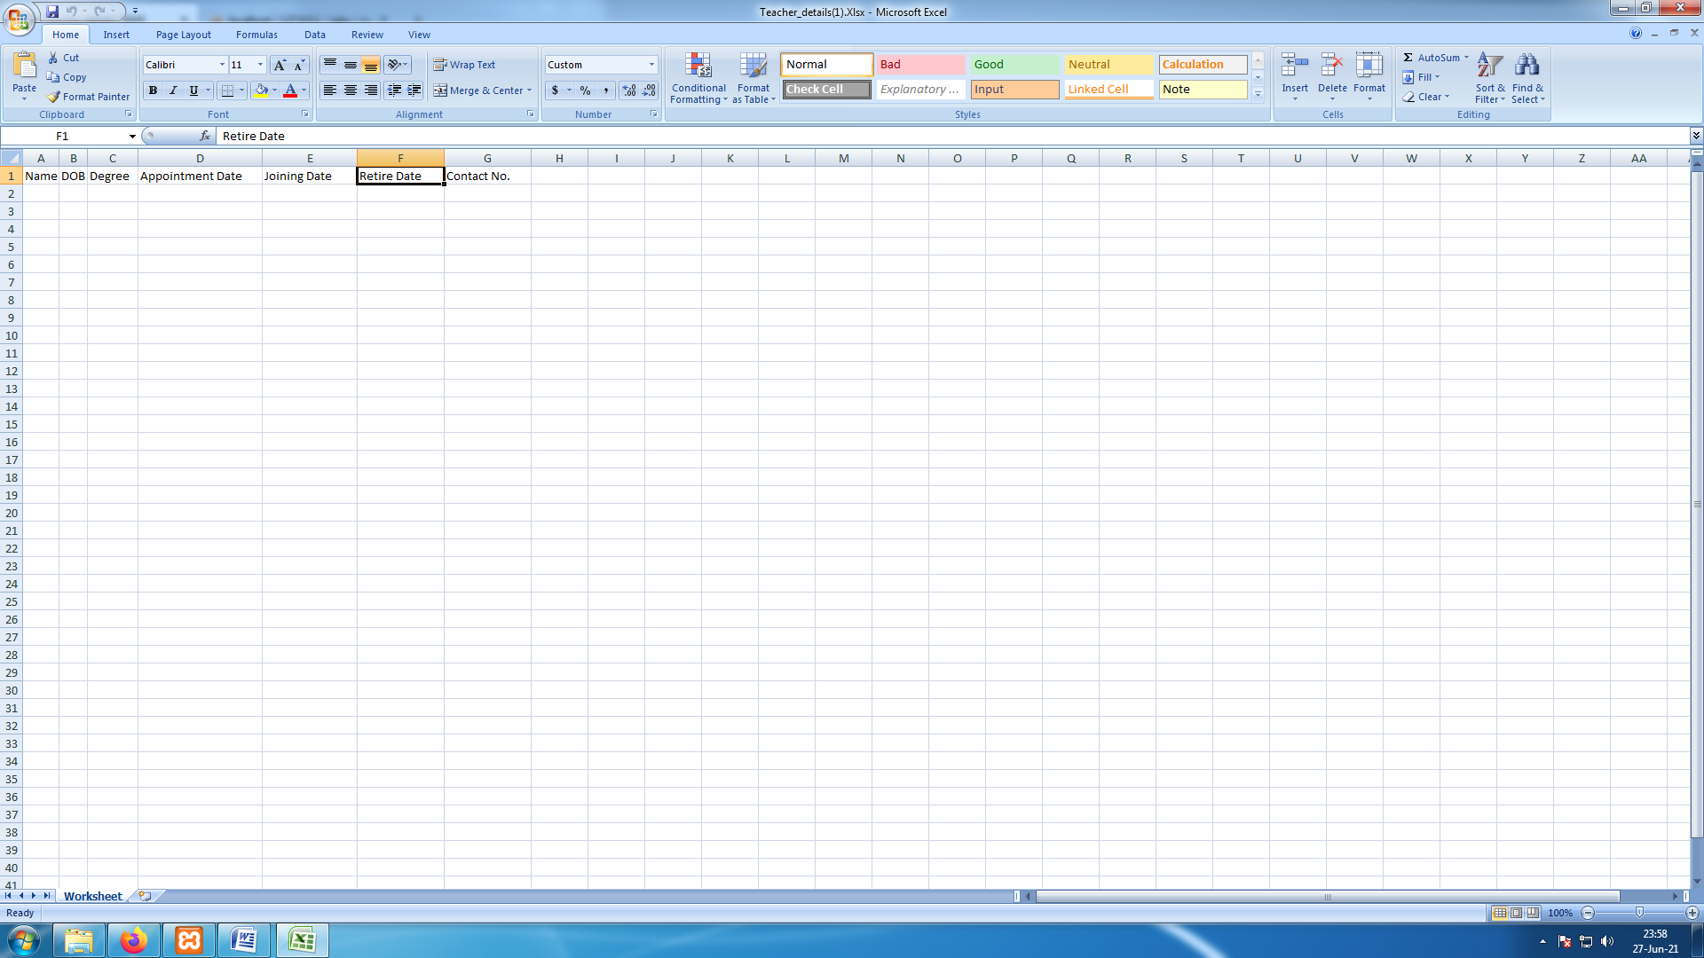

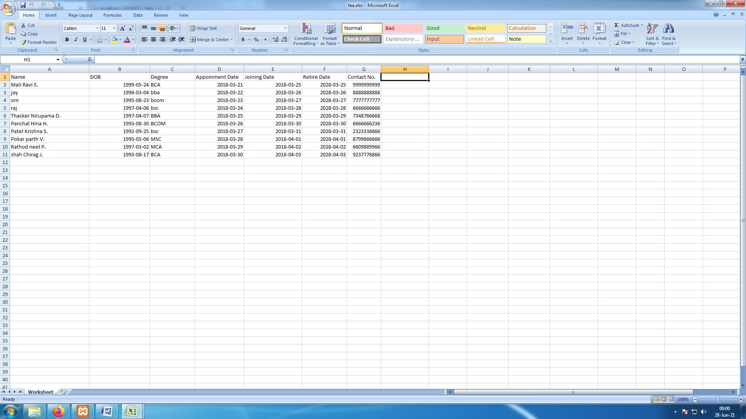**[ Image 3.1.1- Demo Sheet Generated by System ]**

**[ Image 3.1.2- Demo Sheet After Admin Fill Columns]**

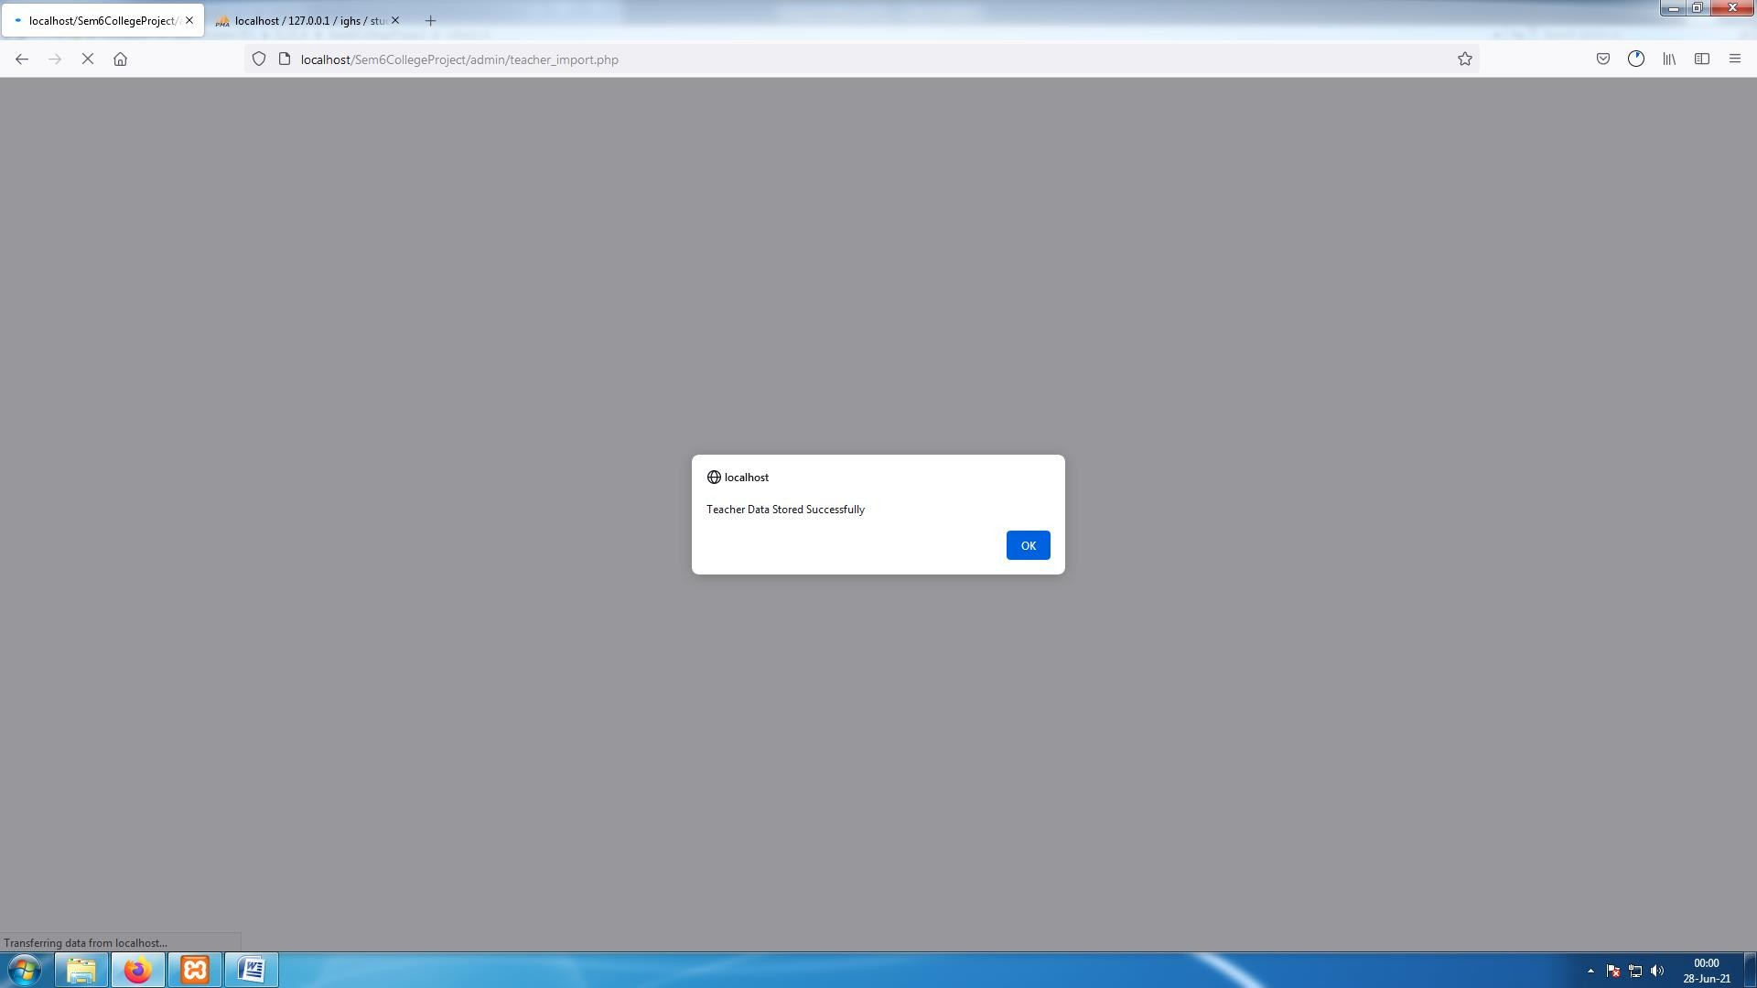

**[ Image 3.1.3- Teacher Imported Success Alert ]**

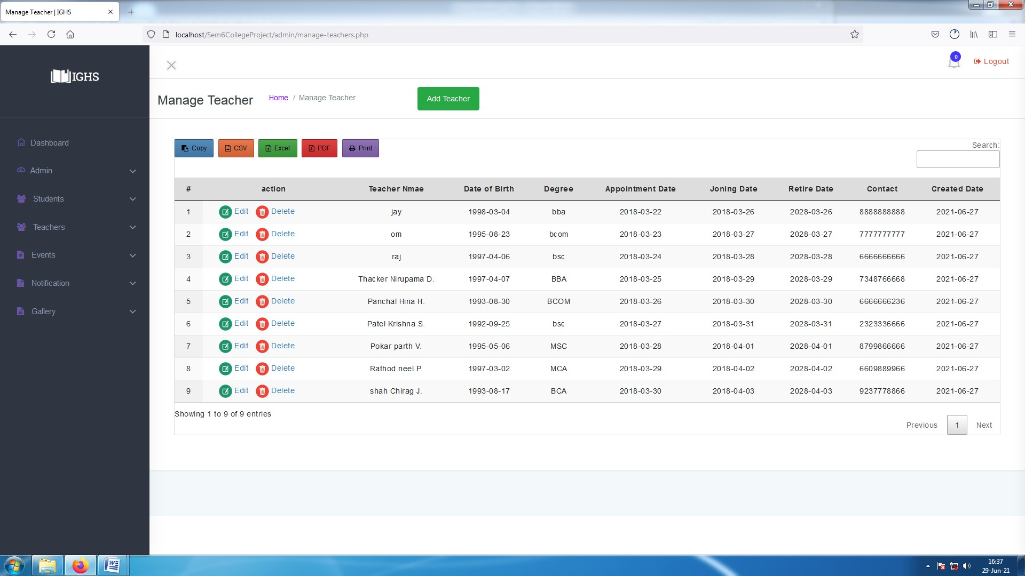

**[ Image 3.2- Manage Teacher After Successfully adding Data ]**

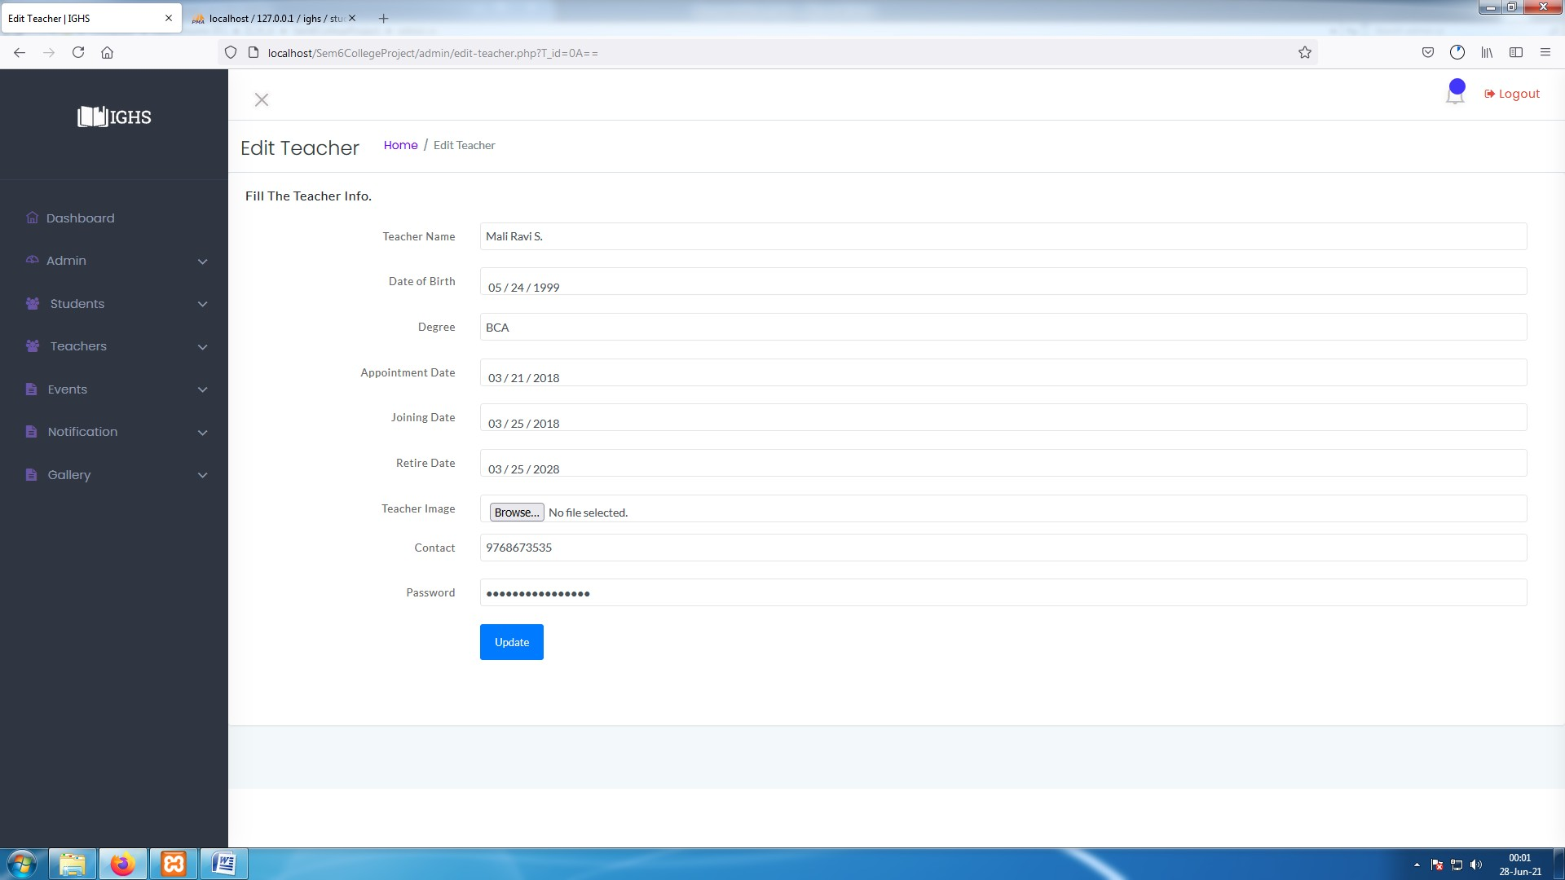

**[ Image 3.3- Edit Existing Teacher Data ]**

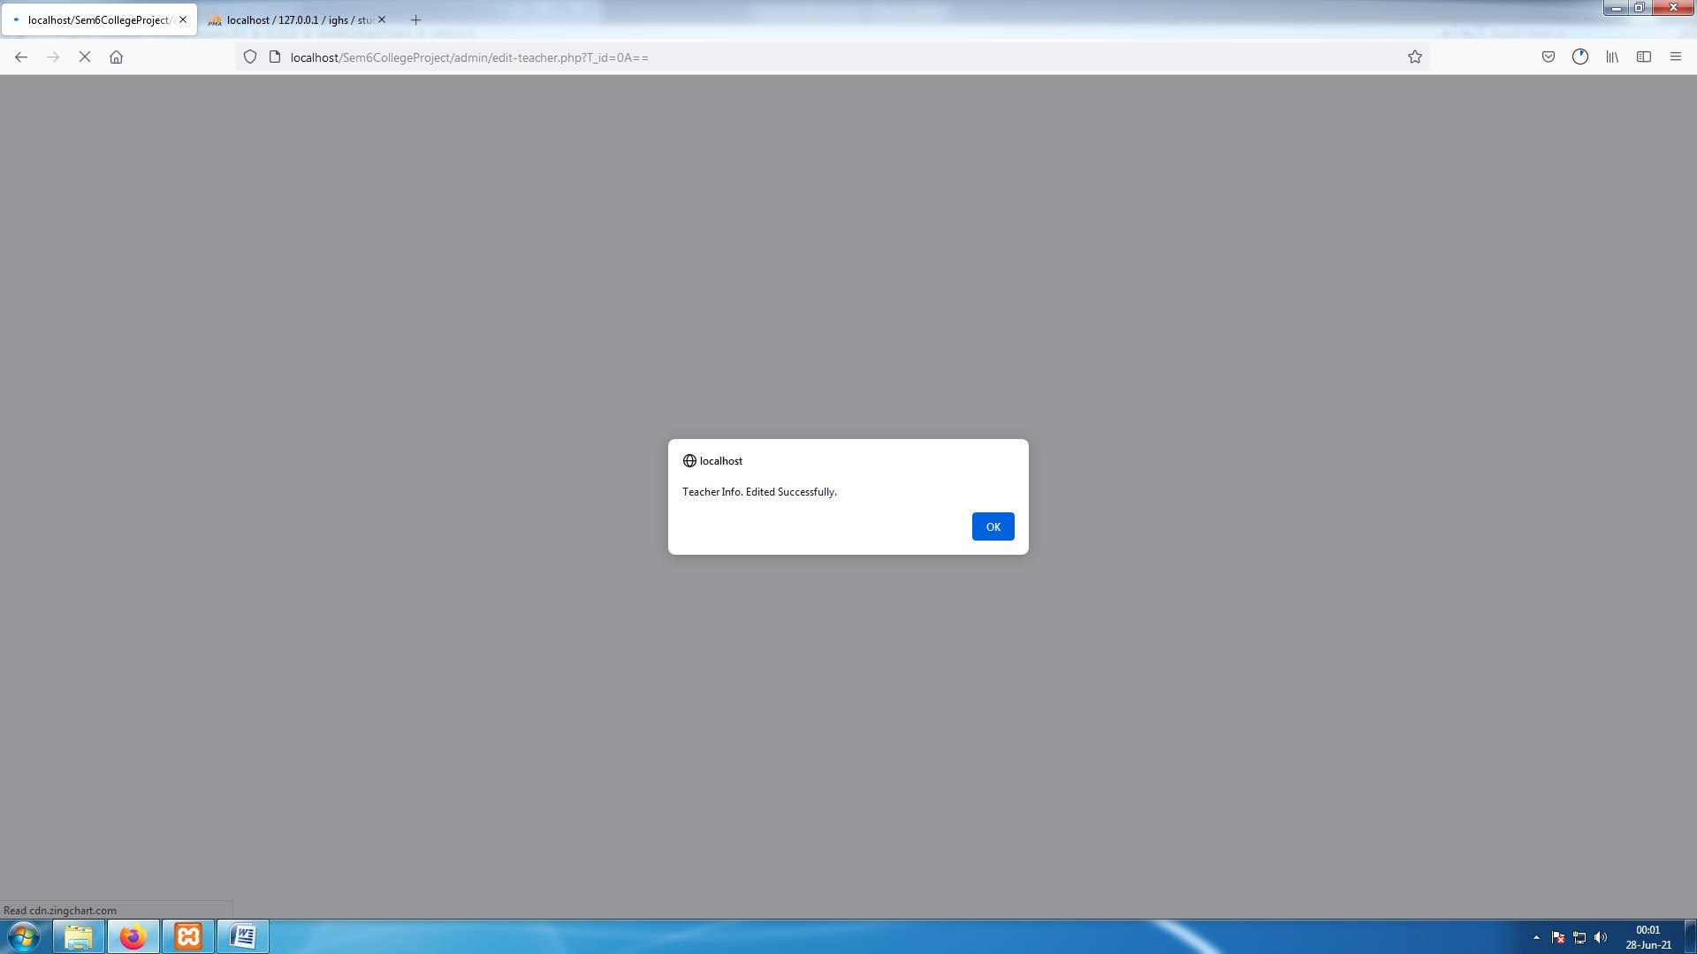

**[ Image 3.3.1- Teacher data Edited Success Alert ]**

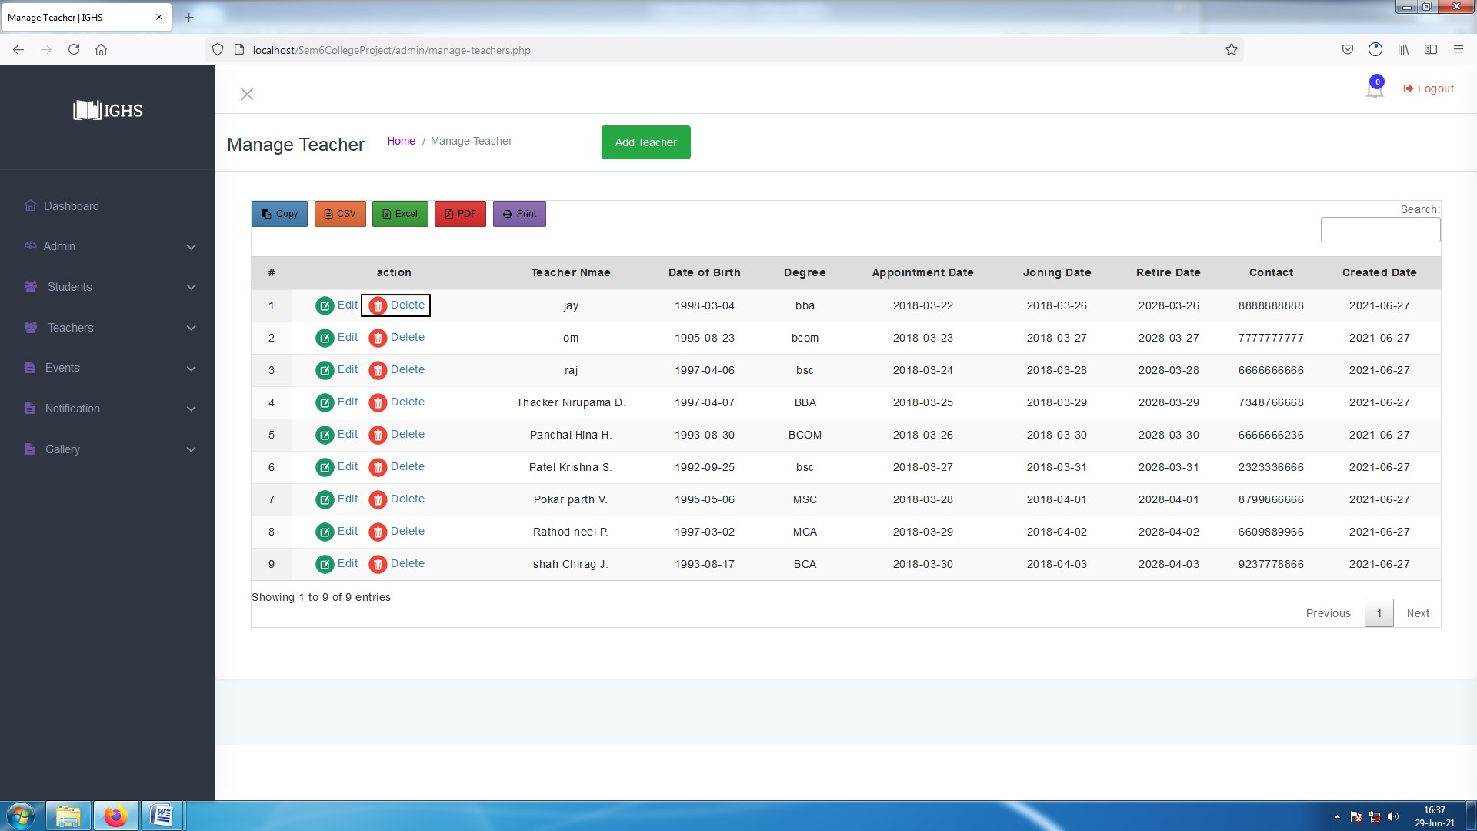

**[ Image 3.4- Delete teacher data ]**

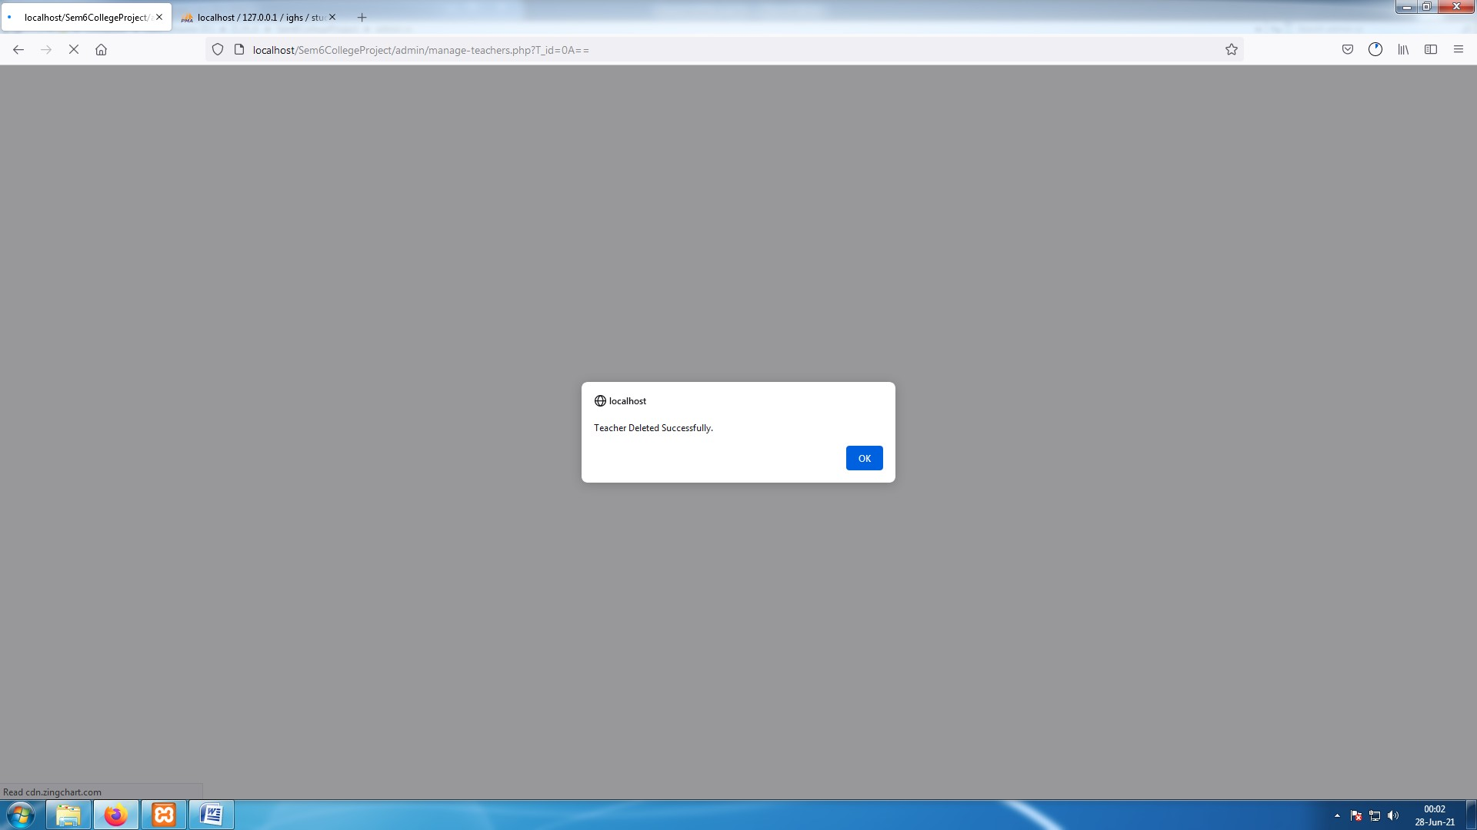

**[Image 3.4.1-Teacher data Deleted Success Alert ]**

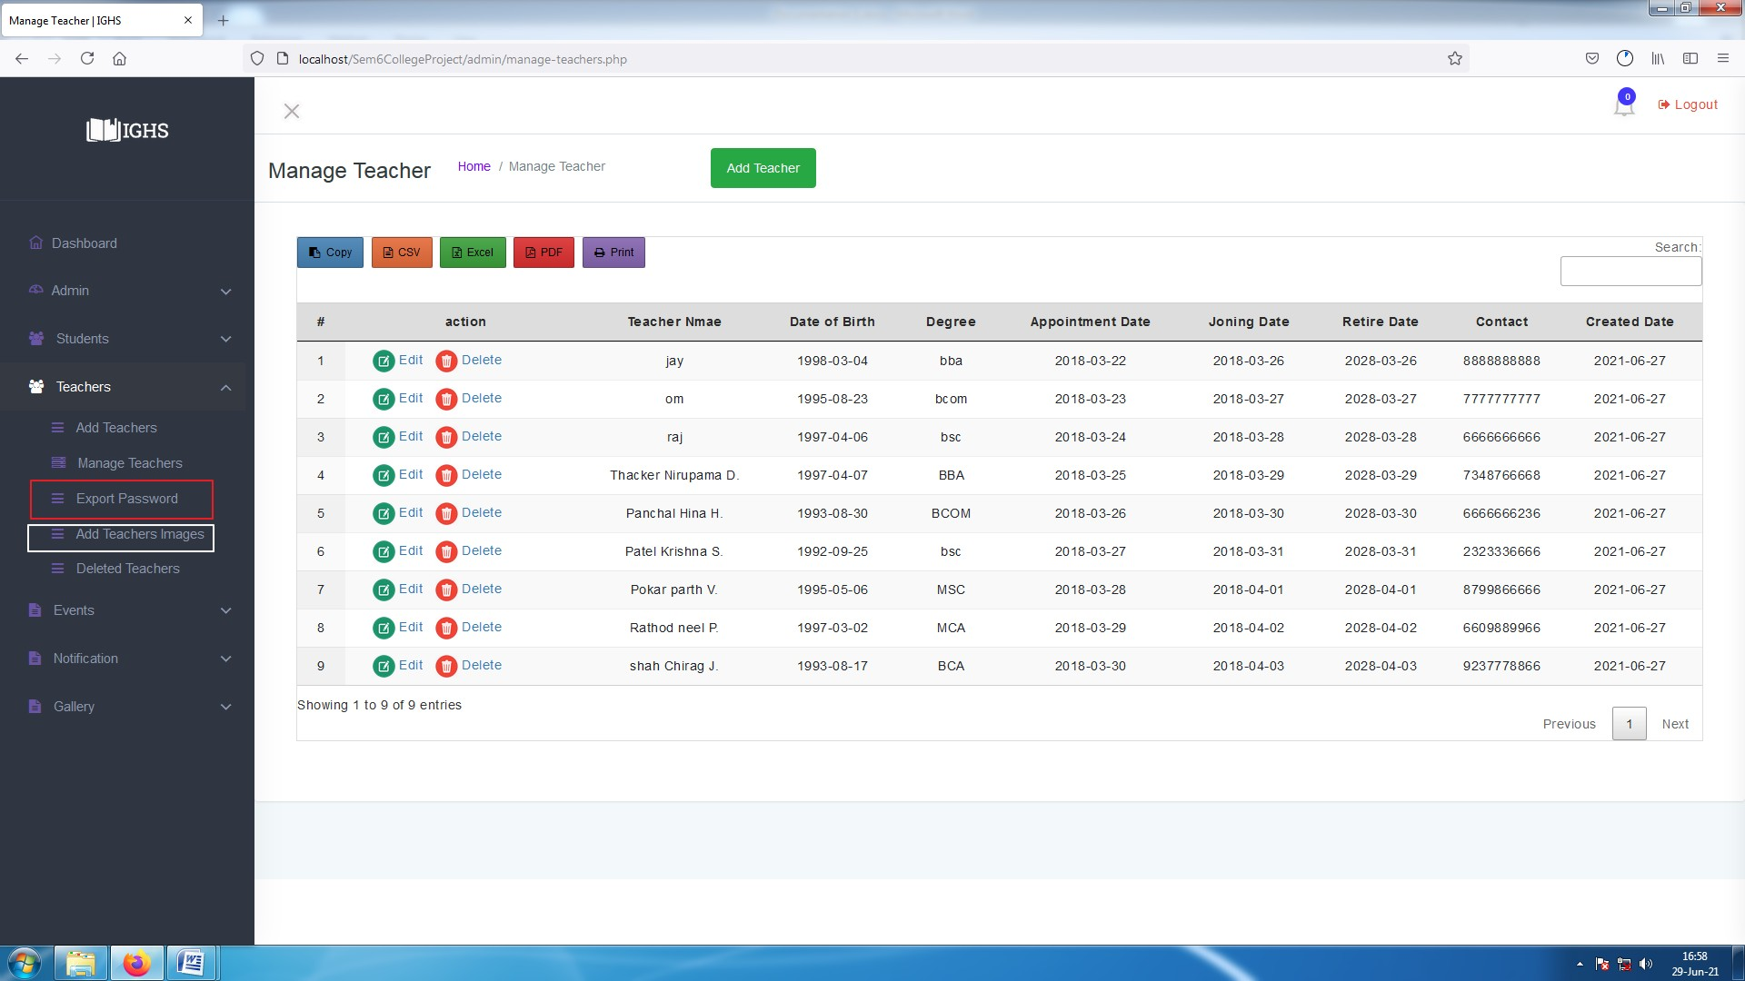

**[ Image 3.5-Manage Teacher ]**

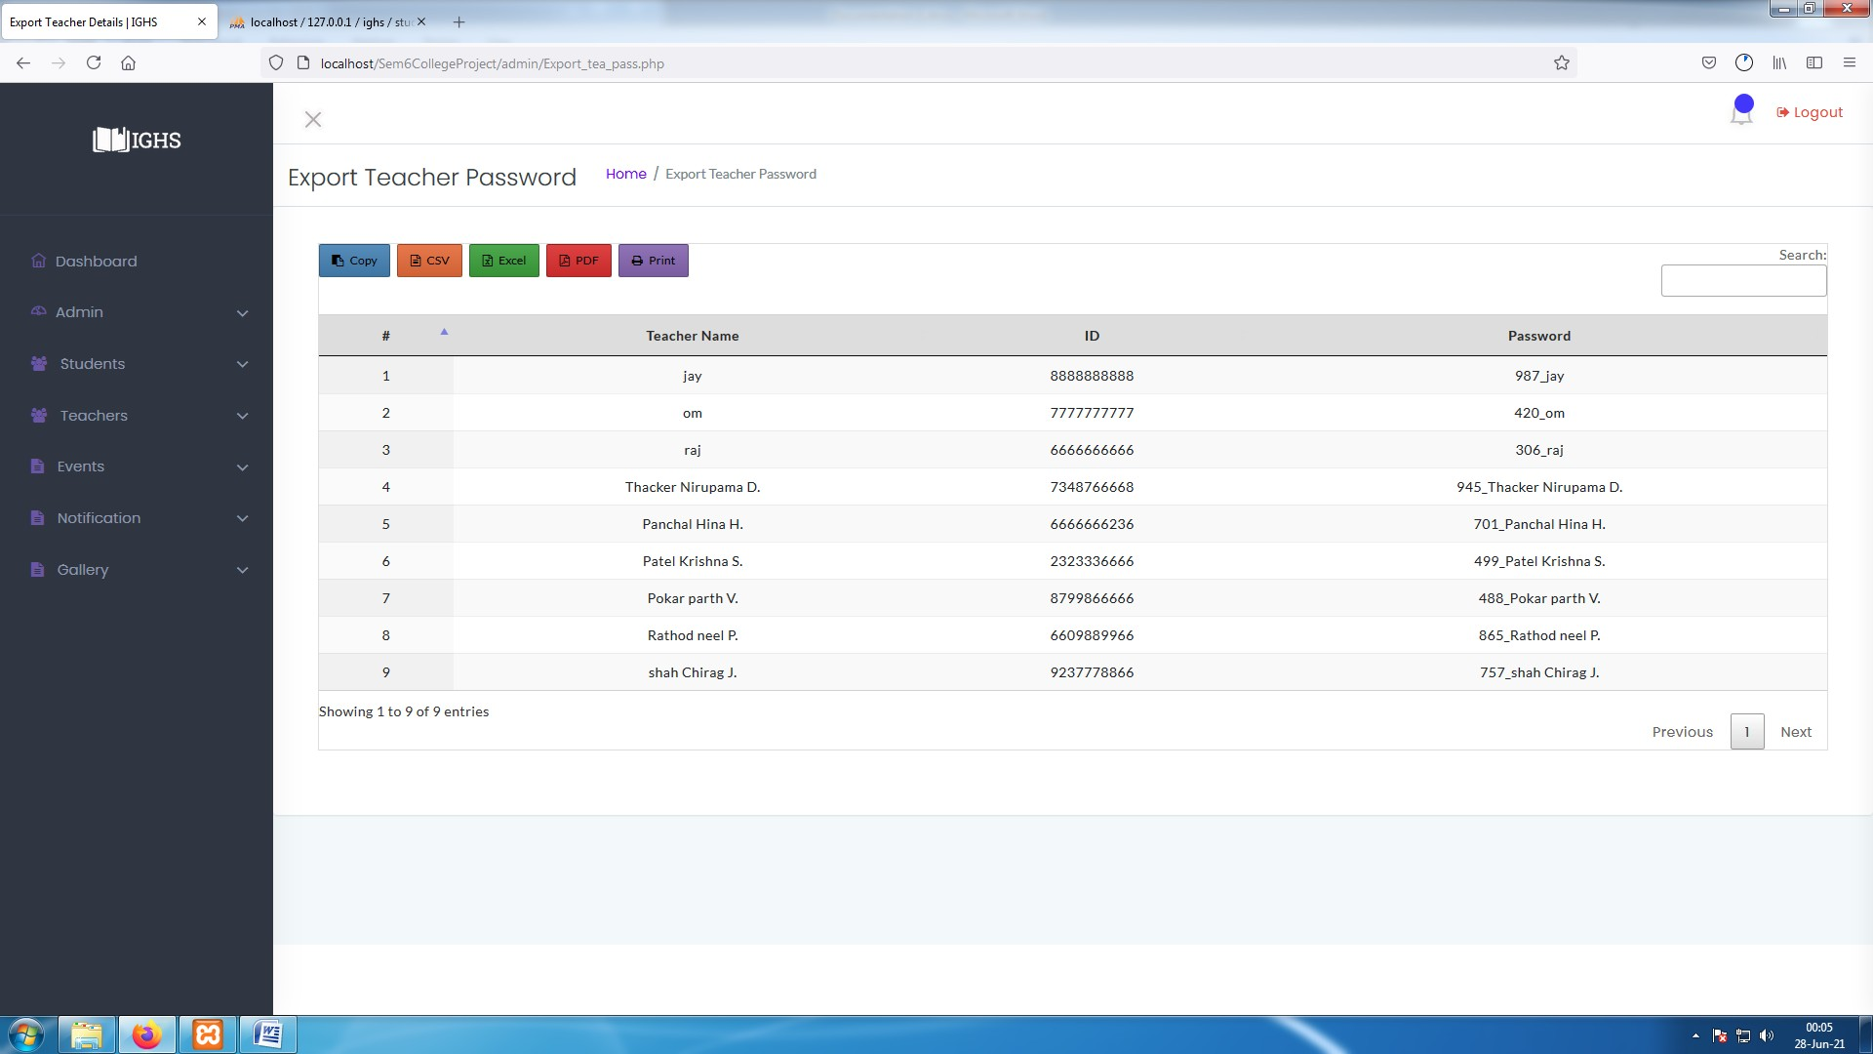

**[ Image 3.5.1- Export Teacher Password ]**

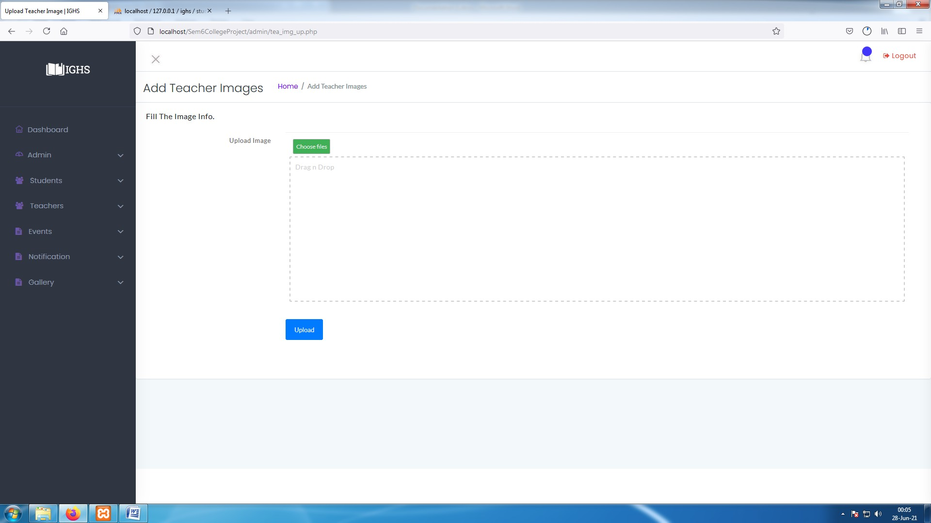

**[ Image 3.5.2- Add Teacher Images]**

* This process is similar as Adding student Images but instead of saving image by Gr. number , admin needs to save Teacher's image with Teacher's full name .

#### Admin : Manage Admin

* Every process listed below ,
  + Add admin
  + Manage admin
  + Edit admin
  + Delete admin
  + Restore admin

are also same as Manage Student and Manage Teacher and its snapshots are as below .

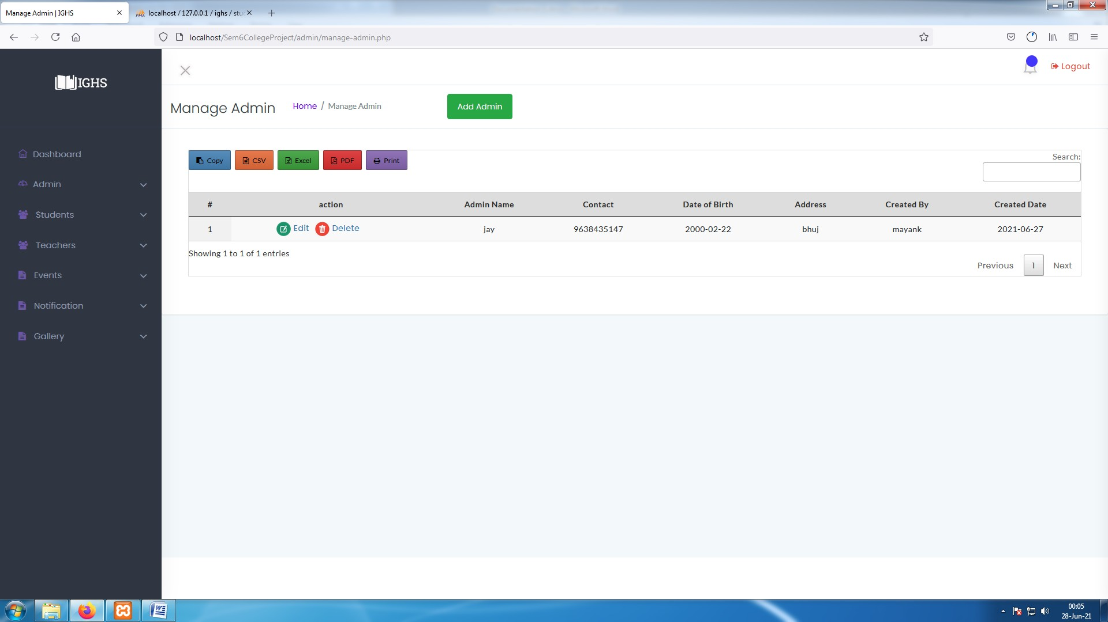

**[ Image 4- Manage Admin ]**

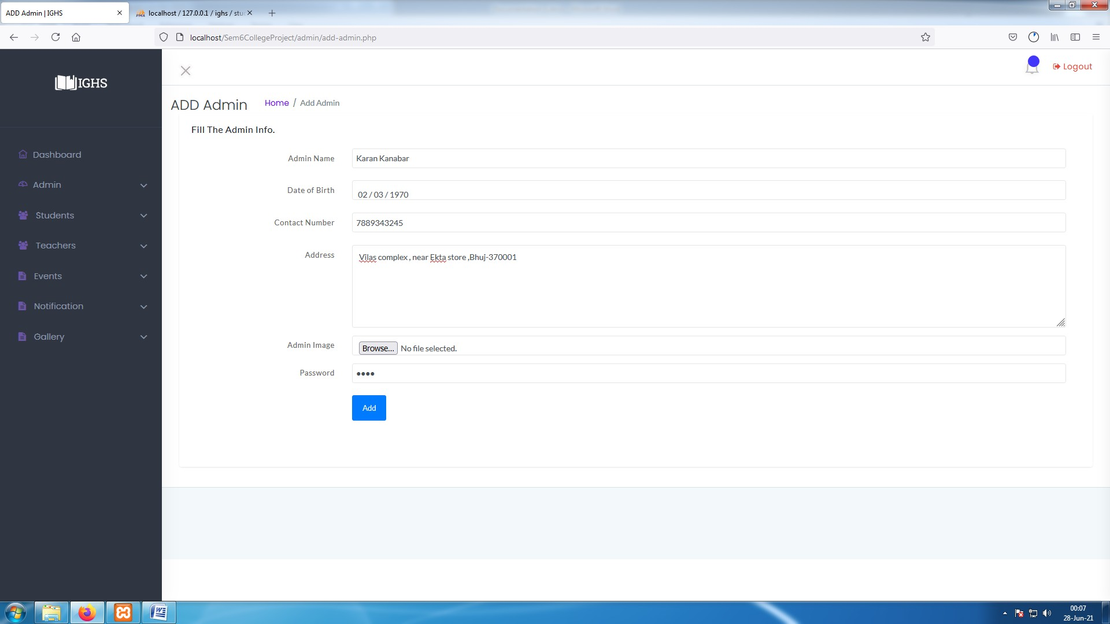

**[ Image 4.1-Add Admin ]**

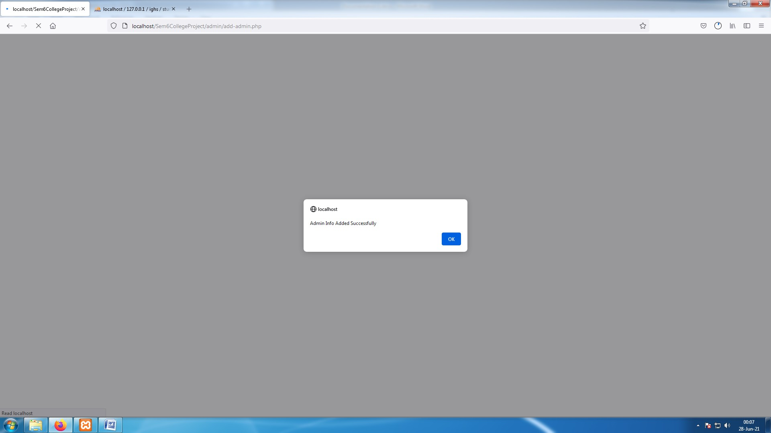

**[ Image 4.1.1- Admin Added Success Alert ]**

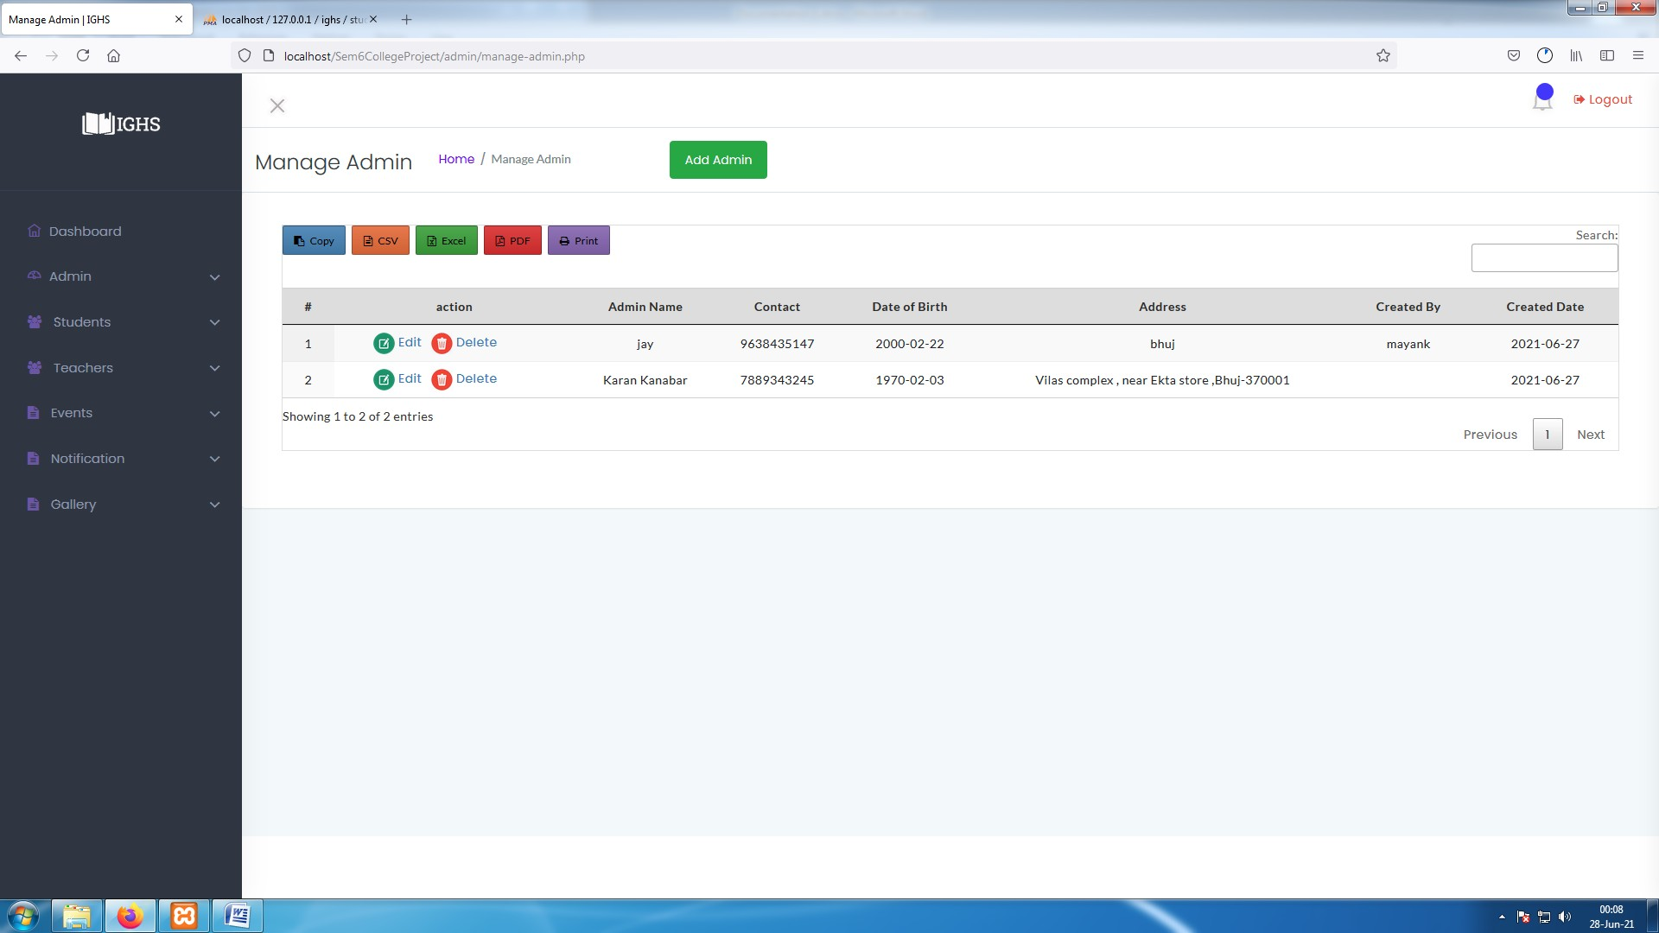

**[ Image 4.2-Manage Admin ]**

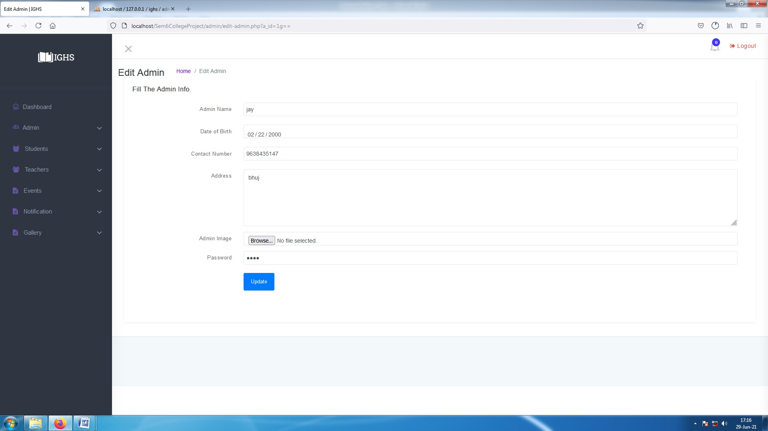

**[ Image 4.2.1- Edit admin Data ]**

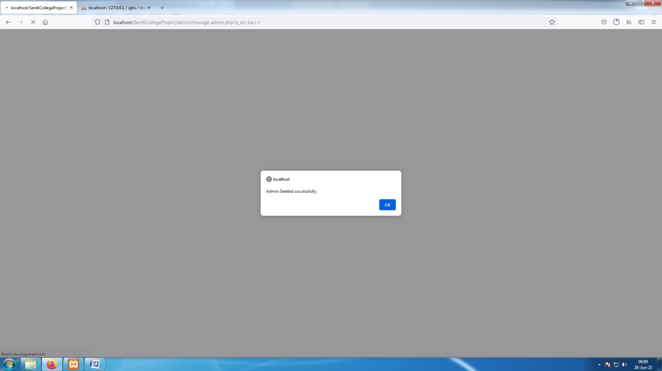

**[ Image 4.2.2- Admin data deleted success message ]**



**[ Image 4.2.3-Manage Admin after delete action]**

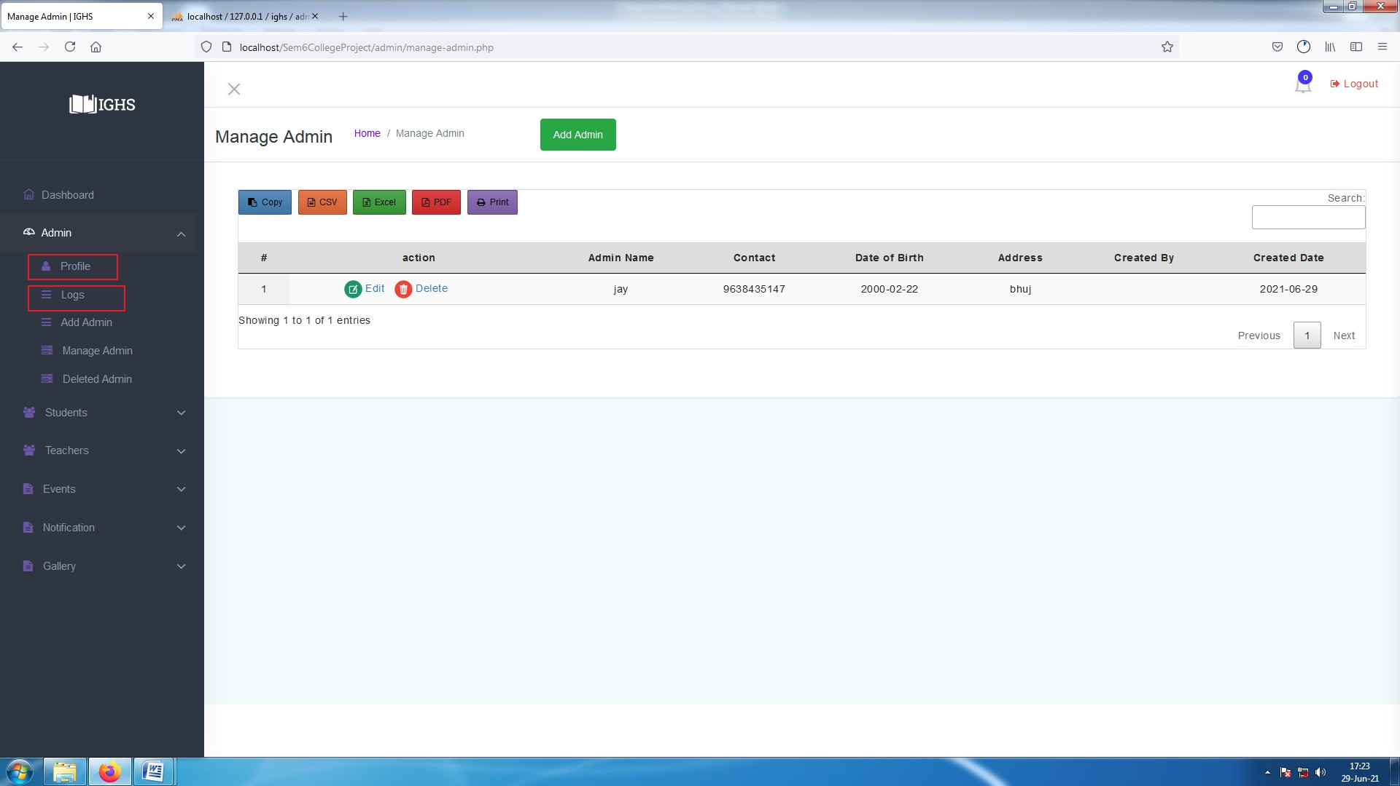

**[ Image 4.3-Manage admin ]**

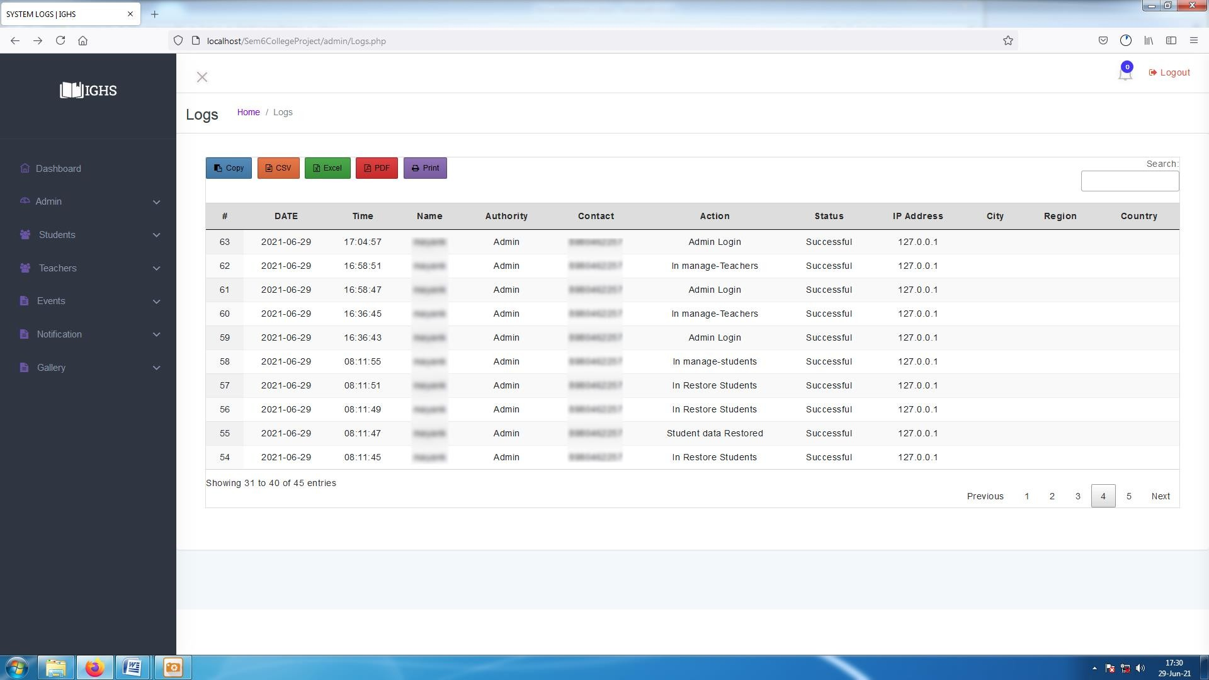

**[ Image 4.3.1- Logs ]**

* Admin can keep track of actions performed by other users in Logs.
* Admin can see their name, Contact number, Name, their Authority (Admin, Teacher , Student), Actions performed by users, Status of performed actions (Successful / Unsuccessful ), User's Ip address and their Location.

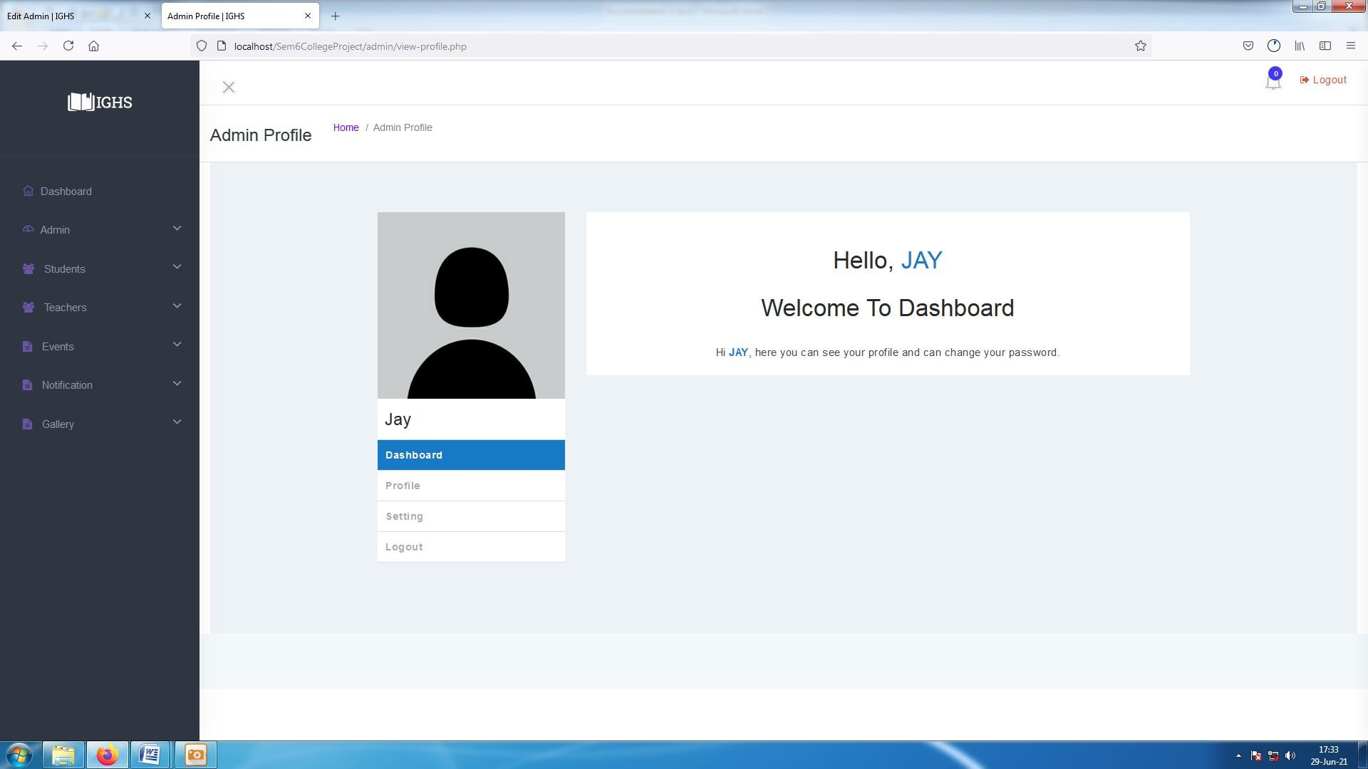

**[ Image 4.3.1-Admin Profile]**

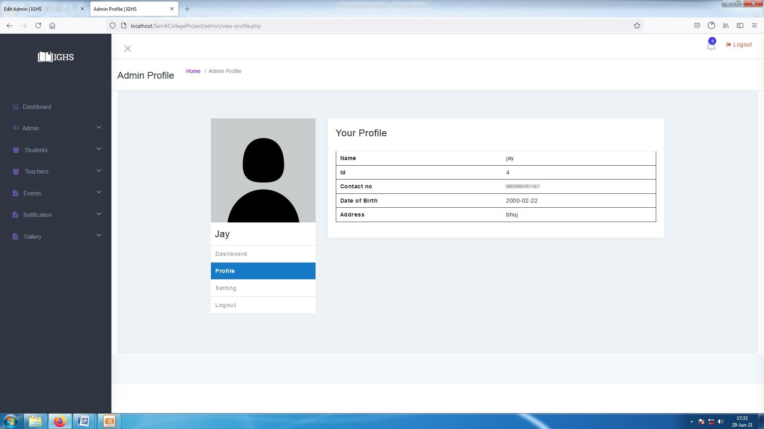

**[ Image 4.3.1-Admin Profile]**

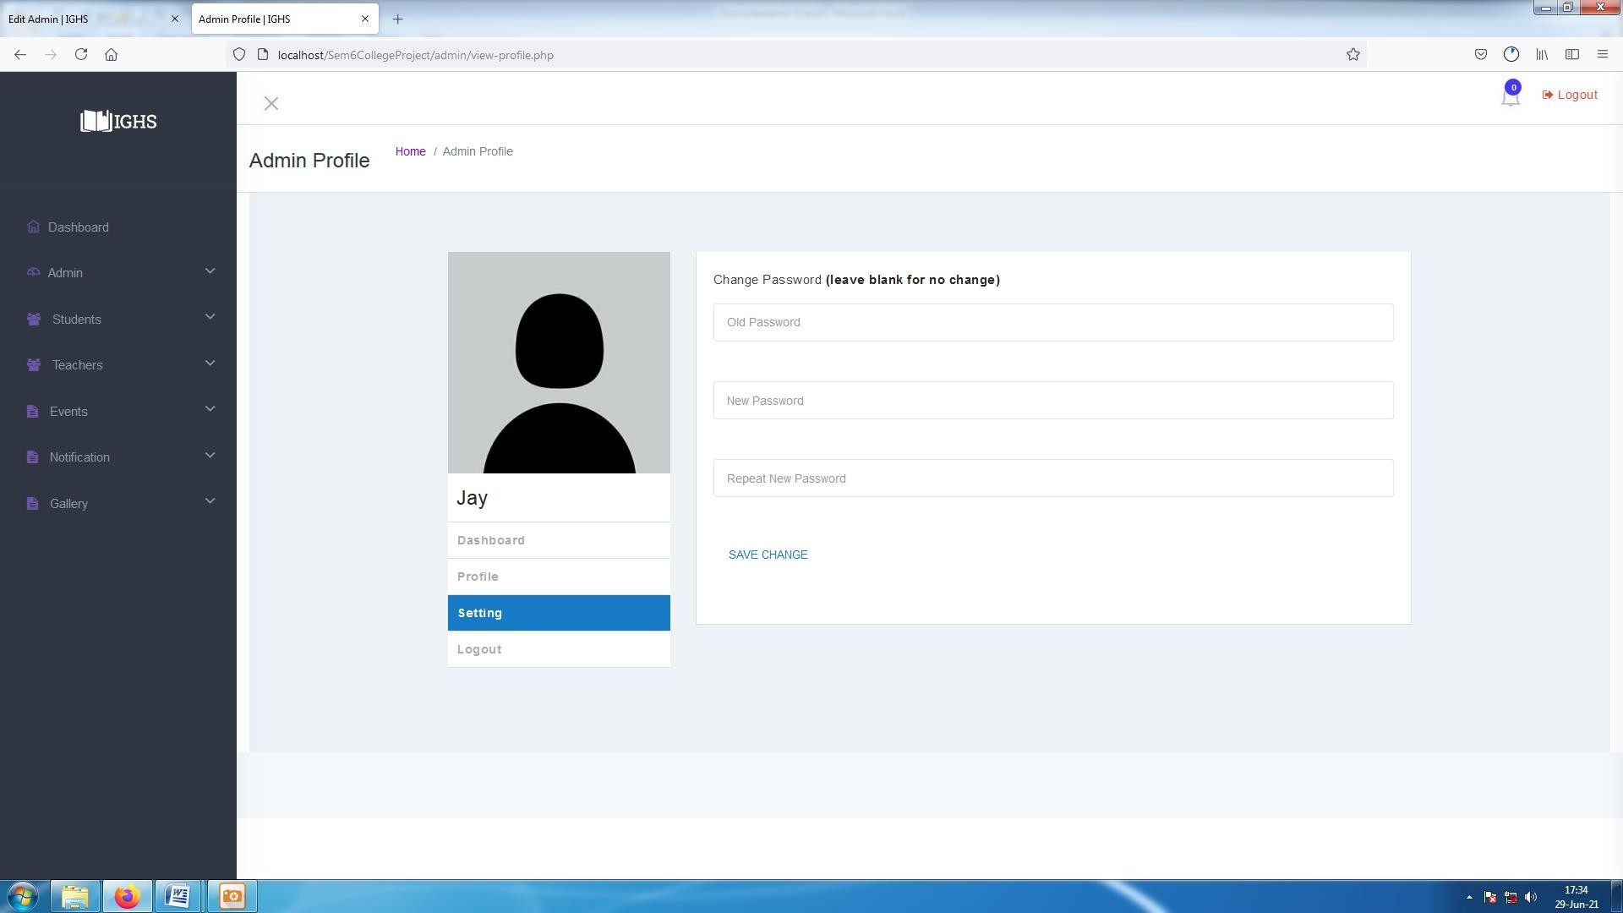

**[ Image 4.3.1- Admin Profile /Change Password]**

#### Admin : Manage Event

* In manage Event features are as below :-
  + Create Event :- Admin can create new events .
  + Delete Event : - Admin can delete Events.
  + Edit Event :- Admin can edit Existing events.
  + Disable Event :- Keeps the Event in system but nobody can see it.
  + Enable Event :- Enables previously disabled events, so everyone can see it.

Its snapshots are as below .

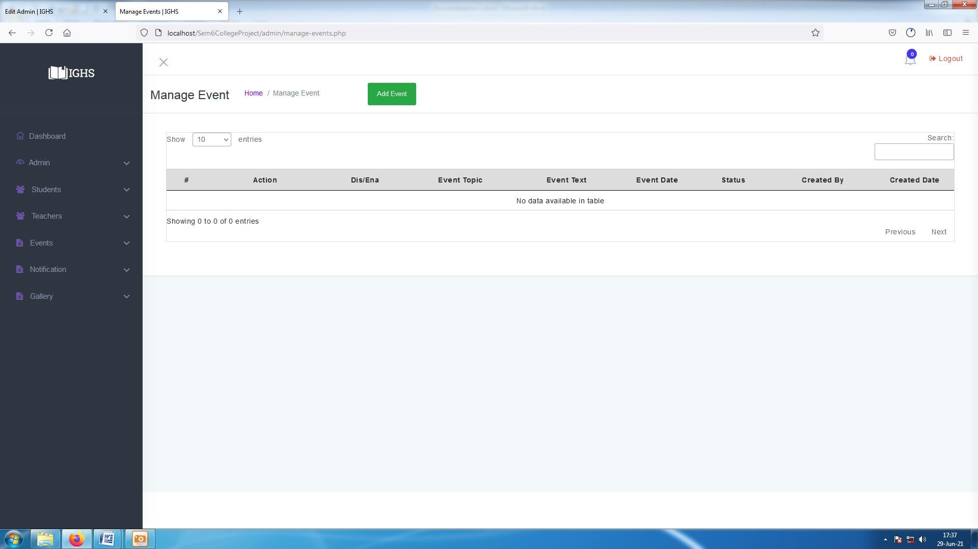

**[ Image 5-Manage Events Before adding data]**

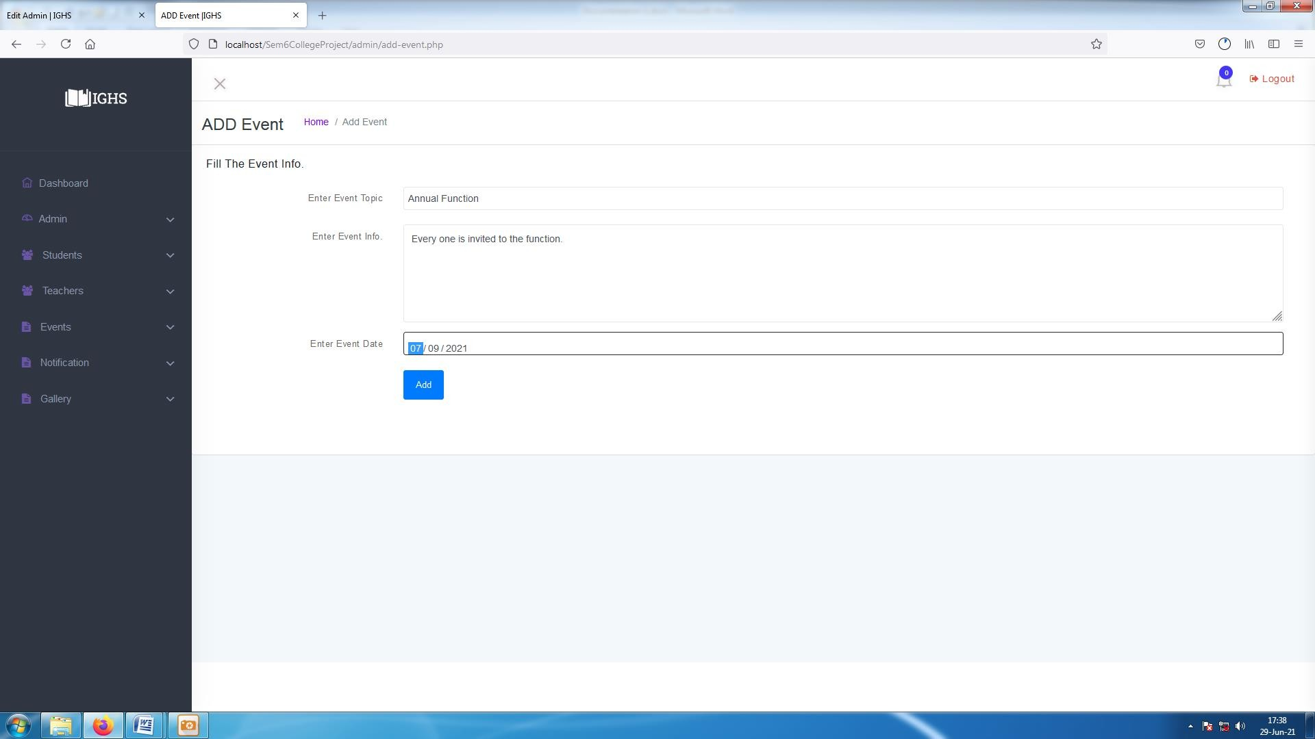

**[ Image 5.1-Add Event Data ]**

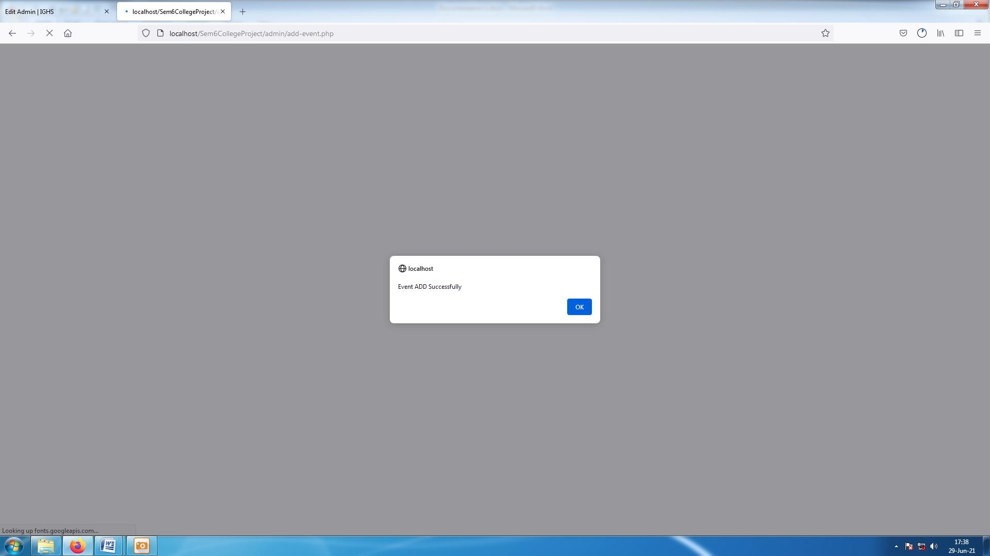

**[ Image 5.1.1- Event added Success Message ]**

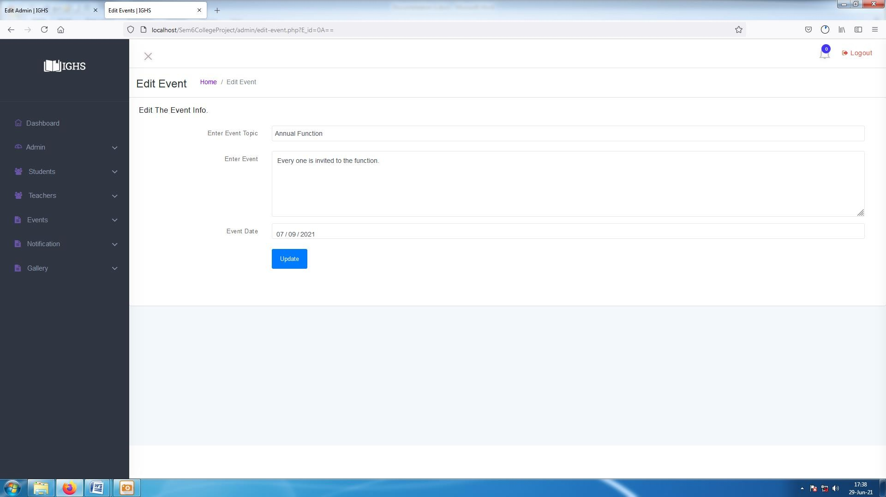

**[ Image 5.2-Edit existing Event Data ]**

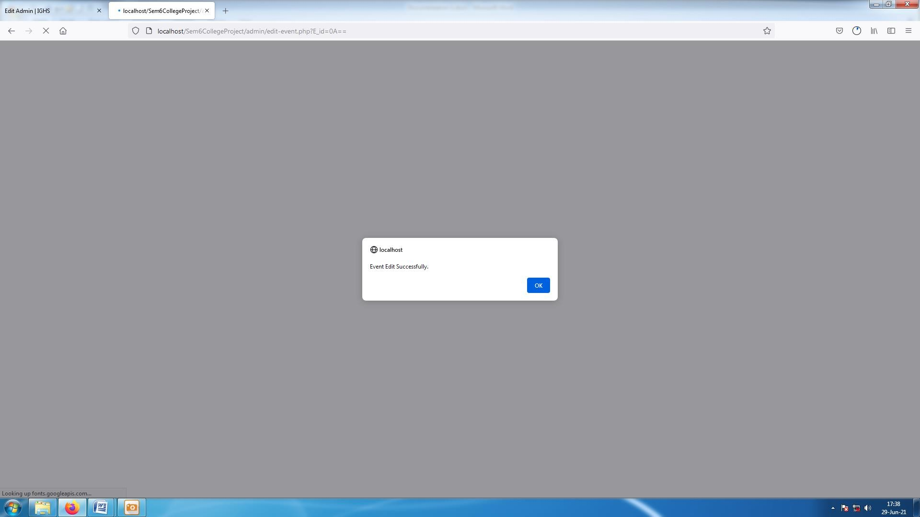

**[ Image 5.2.1-Event Edited Success Message ]**

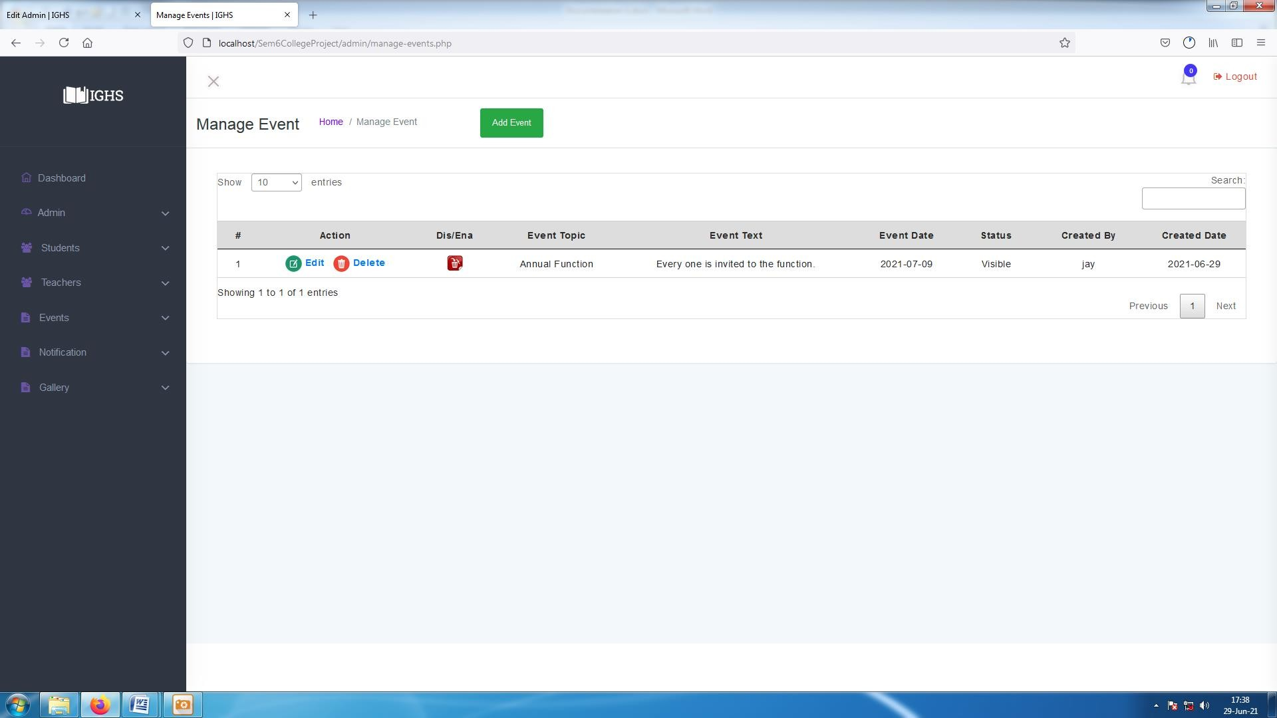

**[ Image 5.3-Disable Event ]**

* Admin can disable event so that event cannot be seen by any user but it is not deleted completely it can be Enabled again.
* Deleted Events are not retrievable.

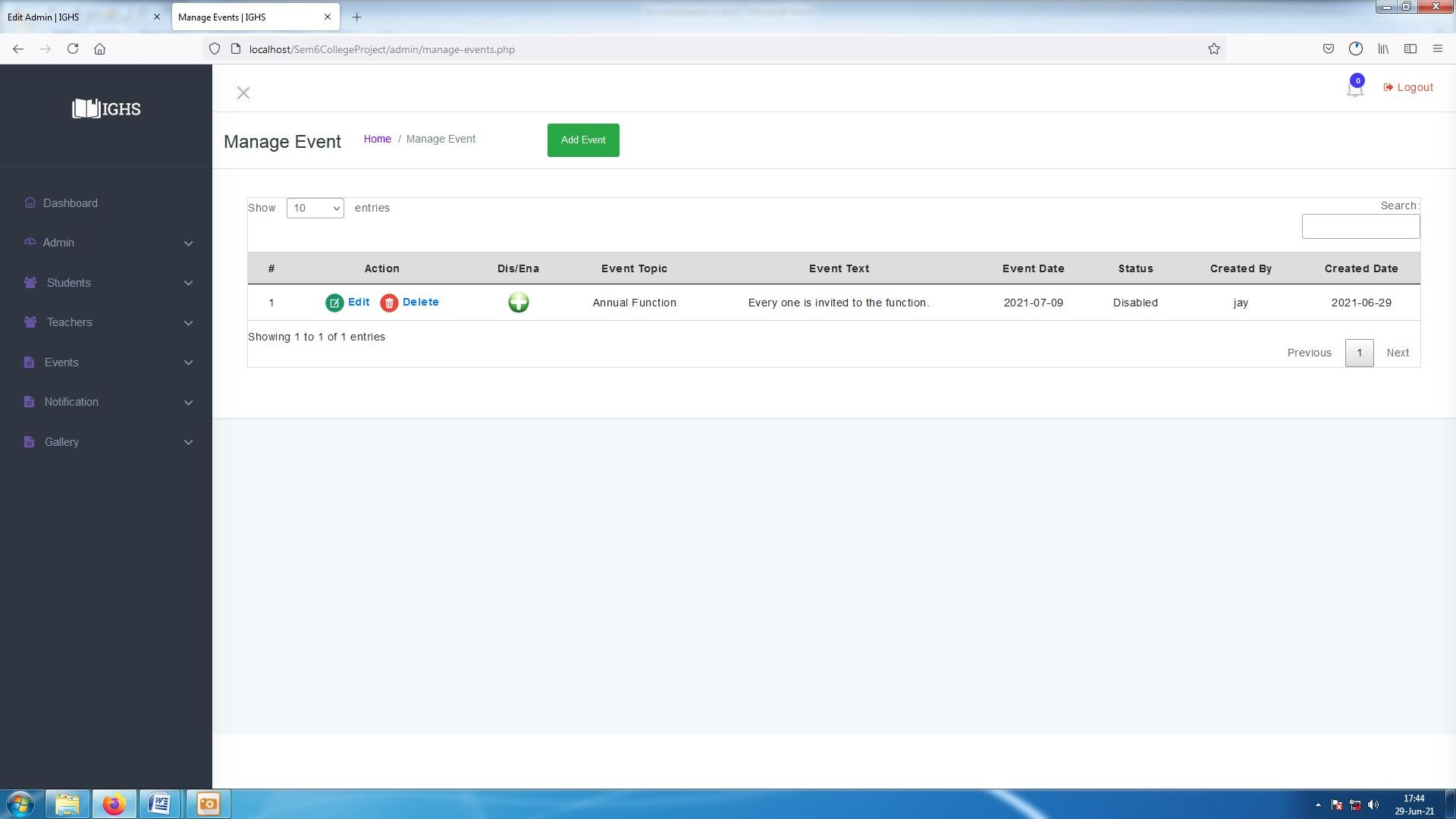

**[ Image 5.3.1-Enable Event]**

* Admin can Enable Previously disabled events so that event can be seen by any user. It can be disabled again

#### Admin : Manage Notification

* In manage Notification features are as below :
  + Add Notification
  + Manage Notification
  + Edit Notification
  + Delete Notification

and its snapshots are as below :-

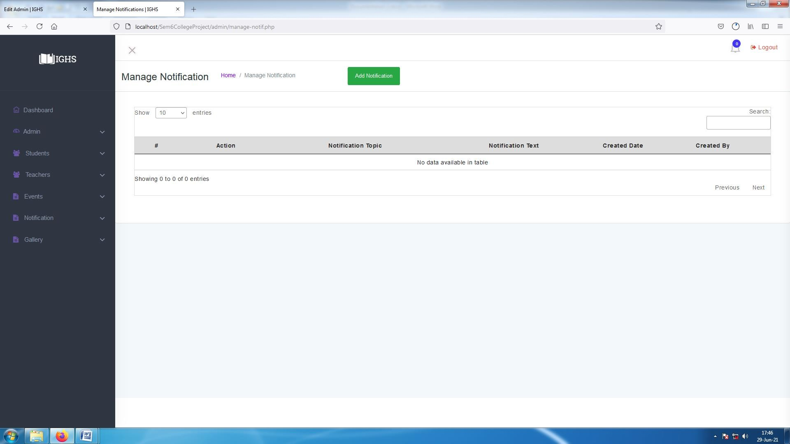

**[ Image 6-Manage Notification page before Adding any notification data]**

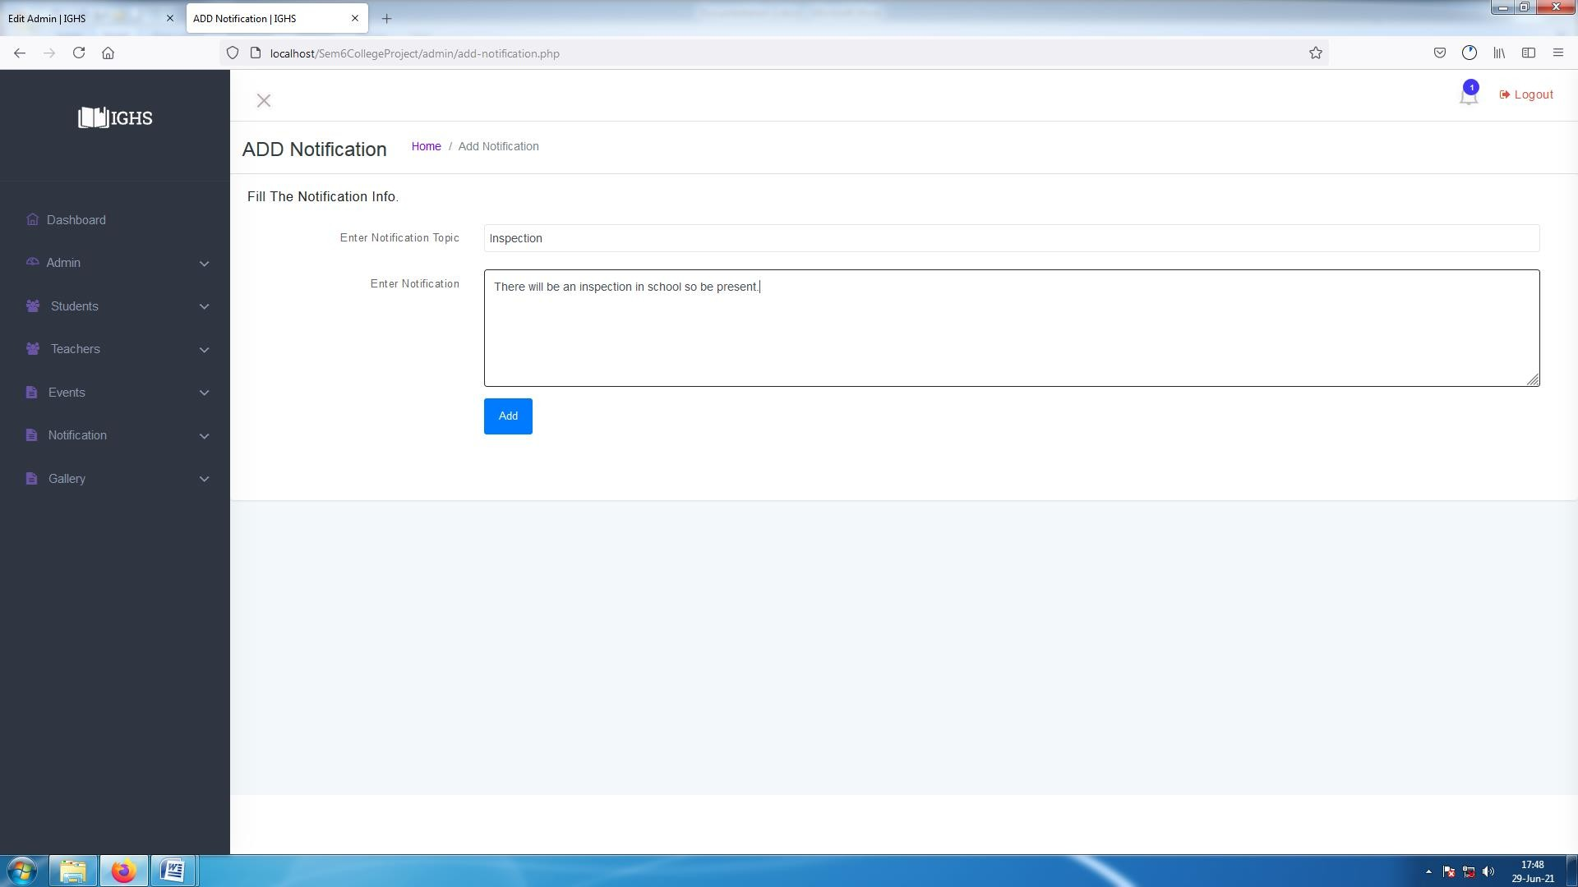

**[ Image 6.1-Add Notification ]**

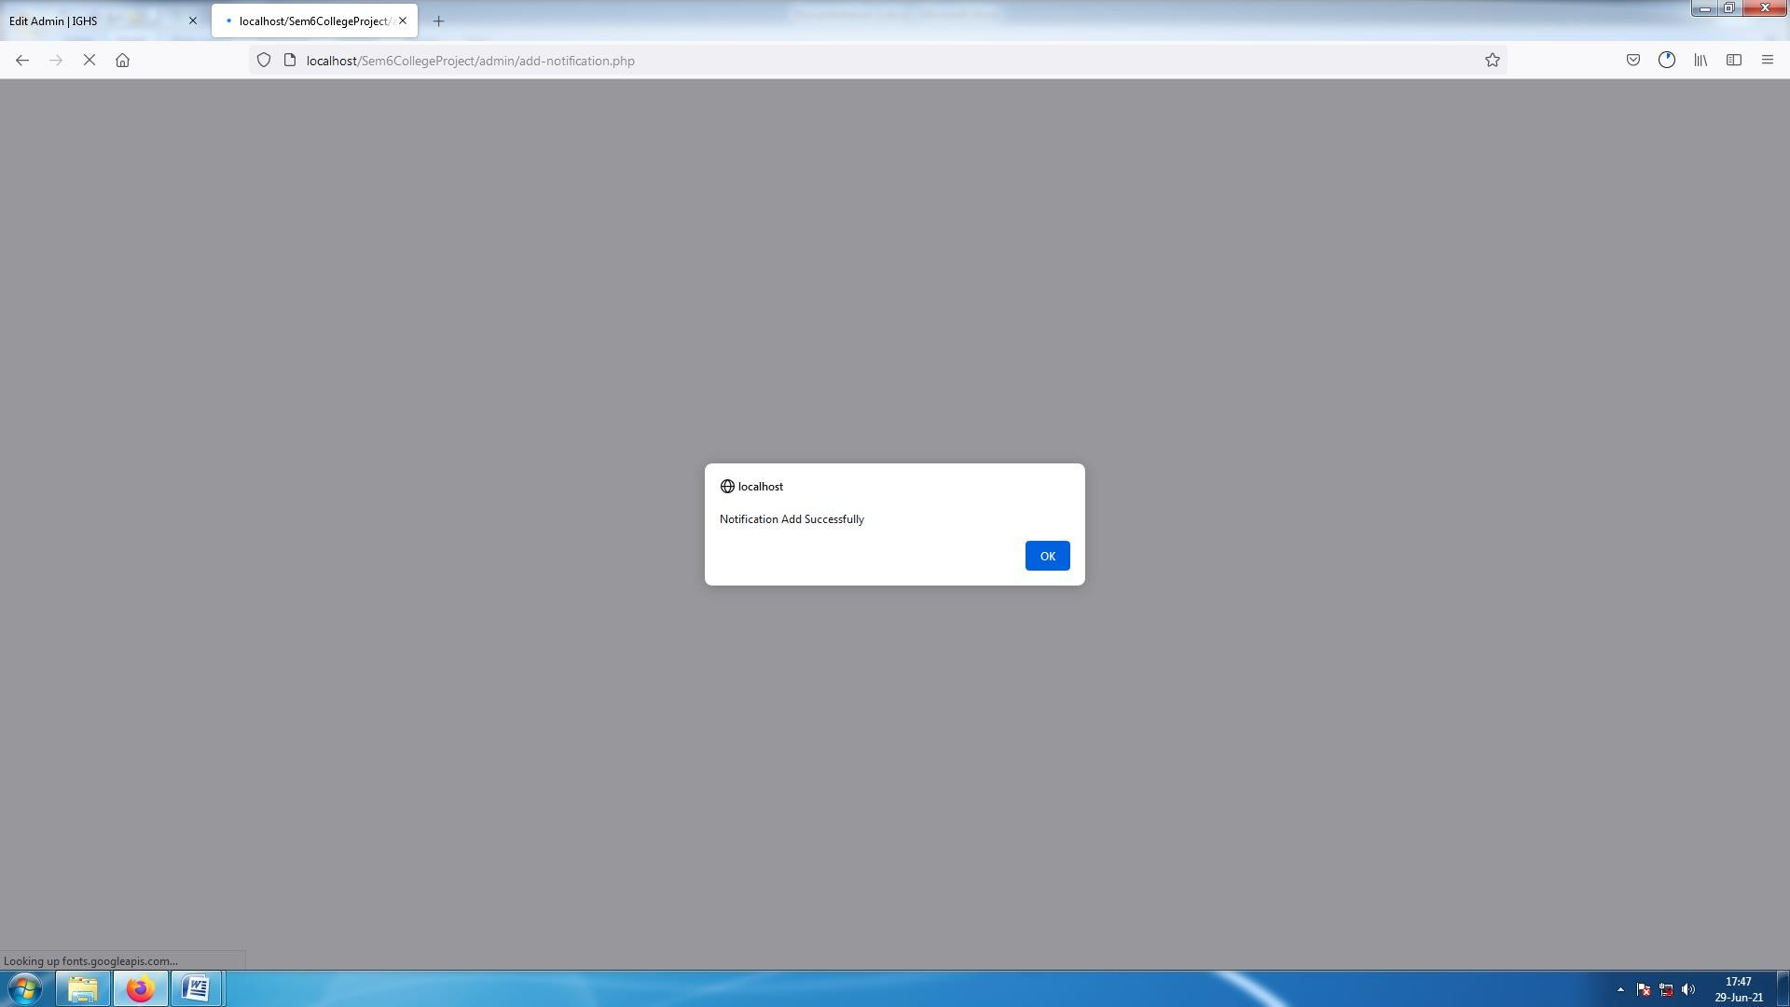

**[ Image 6.1.1-Notification Added Success Alert]**

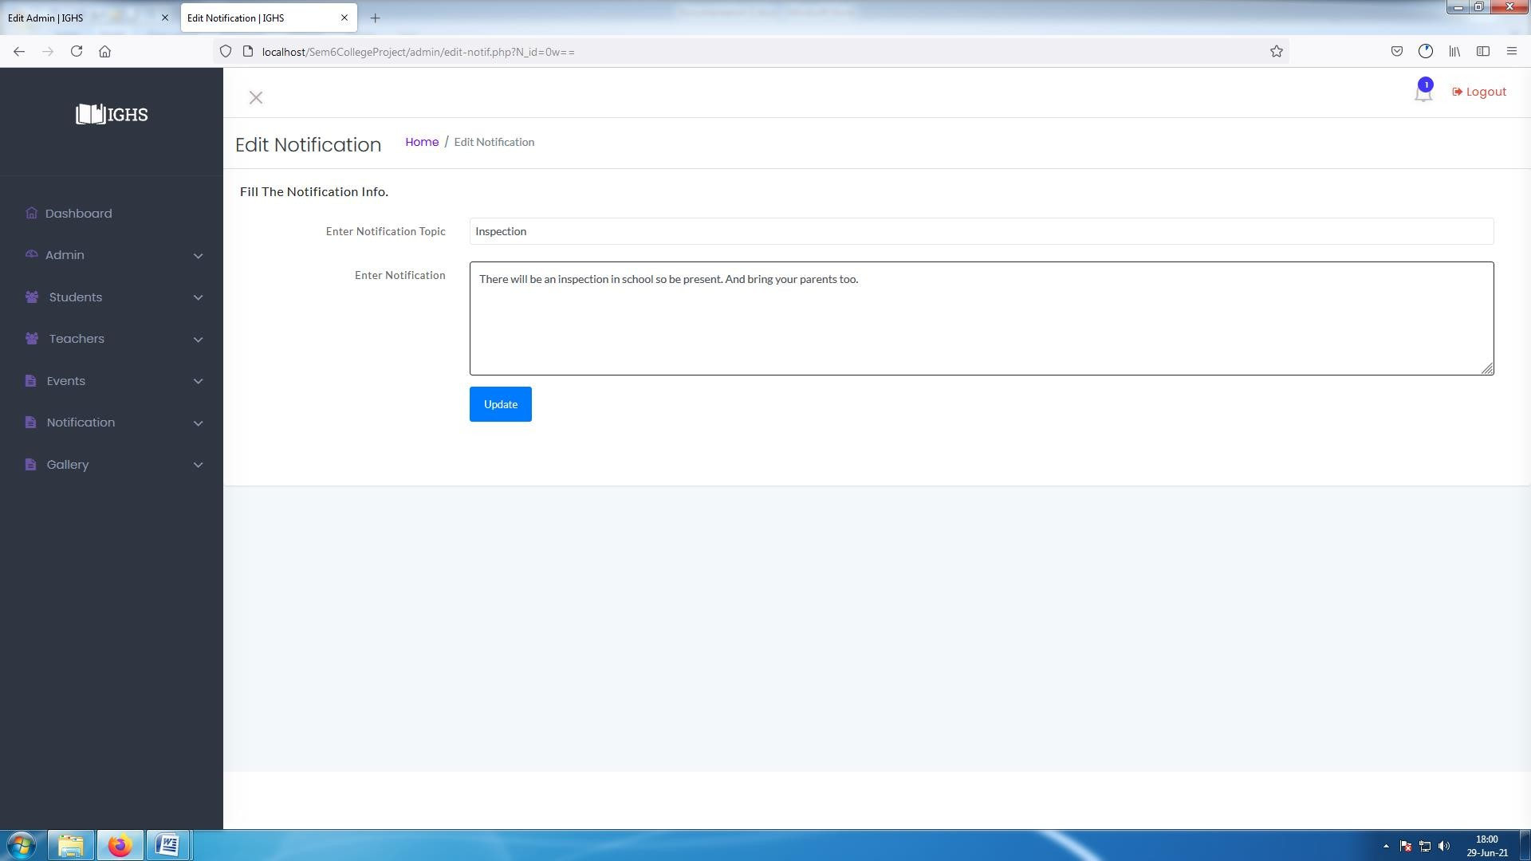

**[ Image 6.2-Edit Existing Notification]**

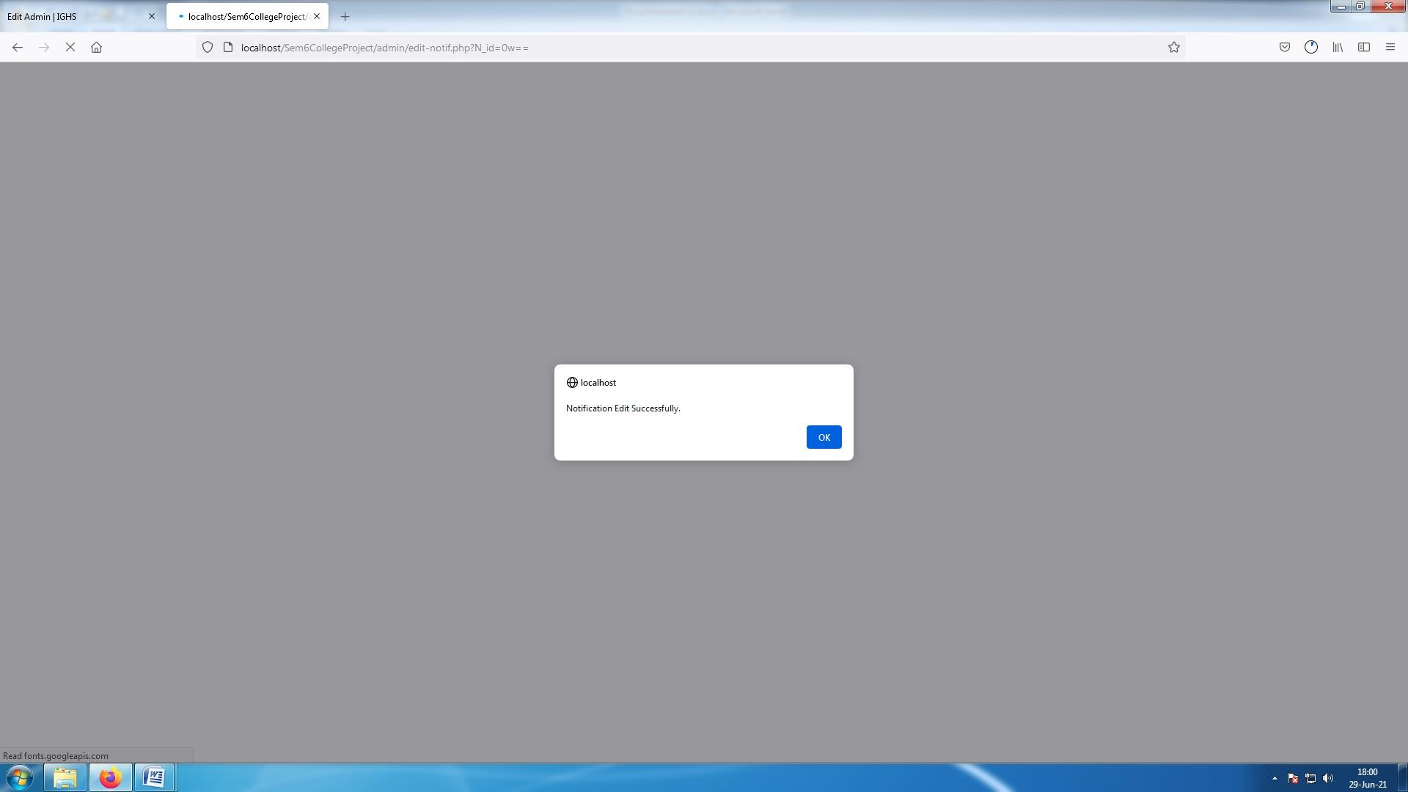

**[ Image 6.2.1- Edited Notification Success Alert ]**

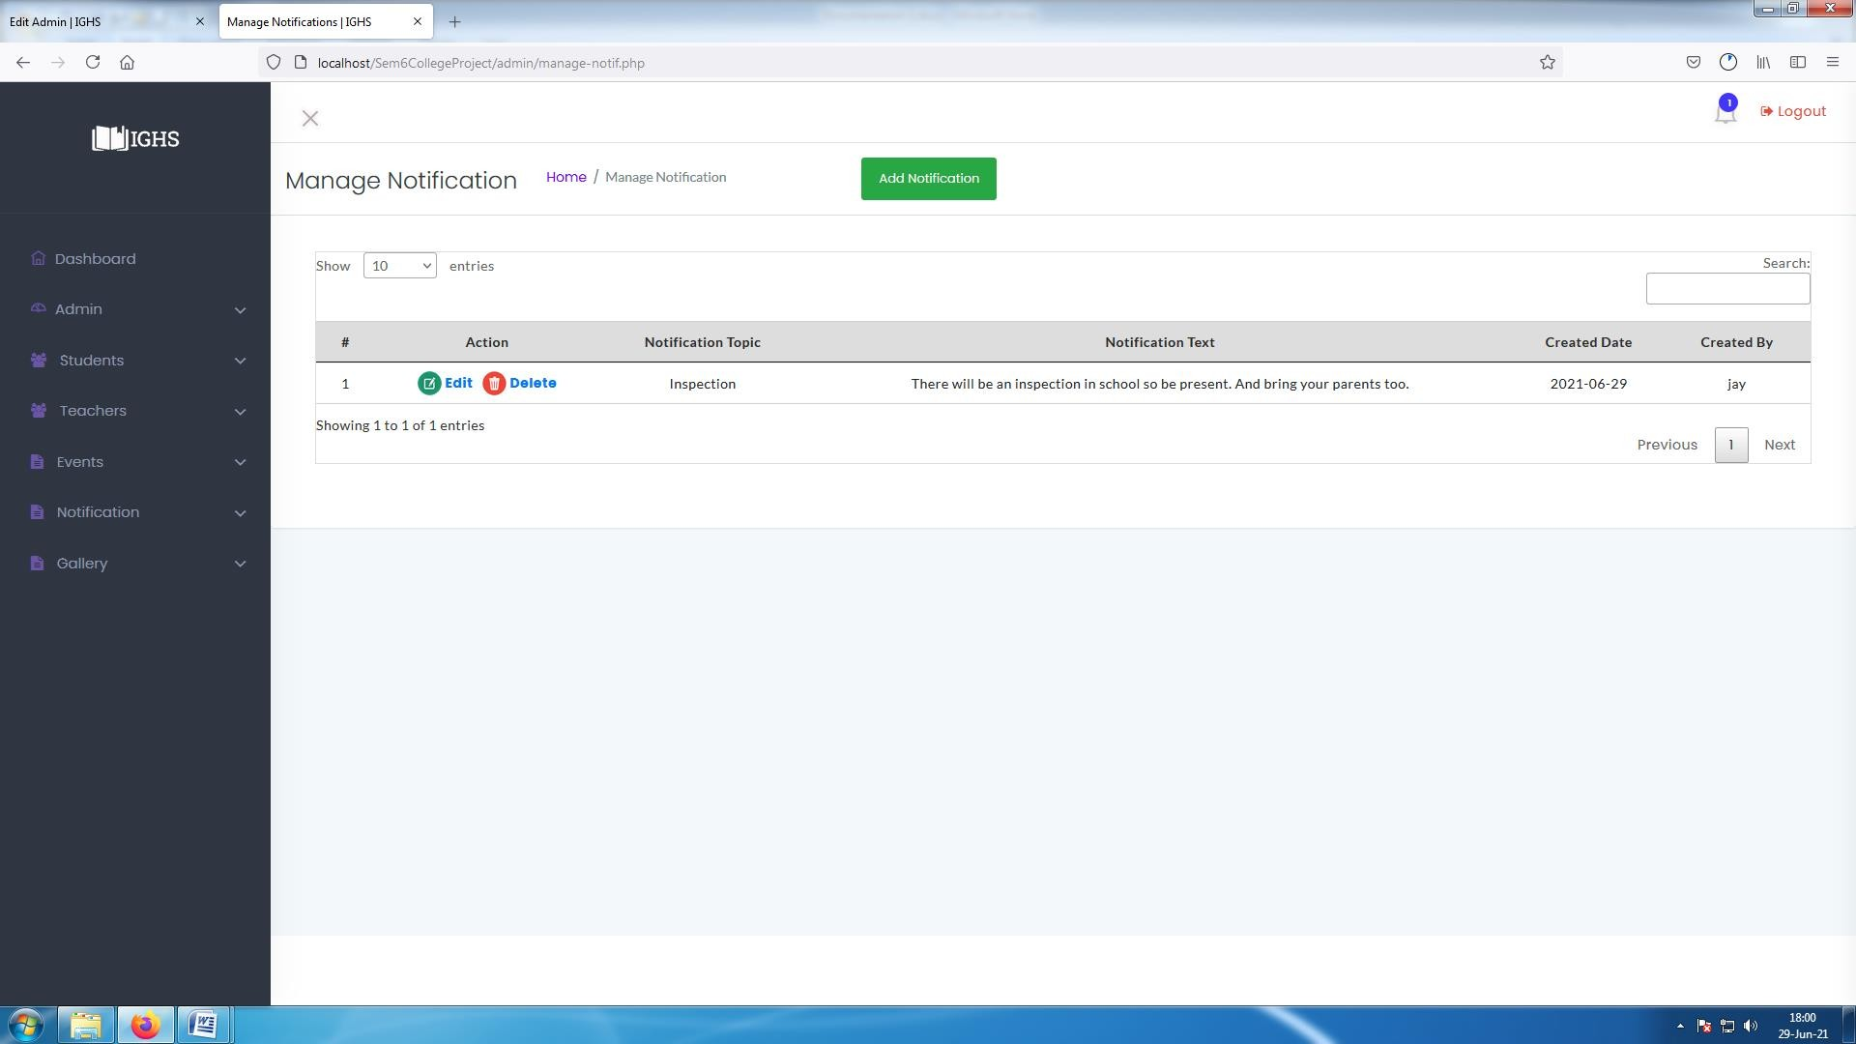

**[ Image 6.3- Manage Notification ]**

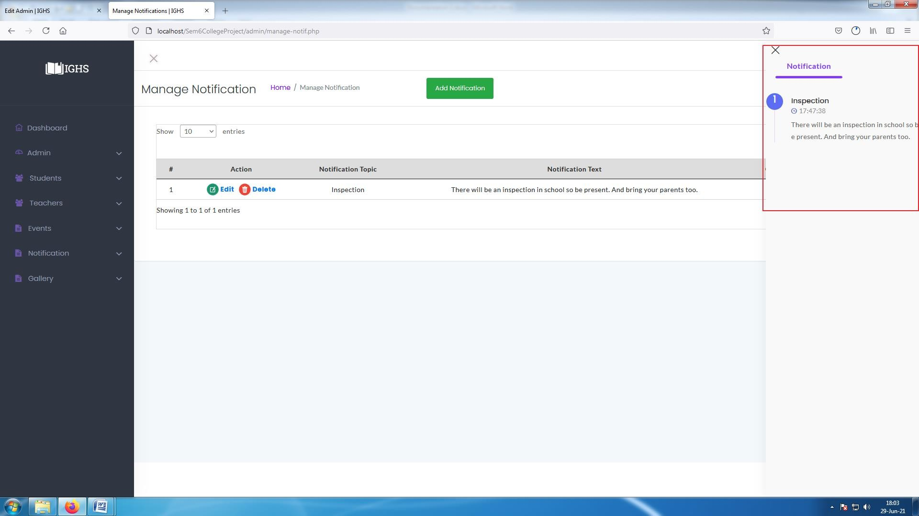

**[ Image 6.3.1- View Notification ]**

* Notification can be seen by clicking on bell icon on top right corner.
* If there is new notification available bell icon will show number of new notifications.

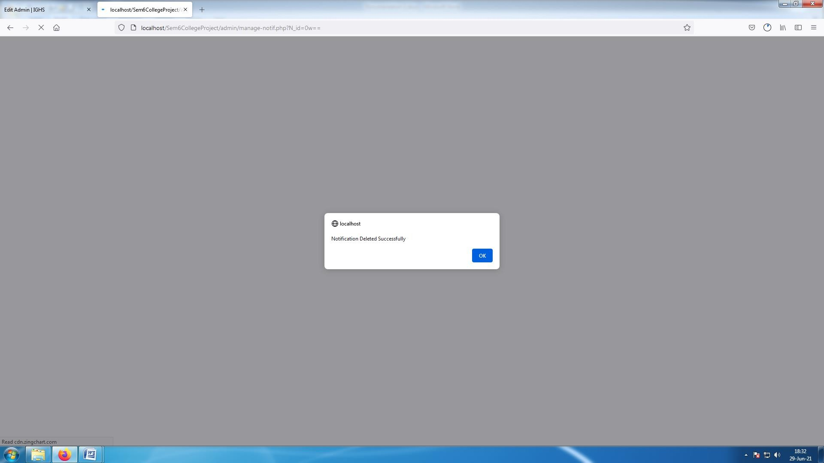

**[ Image 6.4- Deleted Notification Success Message]**

#### Admin : Manage Gallery

* In Manage Gallery features are as below :
  + Add Images
  + Delete Image

and its snapshots are as below :-

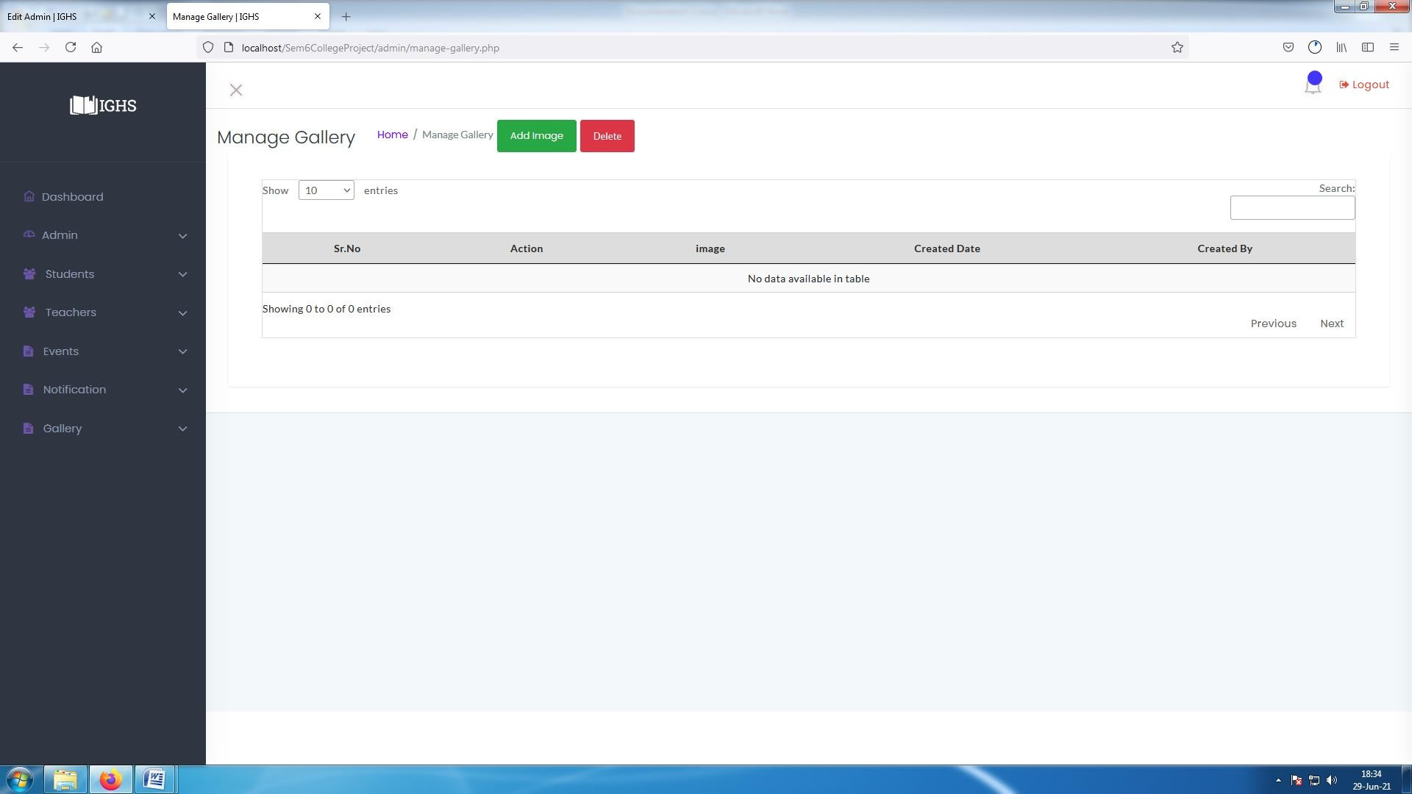

**[ Image 7- Manage Gallery]**

* Admin can upload any event images to the website so every user can see them.

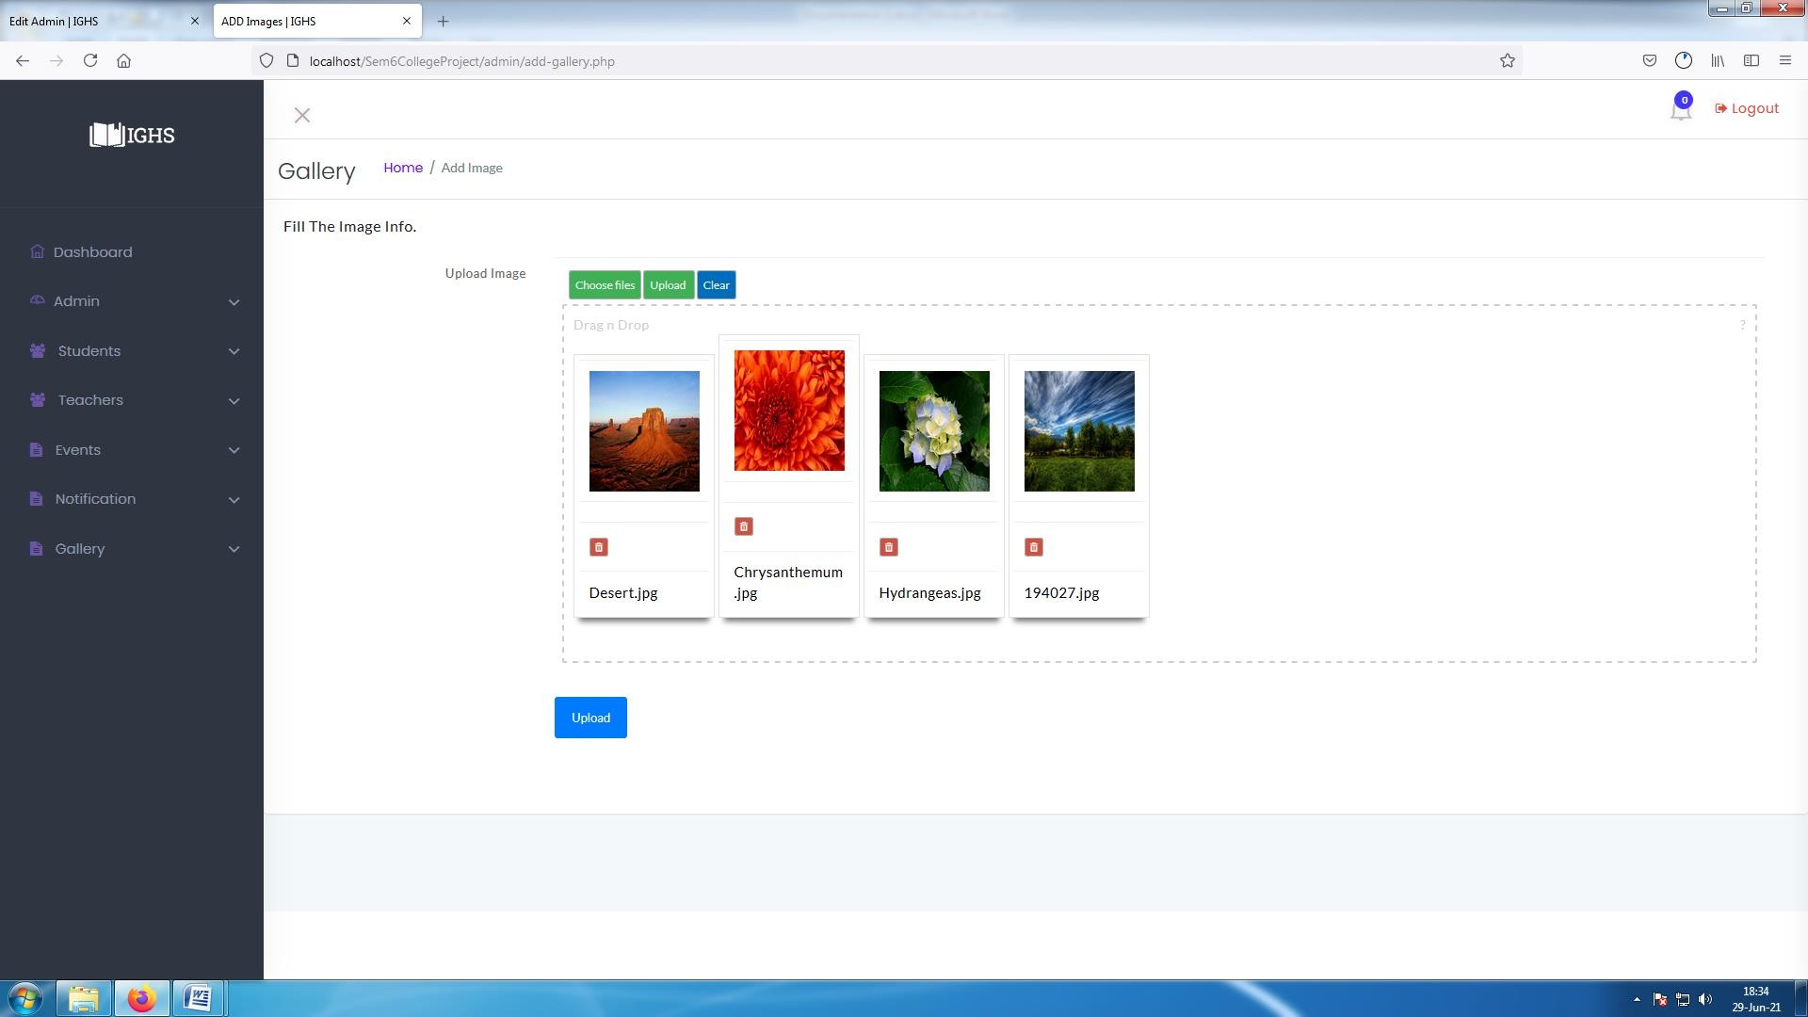

**[ Image 7.1-Add Images]**

* Admin can upload multiple images together by dragging them into specified area or by clicking on "Choose Images".
* Then click on "Upload" to upload images.

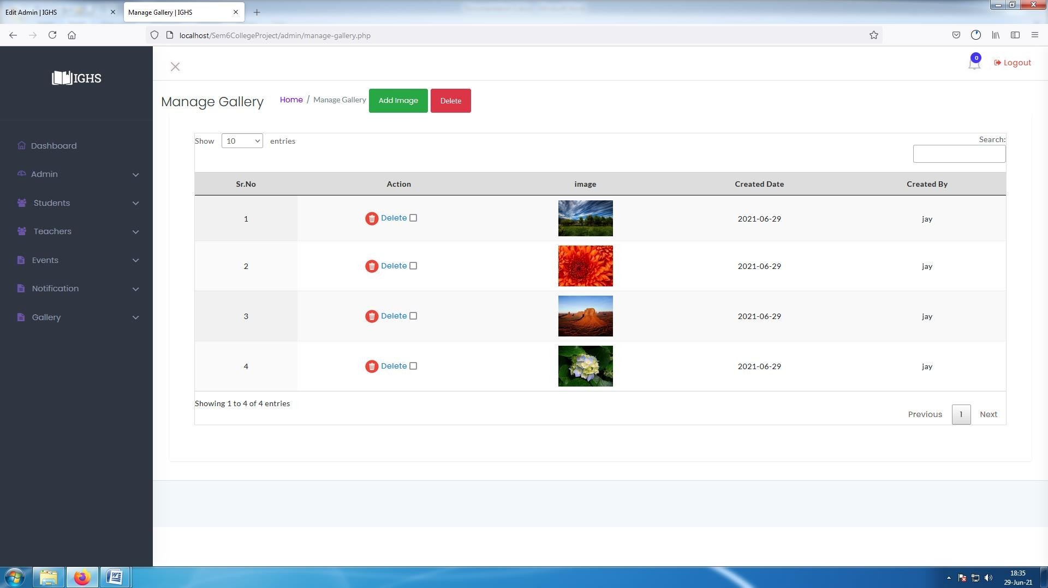

**[ Image 7.2-Manage Images ]**

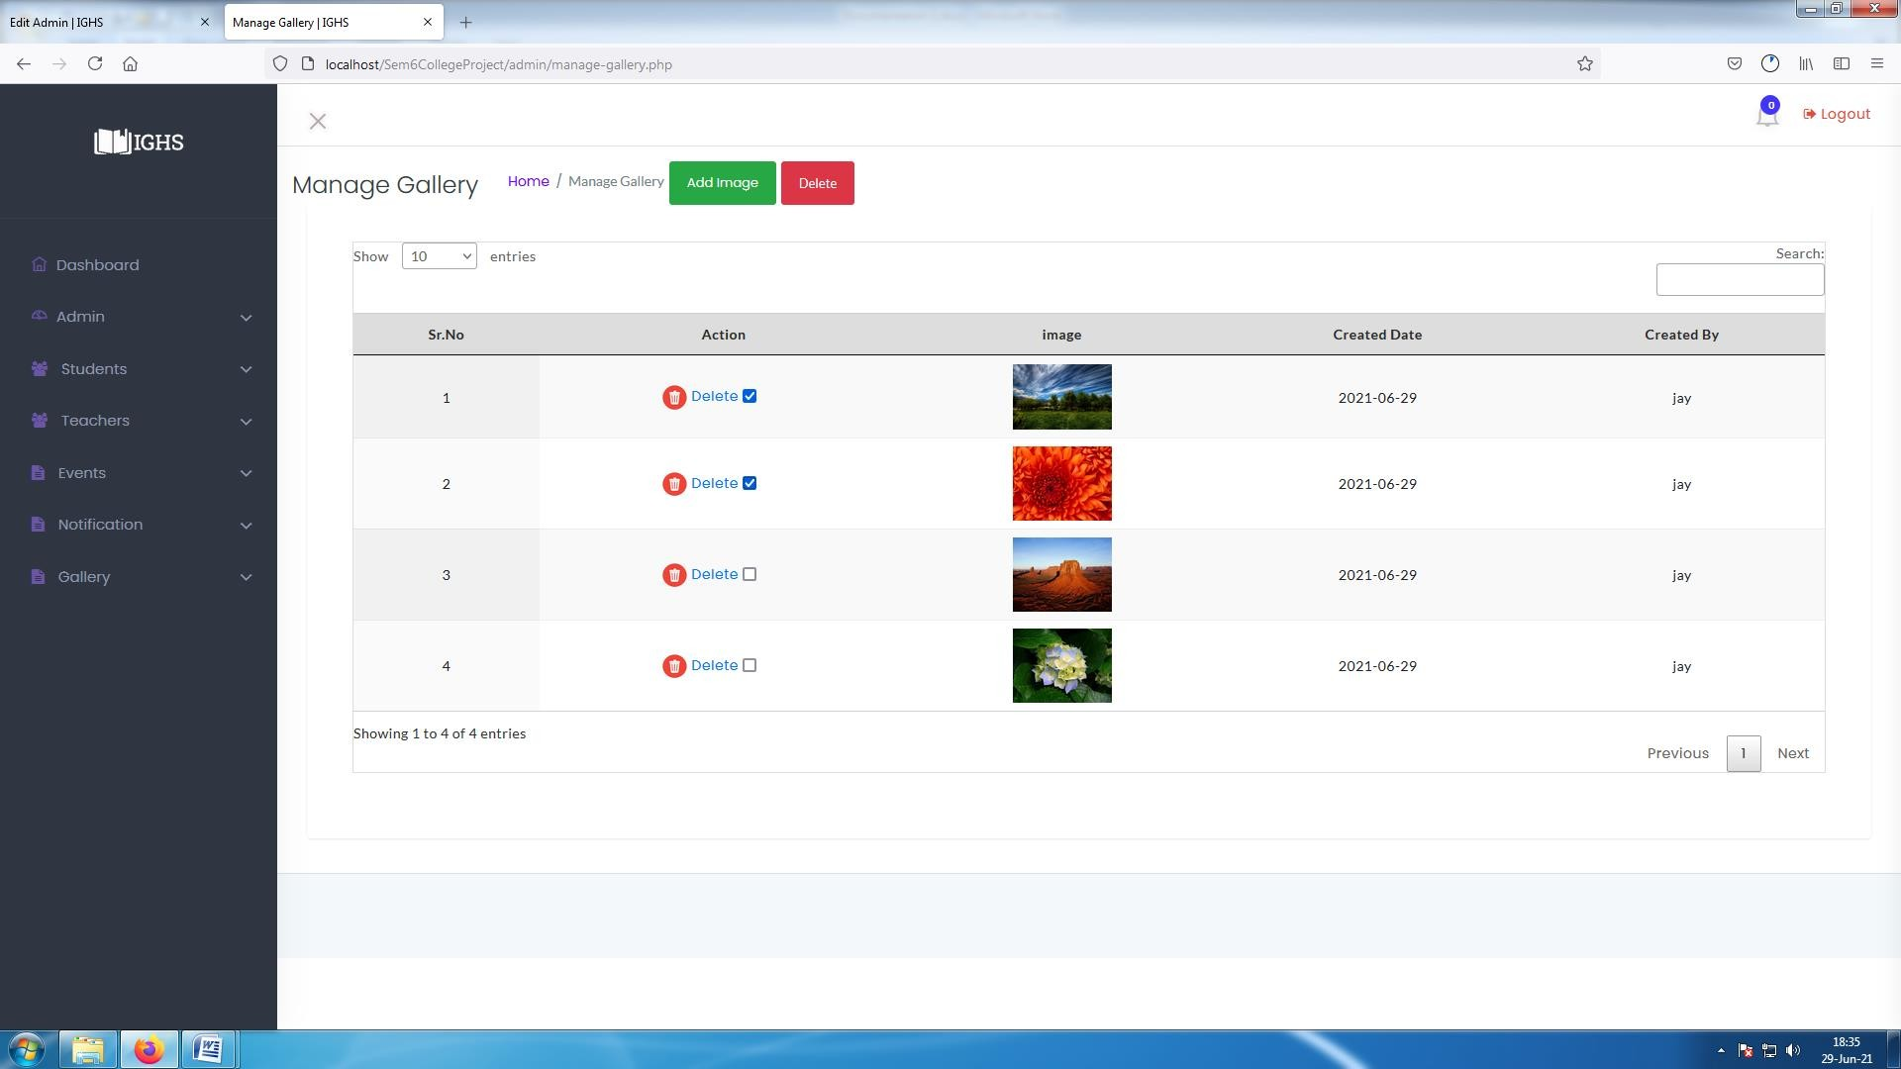

**[ Image 7.3-Delete Images]**

* Admin can delete multiple images or one by one.

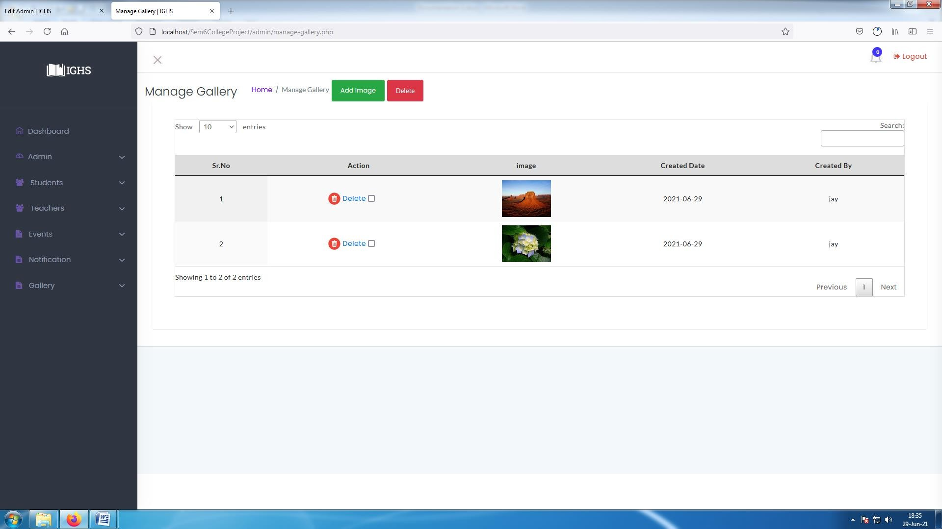

**[ Image 7.3.1-After Deleting selected images ]**

#### Teacher Panel

* In dashboard teachers can access their features, teachers features are as listed below :
  + Upload Resources : Teacher can upload different files.
  + Delete Resources : Teacher can delete uploaded files.
  + Download Resources : Teacher can download uploaded files.
  + Reply to Students Message : Teacher can message students.
  + Delete Conversation : Teacher can delete conversation for their side only.
  + Checkout Events : Teacher can see Events.
  + Checkout Gallery images : Teacher can see Gallery Images.
  + Reselect subjects : Teacher can reselect their own subjects . and its snapshots are as below :-

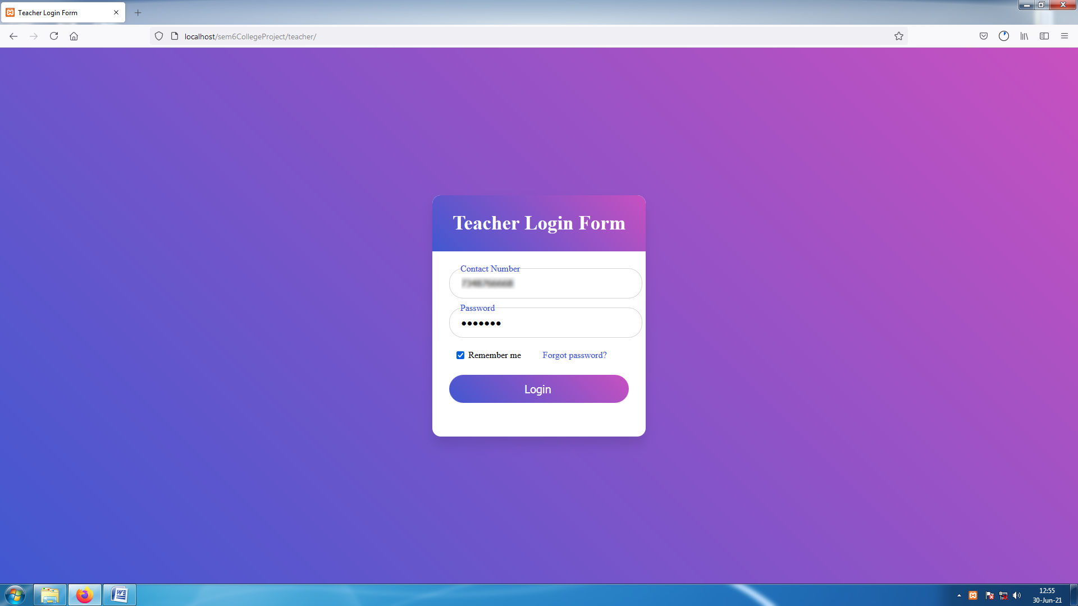

**[ Image 8- Teacher Login page ]**

* Teacher can also use forgot password as shown in admin **image 1.1**, **image 1.2** and **image 1.3.**

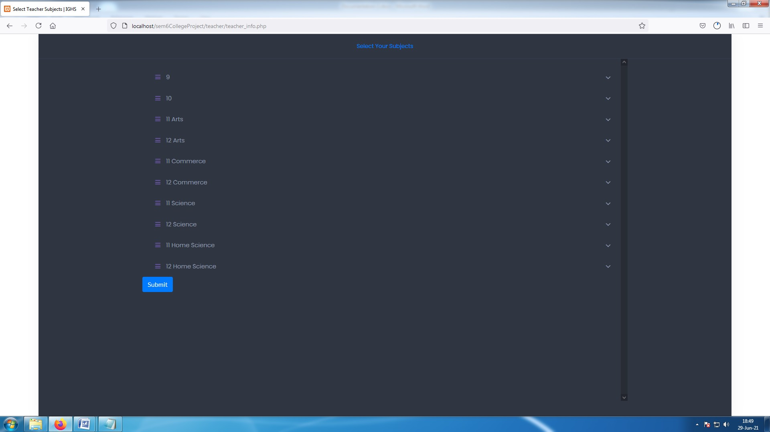

##### [Image 8.0.1- Select Subjects]

* Teacher will have to select subjects from the class list
* It is mandatory to select at least one subject in any class.
* this page will appear one time only. But teacher can change their subjects later too.

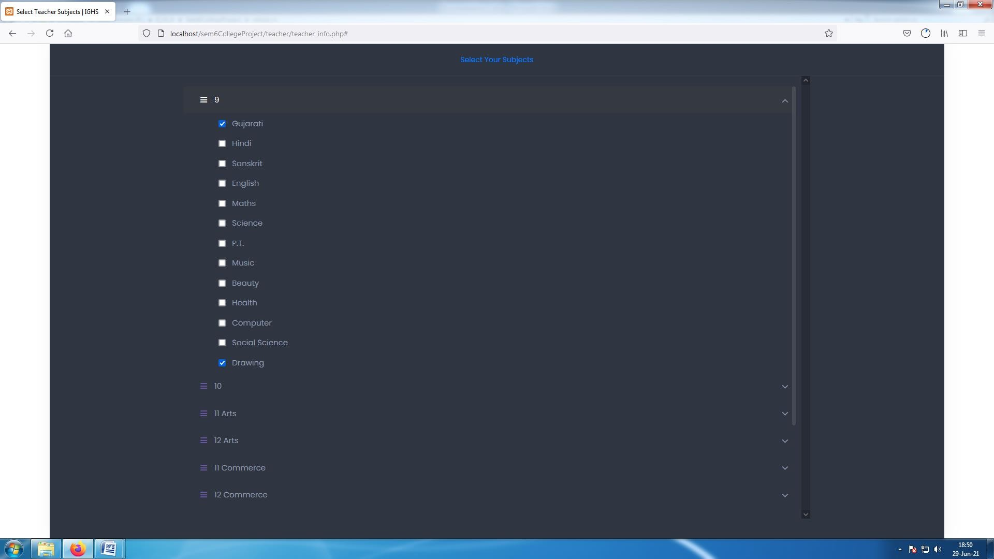

##### [ Image 8.0.2-Selecting subjects]

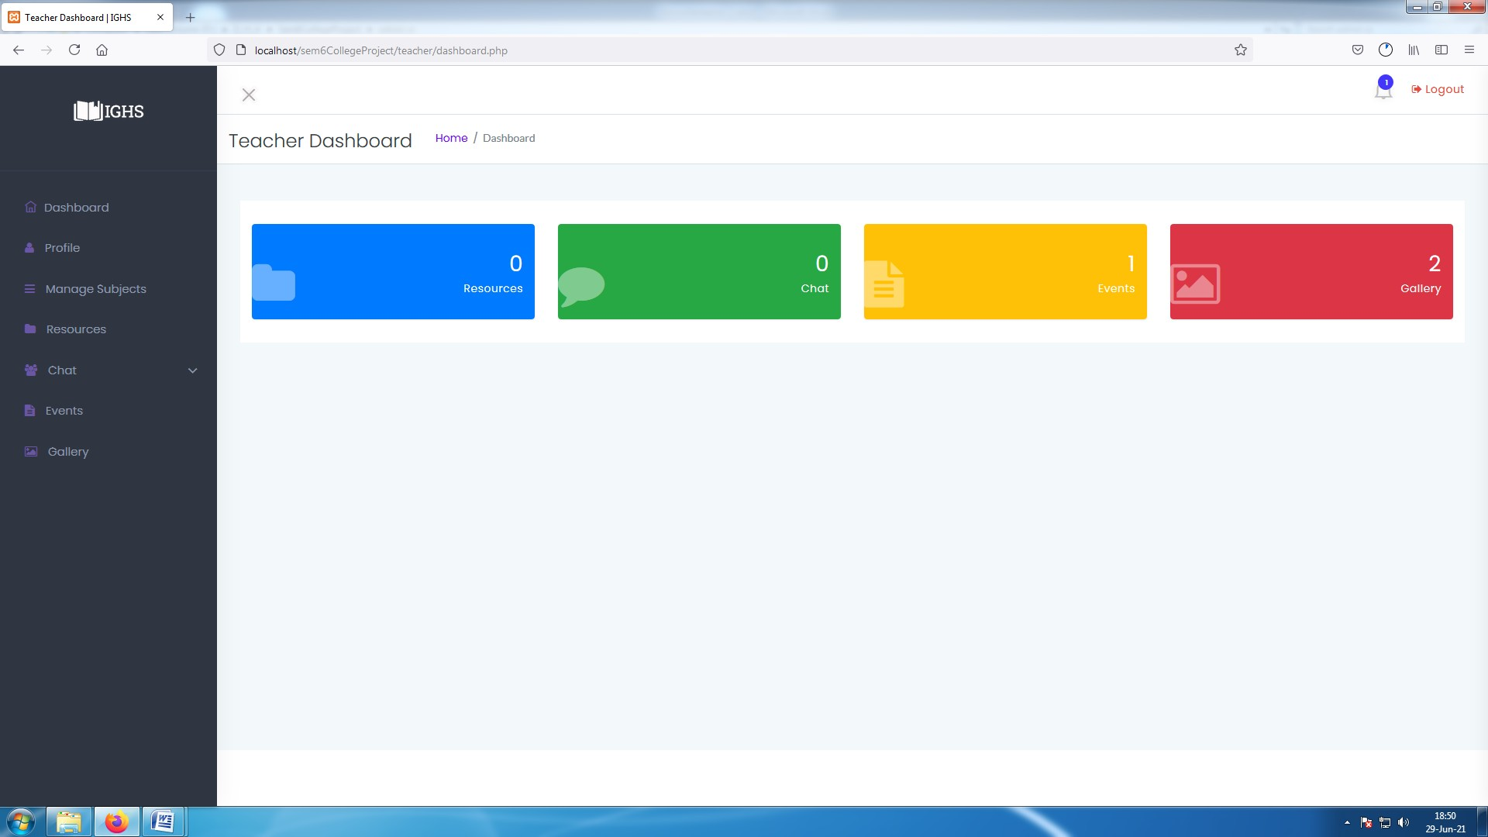

**[ Image 8.1-Teacher Dashboard ]**

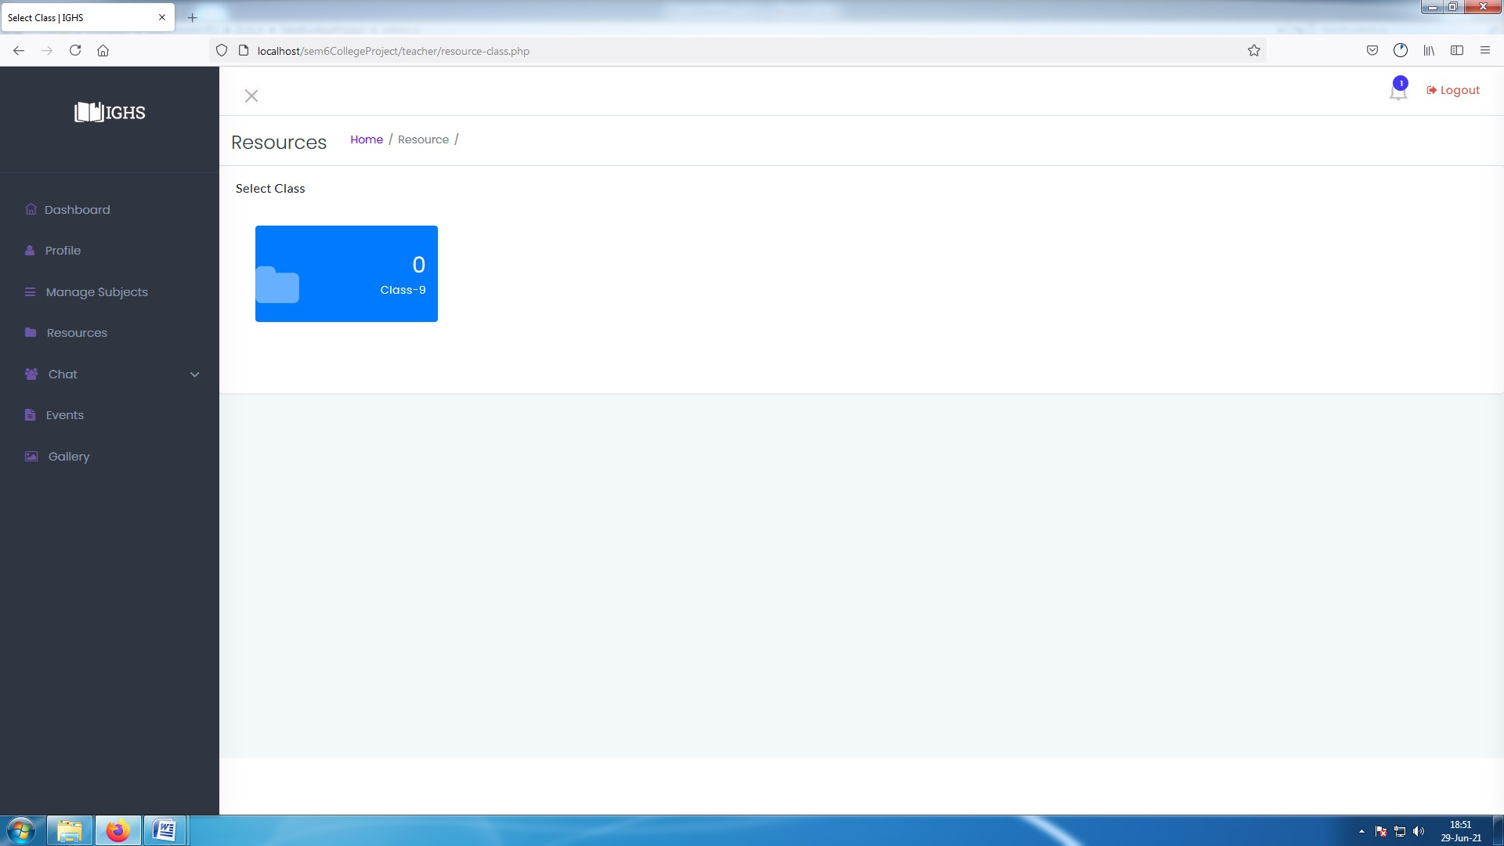

**[ Image 8.2-Select class ]**

* To upload teacher will need to select class .
* Teacher will see only those class which they selected

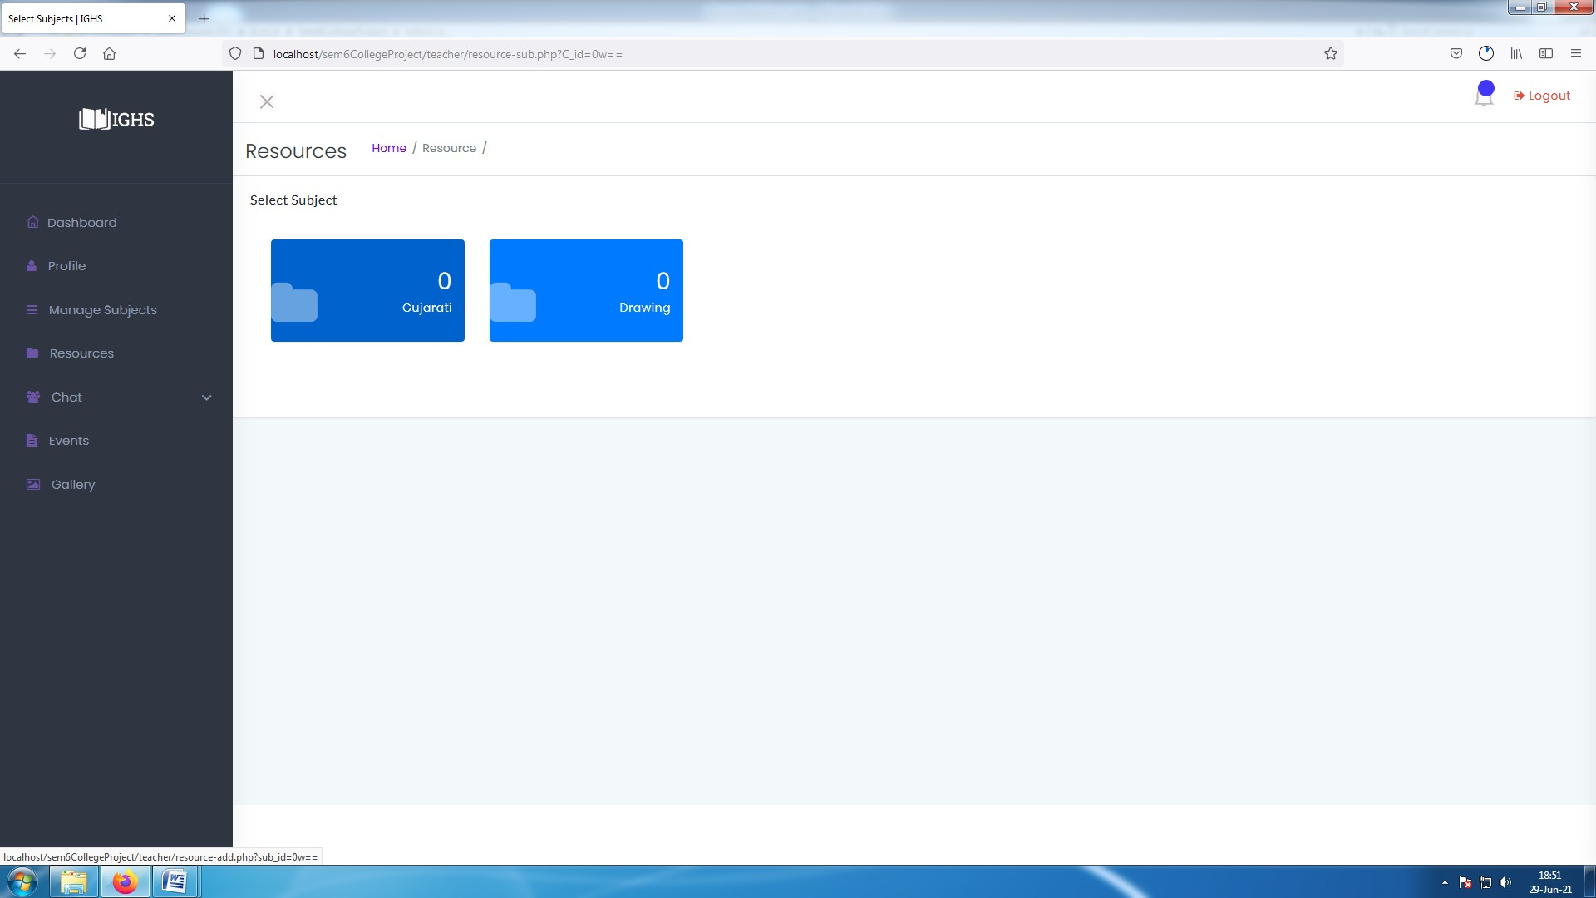

##### [ Image 8.2.1-Select Subject ]

* Teacher will need to select subject to upload resources.
* Teacher will see only those subject which they selected.

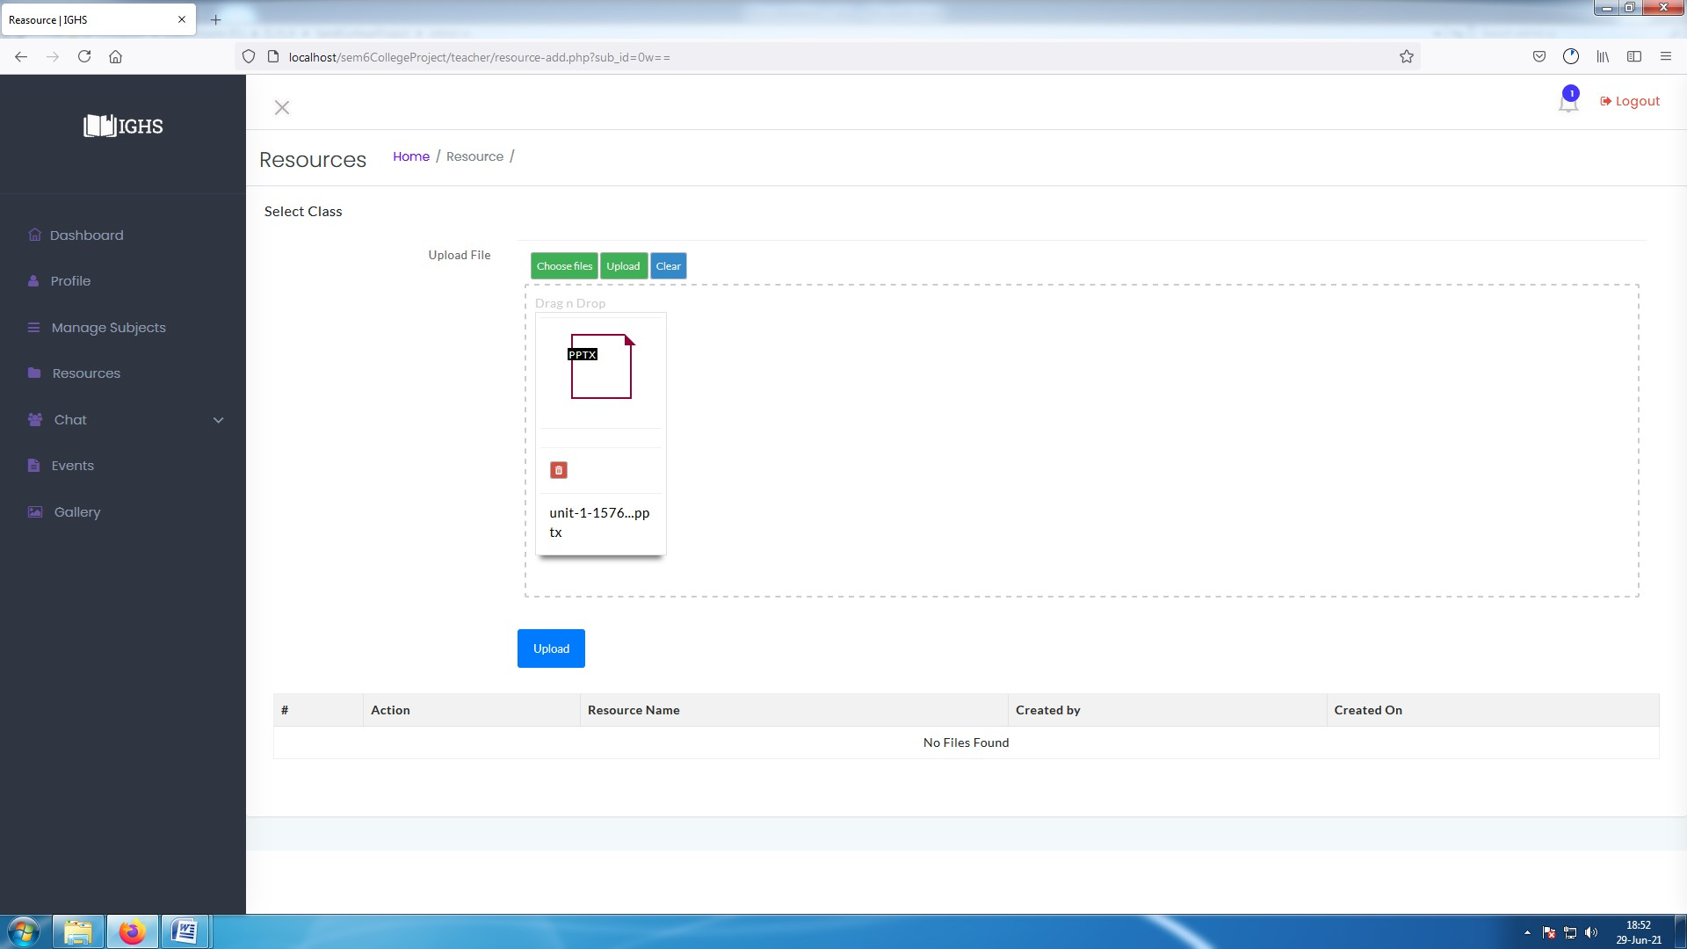

##### [ Image 8.3-Upload Resource files ]

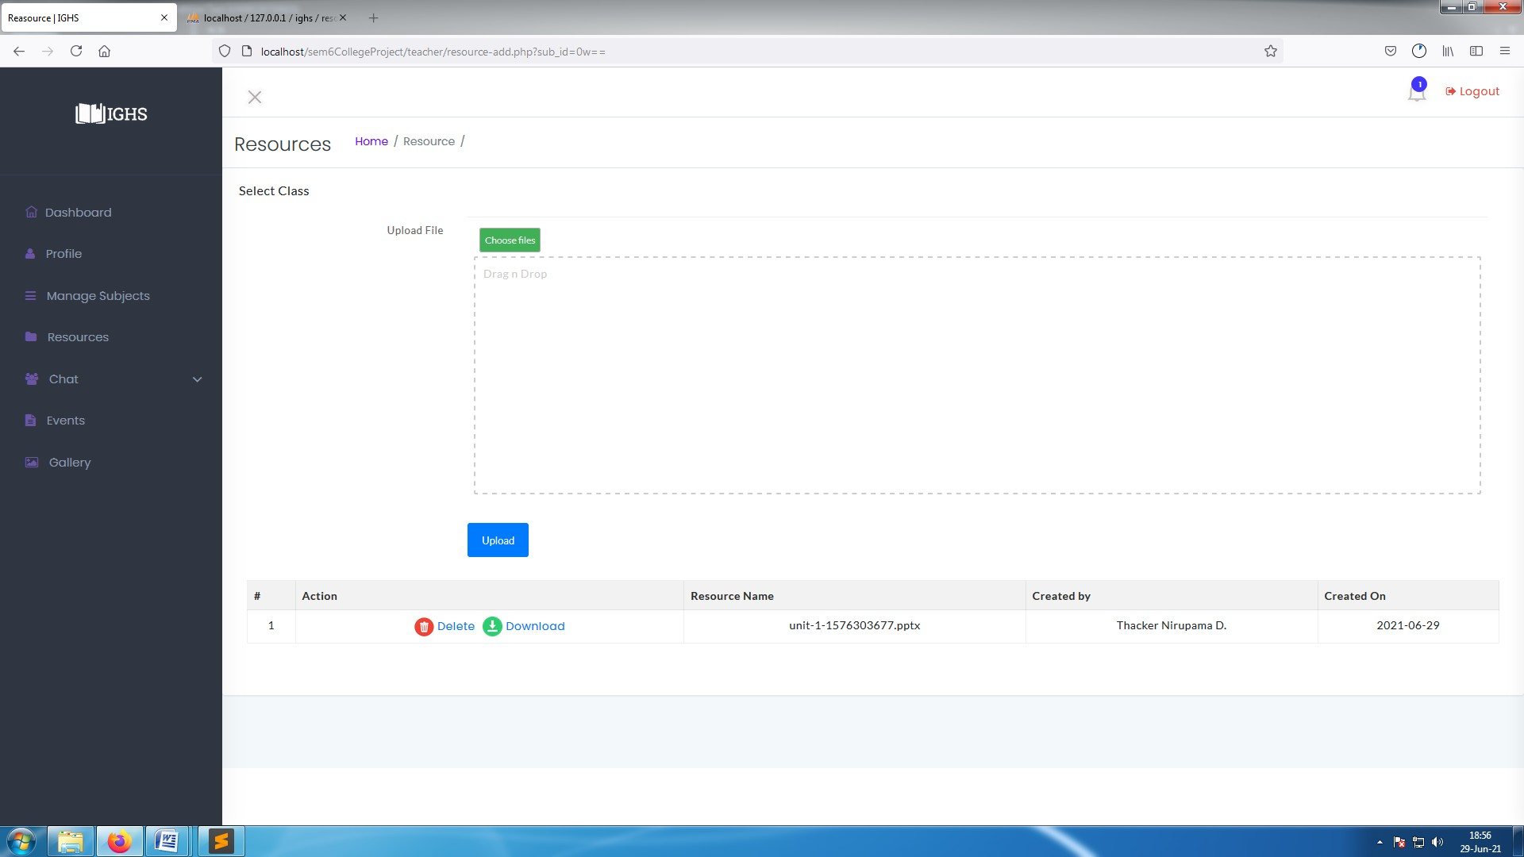

**[ Image 8.3.1-Resources ]**

* Teachers can delete or download those resource files which they uploaded.

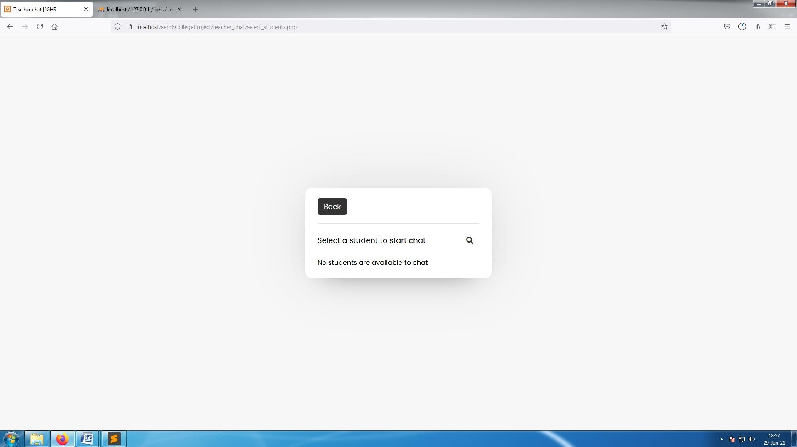

##### [ Image 8.4- Chat section ]

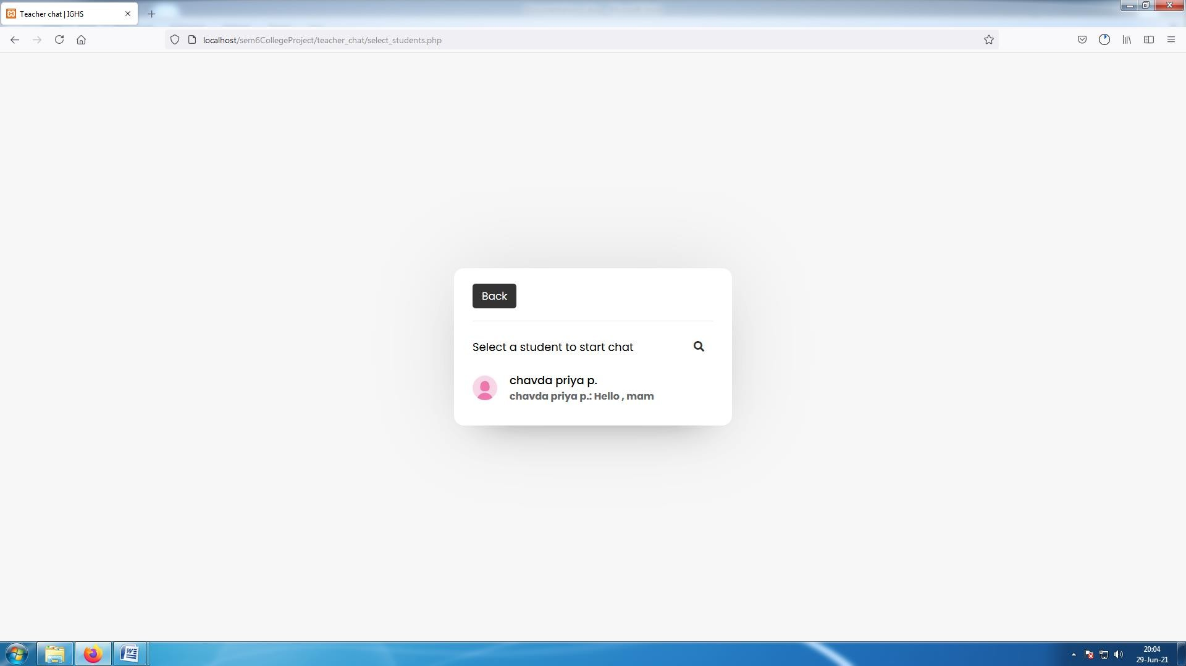

**[ Image 8.4.1-Chat After receiving message ]**

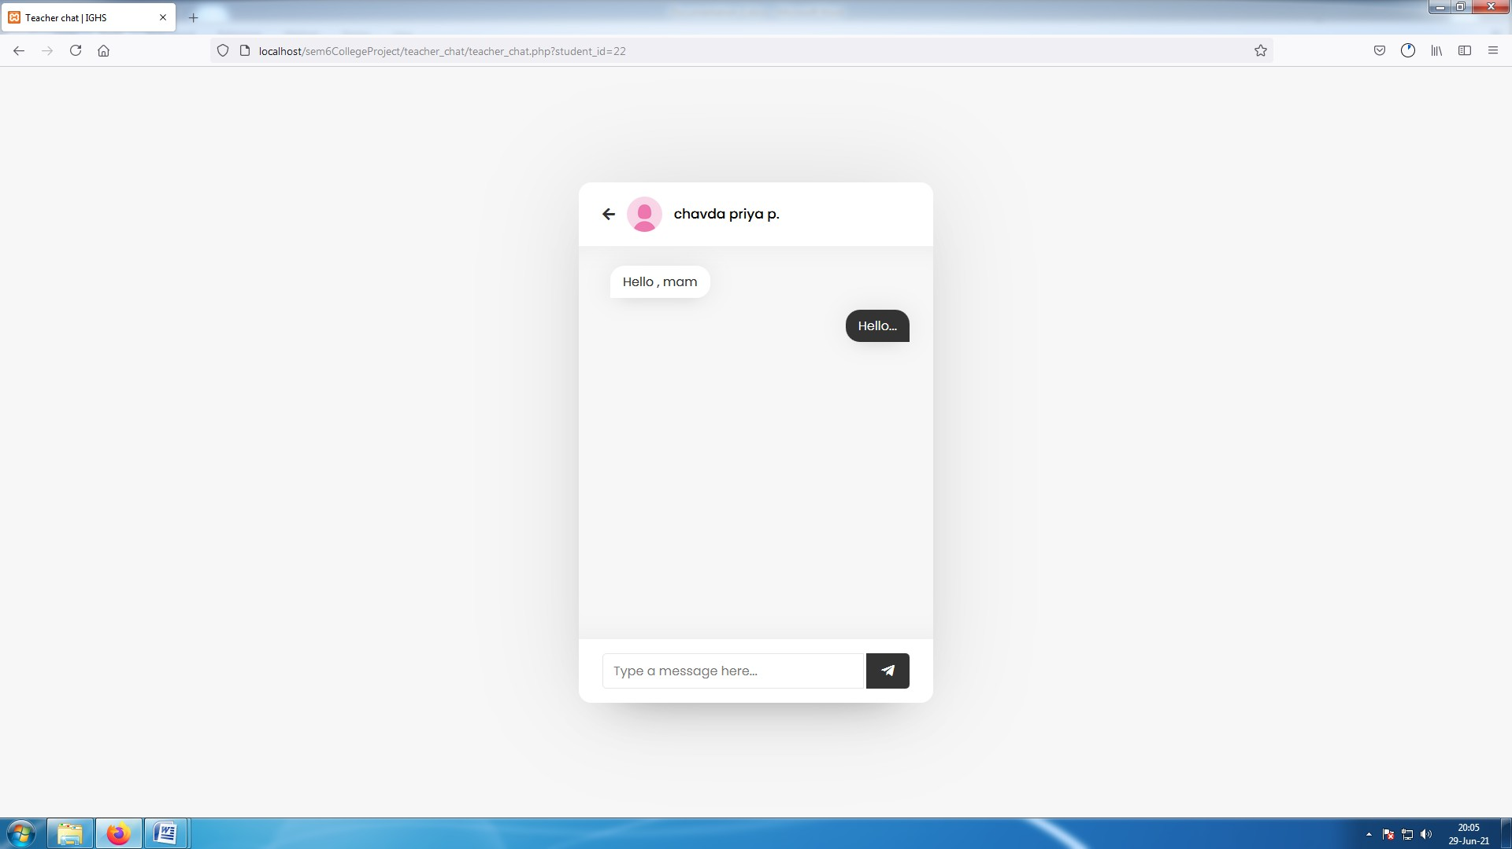**[ Image 8.4.2-Conversation ]**

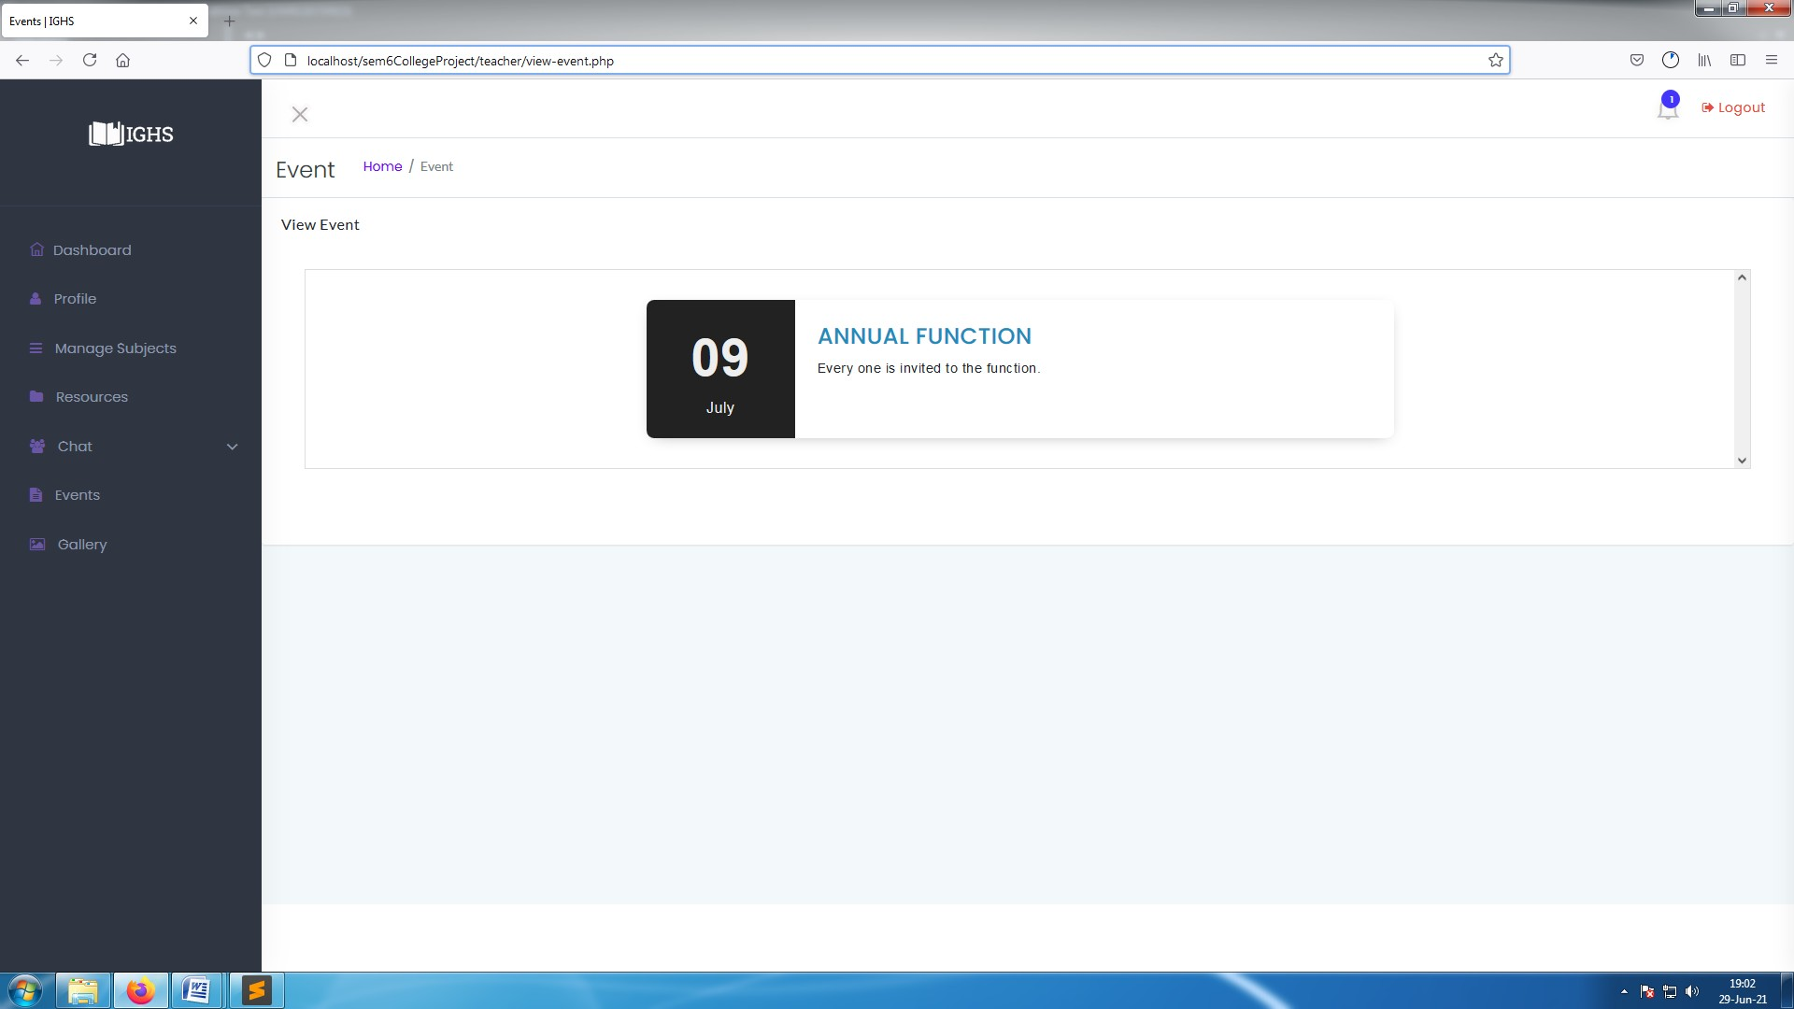

##### [ Image 8.5- Event Details ]

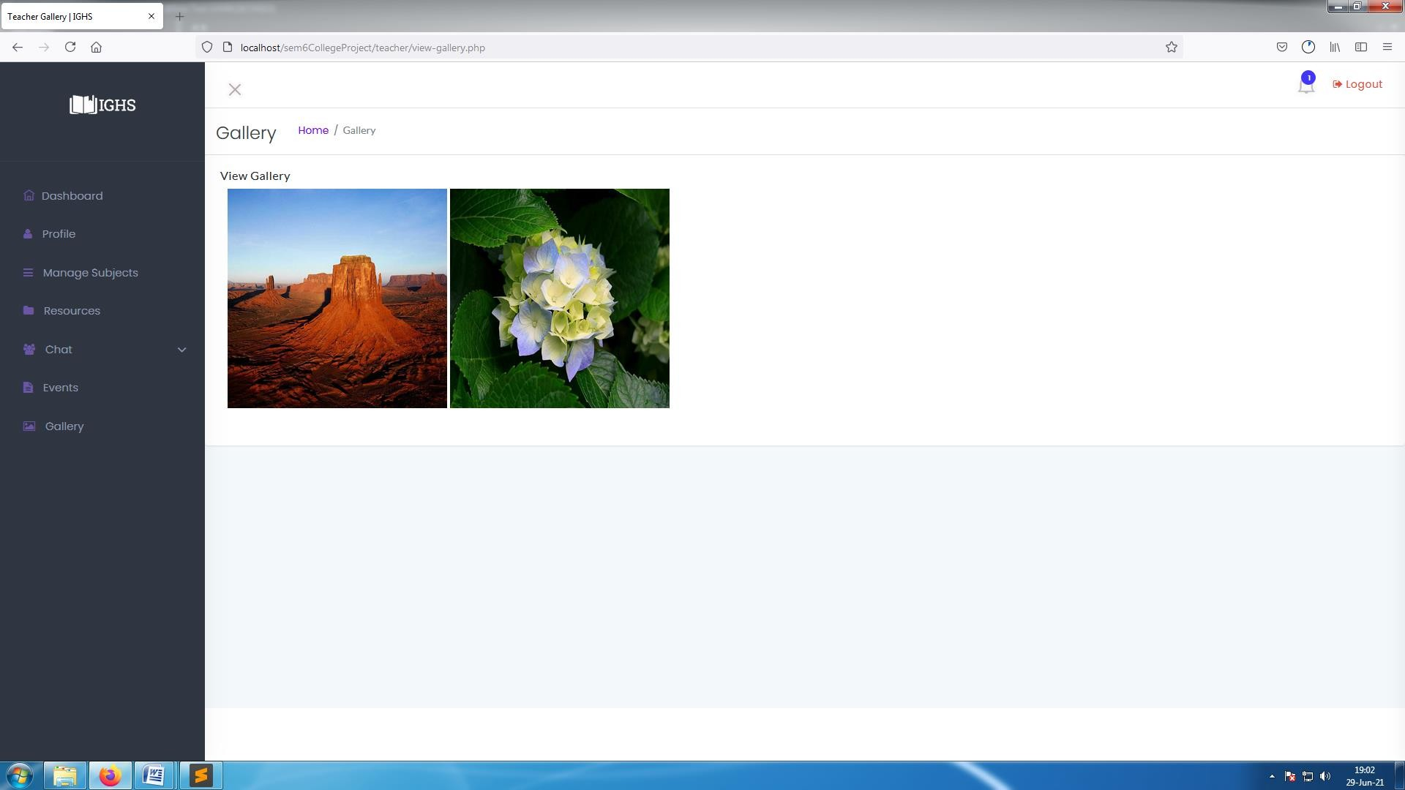

**[ Image 8.6-View gallery]**

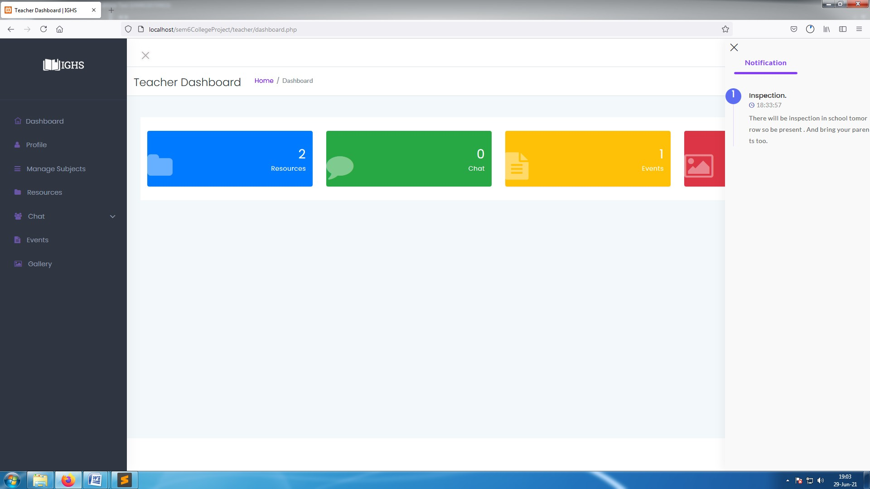

**[ Image 8.7-View Notifications]**

**Student : Panel**

* + In main window Student can see a image slider with school's Images and access other features as listed below : -
  + Downloads Resources : Students can download Resources uploaded by their subject teacher .
  + Gallery : Students can access Gallery images uploaded by admins.
  + Profile : Students can access their own profiles and change password.
  + Chat : Students can message any teacher to solve their queries.
  + Notification : Students can receive notification from admin . and its snapshots are as below :-

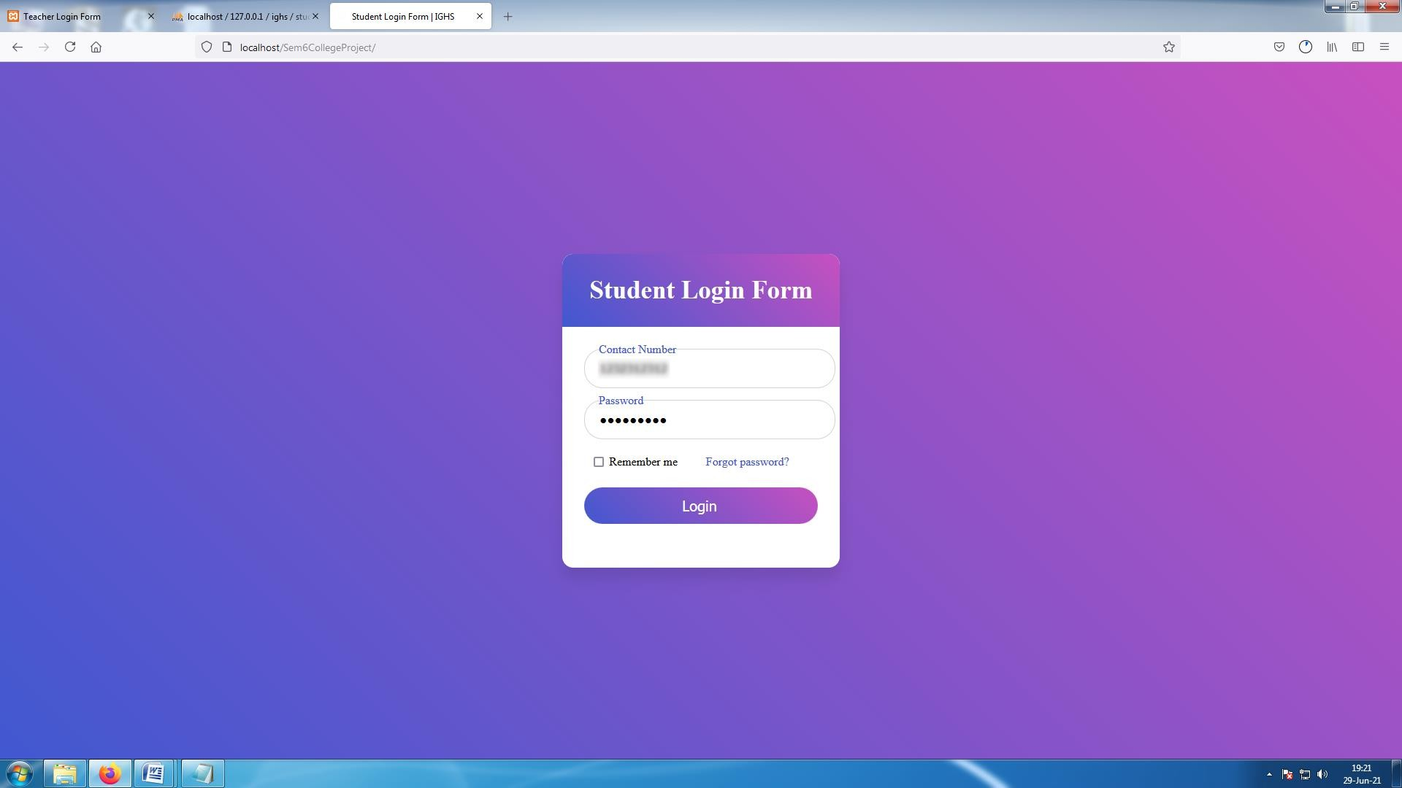

##### [ Image 9-Student Login page]

* Students can also use forgot password as shown in admin **image 1.1**, **image 1.2** and **image 1.3.**

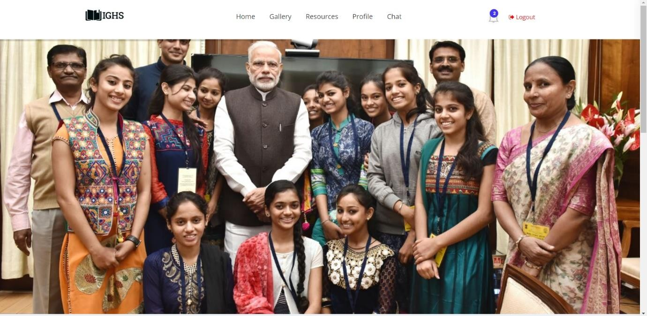

**[ Image 9.1-Home page / Image Slider]**

* Students can see Sliding images and Event details on home page .

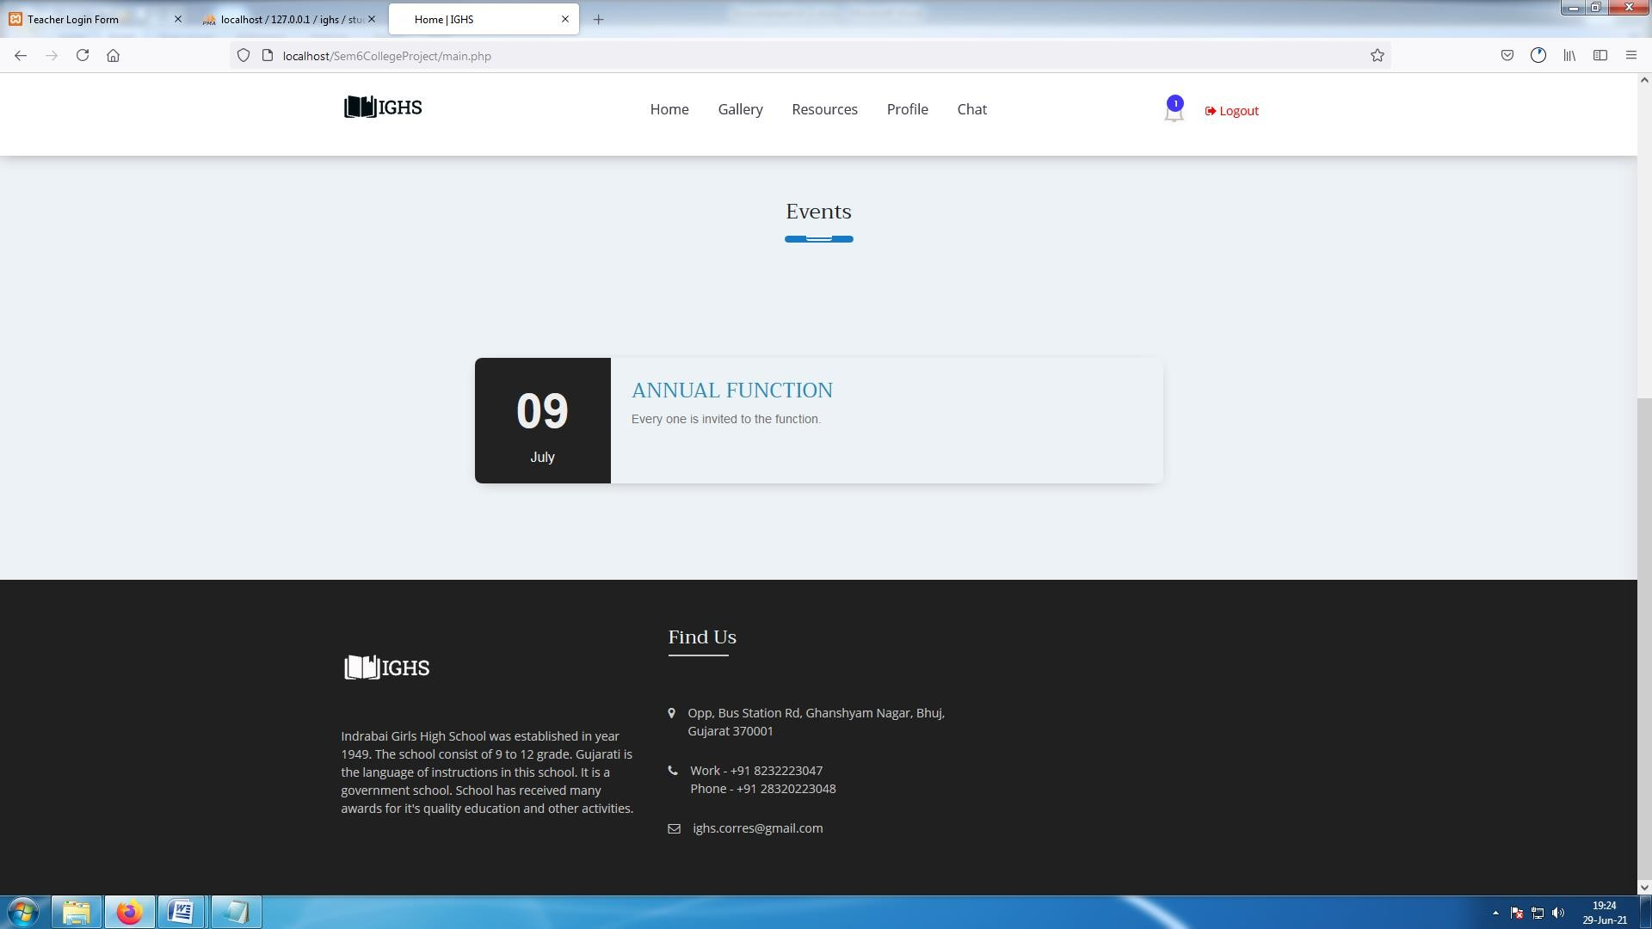

**[ Image 9.1.1-Home page / Event details]**

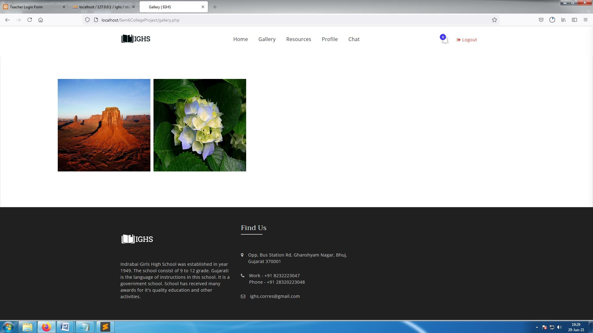

**[ Image 9.2-Gallery Images ]**

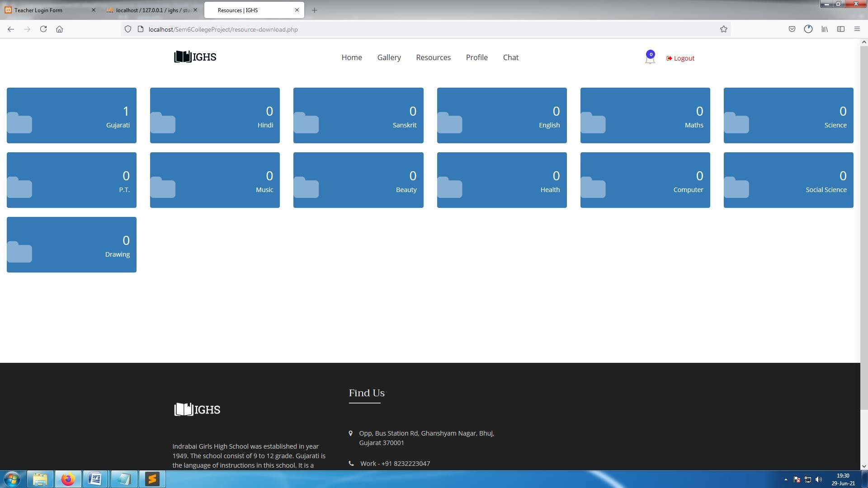

**[ Image 9.3-Download Resources ]**

* Students will see list of their Subjects .
* After selecting subject they can download resource files if their subject teacher uploaded any files.

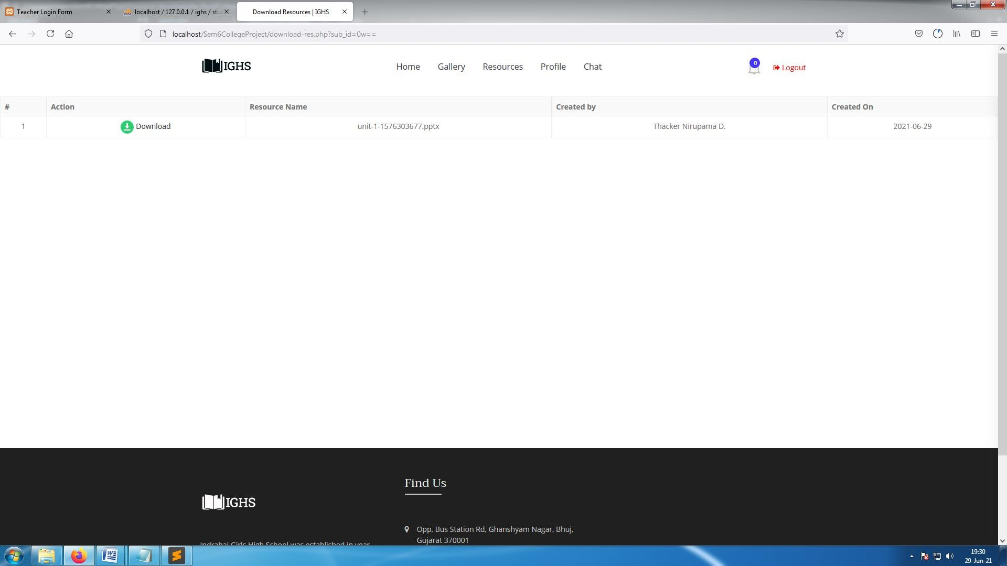

**[ Image 9.3.1- subject-Gujrati / Resources ]**

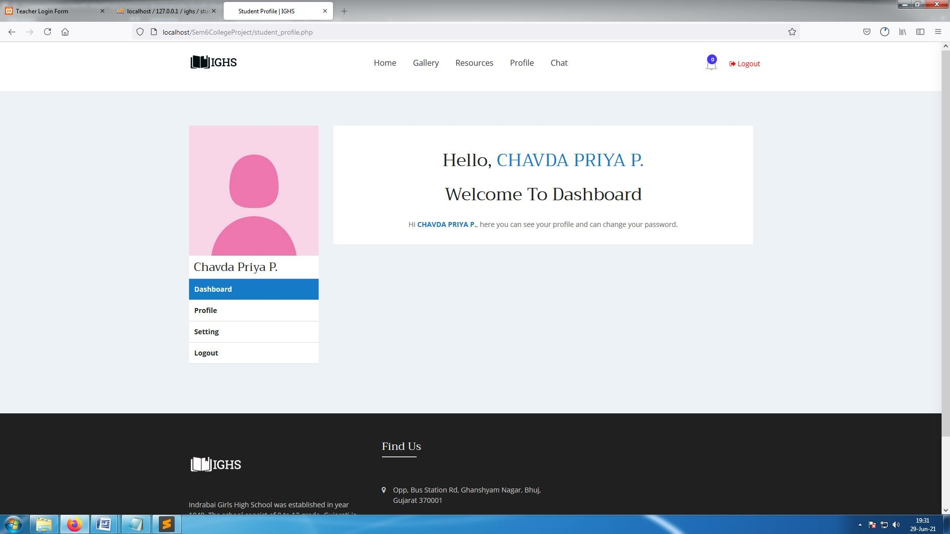

**[ Image 9.4-Student Profile]**

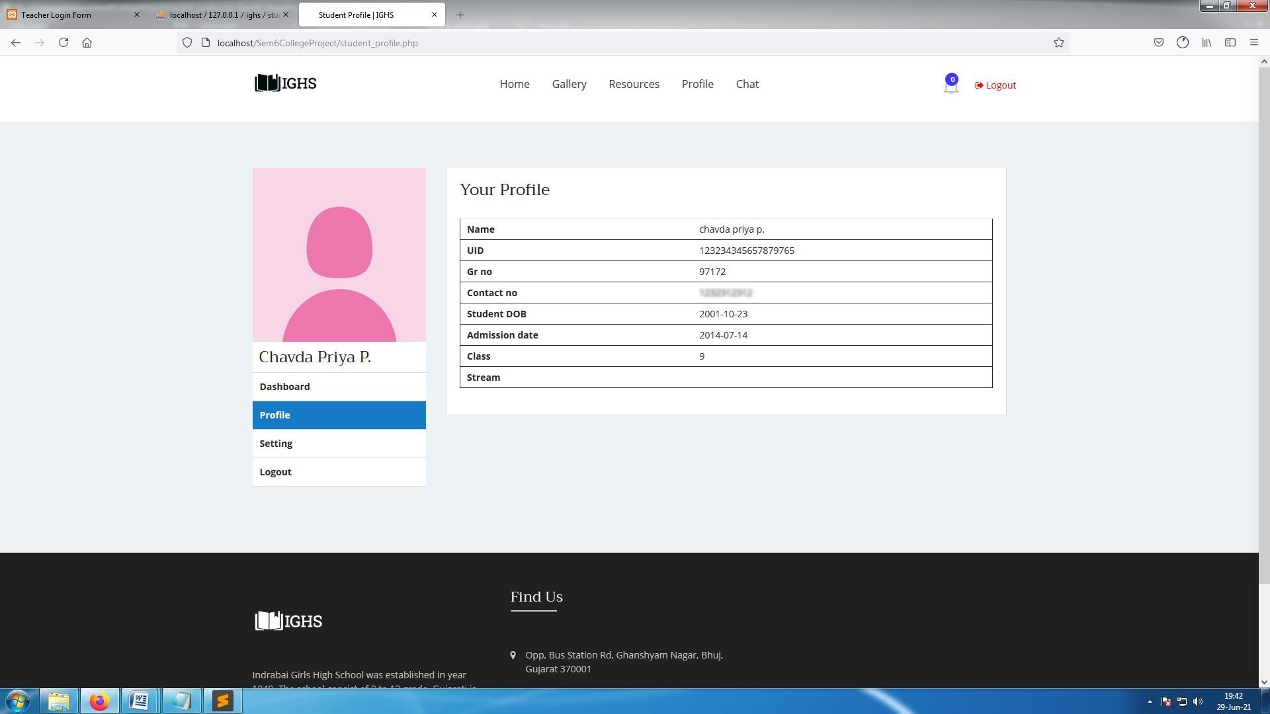**[ Image 9.4.1-Student Profile ]**

* Students can see their own personal details in Profile section.

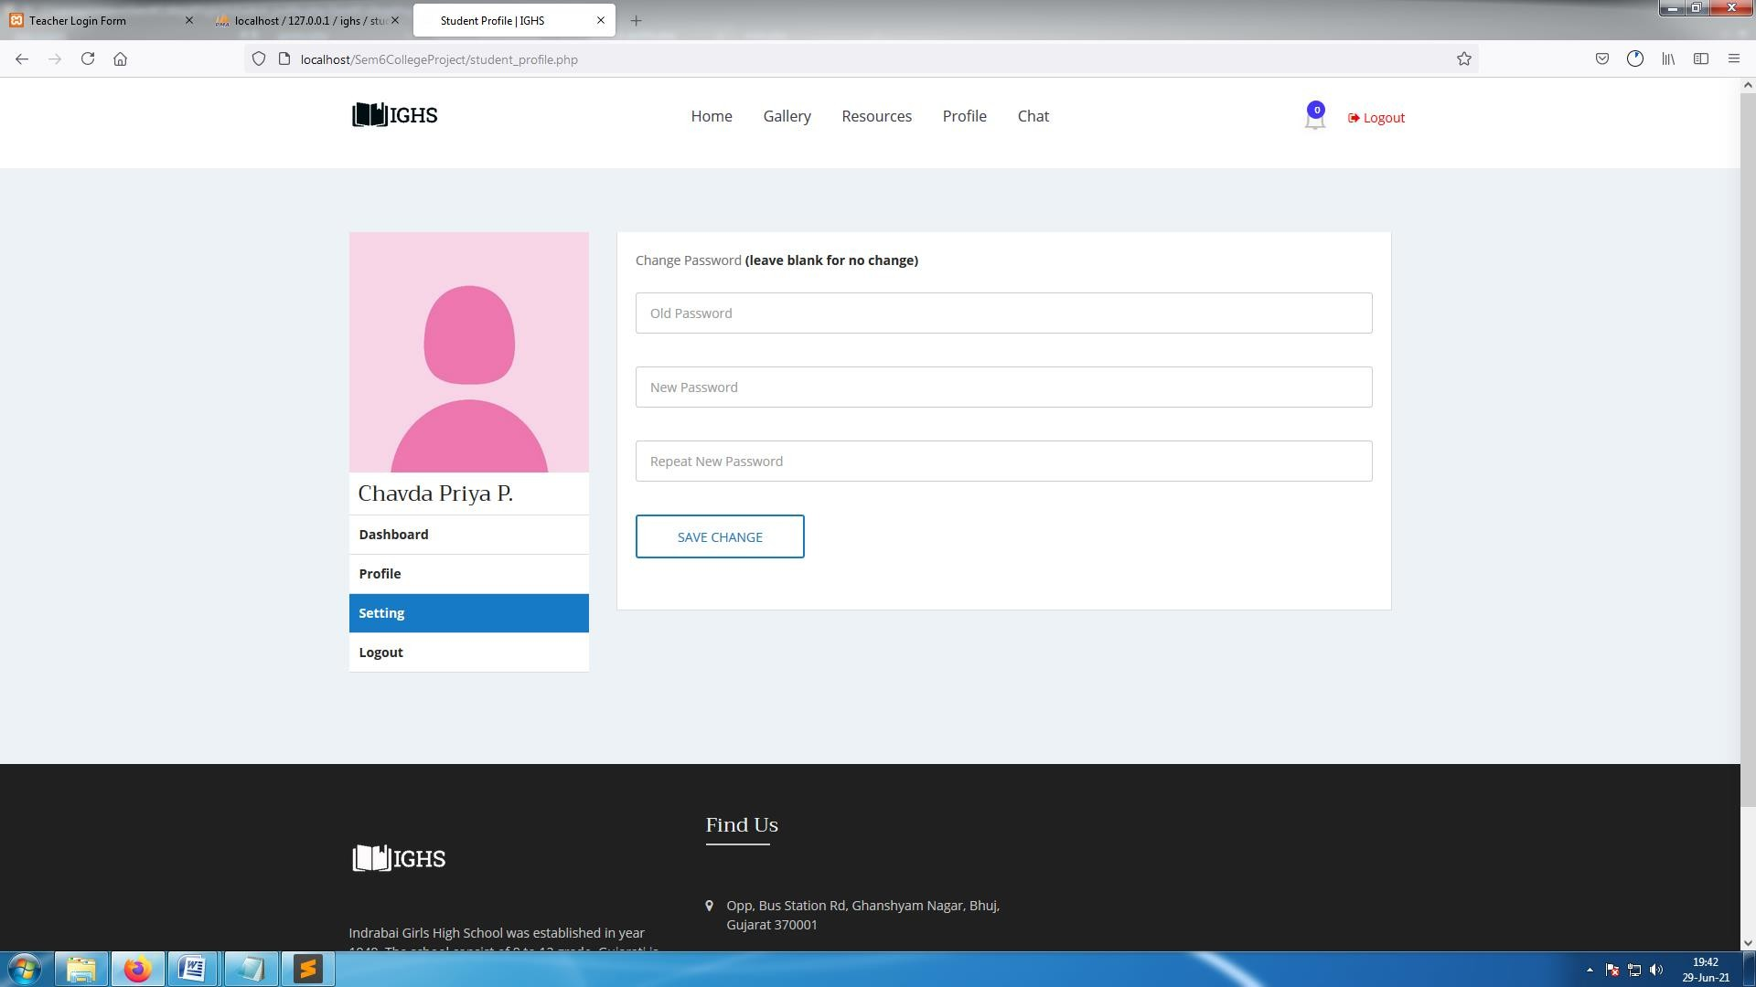

**[ Image 9.4.2-Change Password ]**

* Students can change their password from profile

**6. Proposed Enhancement ,**

**Limitations and**

**Future Enhancement**

**Limitations**

* + This website is designed only for the particular school so only students and staff can login to this website.
  + We can't send images as a resource file.
  + Students and Teachers can't change their personal data by themselves they have to contact admin for that.
  + Students & Teachers get their notifications and details about events only if they login to website.
  + Teachers will also receive same notifications as students , there is no different section.

#### Future Enhancement

* + Push notifications via web browser
  + Sending images on chat box.
  + Online offline feature with firebase.
  + Taking attendance of students.
  + Getting Results of students.
  + Time table which can be changed by admin

.

**7.Conclusion**

It can be concluded from above discussion that a reliable, fast, efficient and secure system has been developed replacing a manual and troublesome system. We have covered all the discussed and essential features for the school

Student management system is bringing a great difference in the lives of students, teachers, and the admin. good management offers better productivity and hence more progress towards development.

Seeing its demands and benefits, we have come forward with best-featured school management website. It has user friendly interface so it will be easier to work with it. It is also a mobile optimized website so that Students and Teachers can use it without having a computer.

This system also has a room for improvement like we have mentioned in the future enhancement section. We would love to try to make this project as better as possible.

It was wonderful and learning experience for us while working on this project so we hope system will be more feasible and adaptable for the users.

### 8.**Bibliography**

#### Websites:

* + <https://www.jqueryscript.net/form/Easy-DragnDrop-AJAX-Uploader-Plugin-For-jQuery-ssi-uploader-js.html>
  + <https://codepen.io/>
  + <https://www.campcodes.com/projects/php/4709/online-student-result-management-system-in-php-mysqli/>
  + <https://elements.envato.com/educo-elearning-education-html-template-AJ3BKZ9>
  + <https://youtu.be/VnvzxGWiK54>
  + <https://phpspreadsheet.readthedocs.io/en/latest/>
  + <https://datatables.net/>
  + <https://stackoverflow.com/questions/4602499/how-can-i-build-a-php-mysql-live-chat/20629415>
  + <https://youtu.be/MwjqI8YfBjw>
  + <https://2factor.in/v3/?at_category=2factor&at_event_action=spr&service=BULK-SMS-OTP-SERVICE-PROVIDER>
  + <https://2fa.api-docs.io/v1/send-sms-otp/sending-sms-otp-custom-otp>